UNITED STATES
SECURITIES AND EXCHANGE COMMISSION
Washington, D.C. 20549
________________________________
FORM 10-Q
(Mark One)
☒ |  |  | QUARTERLY REPORT PURSUANT TO SECTION 13 OR 15(d) OF THE SECURITIES EXCHANGE ACT OF 1934
For the quarterly period ended December 26, 2025
or
☐ |  |  | TRANSITION REPORT PURSUANT TO SECTION 13 OR 15(d) OF THE SECURITIES EXCHANGE ACT OF 1934
For the transition period from _______ to _______
Commission File Number 001-33278
________________________________
AVIAT NETWORKS, INC.
(Exact name of registrant as specified in its charter)
________________________________
Delaware |  |  |  |  |  |  |  |  |  |  |  | 20-5961564
(State or other jurisdiction of incorporation or organization) |  |  |  |  |  |  |  |  |  |  |  | (I.R.S. Employer Identification No.)
200 Parker Drive, Suite C100A, |  |  | Austin, |  |  | Texas |  |  |  |  |  | 78728
(Address of principal executive offices) |  |  |  |  |  |  |  |  |  |  |  | (Zip Code)
(408) 941-7100
(Registrant’s telephone number, including area code)
________________________________
Securities registered pursuant to Section 12(b) of the Act:
Title of each class |  |  | Trading Symbol(s) |  |  | Name of each exchange on which Registered
Common Stock |  |  | AVNW |  |  | The Nasdaq Stock Market LLC
Preferred Share Purchase Rights |  |  |  |  |  | The Nasdaq Stock Market LLC
Indicate by checkmark whether the registrant (l) has filed all reports required to be filed by Section 13 or 15(d) of the Securities Exchange Act of 1934 during the preceding 12 months (or for such shorter period that the registrant was required to file such reports), and (2) has been subject to such filing requirements for the past 90 days. Yes ☒ No ☐
Indicate by check mark whether the registrant has submitted electronically every Interactive Data File required to be submitted pursuant to Rule 405 of Regulation S-T (§232.405 of this chapter) during the preceding 12 months (or for such shorter period that the registrant was required to submit such files). Yes ☒ No ☐
Indicate by check mark whether the registrant is a large accelerated filer, an accelerated filer, a non-accelerated filer, a smaller reporting company, or an emerging growth company. See the definitions of “large accelerated filer,” “accelerated filer,” “smaller reporting company,” and “emerging growth company” in Rule 12b-2 of the Exchange Act.
Large accelerated filer |  |  | ☐ |  |  |  |  |  | Accelerated filer |  |  | ☒
Non-accelerated filer |  |  | ☐ |  |  |  |  |  | Smaller reporting company |  |  | ☐
Emerging growth company |  |  | ☐
If an emerging growth company, indicate by check mark if the registrant has elected not to use the extended transition period for complying with any new or revised financial accounting standards provided pursuant to Section 13(a) of the Exchange Act. ☐
Indicate by check mark whether the registrant is a shell company (as defined in Rule 12b-2 of the Exchange Act). Yes ☐ No ☒
The number of shares outstanding of the registrant’s common stock as of January 30, 2026 was 12,902,310.

AVIAT NETWORKS, INC.
QUARTERLY REPORT ON FORM 10-Q
For the Quarterly Period Ended December 26, 2025
Table of Contents
 |  |  | Page
Part I. Financial Information |  |  | 3
Item 1. Financial Statements |  |  | 3
Condensed Consolidated Statements of Operations (Unaudited) |  |  | 3
Condensed Consolidated Statements of Comprehensive Income (Loss) (Unaudited) |  |  | 4
Condensed Consolidated Balance Sheets (Unaudited) |  |  | 5
Condensed Consolidated Statements of Cash Flows (Unaudited) |  |  | 6
Condensed Consolidated Statements of Equity (Unaudited) |  |  | 7
Notes to Condensed Consolidated Financial Statements (Unaudited) |  |  | 9
Item 2. Management’s Discussion and Analysis of Financial Condition and Results of Operations |  |  | 24
Item 3. Quantitative and Qualitative Disclosures About Market Risk |  |  | 28
Item 4. Controls and Procedures |  |  | 30
Part II. Other Information |  |  | 31
Item 1. Legal Proceedings |  |  | 31
Item 1A. Risk Factors |  |  | 31
Item 2. Unregistered Sales of Equity Securities and Use of Proceeds |  |  | 31
Item 3. Defaults upon Senior Securities |  |  | 31
Item 4. Mine Safety Disclosures |  |  | 31
Item 5. Other Information |  |  | 31
Item 6. Exhibits |  |  | 32
Signatures |  |  | 33

2

PART I. FINANCIAL INFORMATION

Item 1.Financial Statements

AVIAT NETWORKS, INC.
CONDENSED CONSOLIDATED STATEMENTS OF OPERATIONS
(Unaudited)
 |  |  | Three Months Ended |  |  |  |  |  |  |  |  |  |  |  | Six Months Ended
(In thousands, except per share amounts) |  |  | December 26,  2025 |  |  |  |  |  | December 27,  2024 |  |  |  |  |  | December 26,  2025 |  |  |  |  |  | December 27,  2024
Revenues:
Product sales |  |  | $ | 81,210 |  |  |  |  | $ | 82,312 |  |  |  |  | $ | 156,294 |  |  |  |  | $ | 143,428
Services |  |  | 30,262 |  |  |  |  |  | 35,885 |  |  |  |  |  | 62,498 |  |  |  |  |  | 63,198
Total revenues |  |  | 111,472 |  |  |  |  |  | 118,197 |  |  |  |  |  | 218,792 |  |  |  |  |  | 206,626
Cost of revenues:
Product sales |  |  | 54,459 |  |  |  |  |  | 54,969 |  |  |  |  |  | 107,146 |  |  |  |  |  | 107,170
Services |  |  | 20,912 |  |  |  |  |  | 22,342 |  |  |  |  |  | 39,882 |  |  |  |  |  | 38,782
Total cost of revenues |  |  | 75,371 |  |  |  |  |  | 77,311 |  |  |  |  |  | 147,028 |  |  |  |  |  | 145,952
Gross margin |  |  | 36,101 |  |  |  |  |  | 40,886 |  |  |  |  |  | 71,764 |  |  |  |  |  | 60,674
Operating expenses:
Research and development |  |  | 6,409 |  |  |  |  |  | 10,222 |  |  |  |  |  | 13,507 |  |  |  |  |  | 20,630
Selling and administrative |  |  | 22,384 |  |  |  |  |  | 21,279 |  |  |  |  |  | 45,760 |  |  |  |  |  | 46,227
Restructuring charges |  |  | 21 |  |  |  |  |  | 1,415 |  |  |  |  |  | 21 |  |  |  |  |  | 1,415
Total operating expenses |  |  | 28,814 |  |  |  |  |  | 32,916 |  |  |  |  |  | 59,288 |  |  |  |  |  | 68,272
Operating income (loss) |  |  | 7,287 |  |  |  |  |  | 7,970 |  |  |  |  |  | 12,476 |  |  |  |  |  | (7,598)
Interest expense, net |  |  | 1,908 |  |  |  |  |  | 1,580 |  |  |  |  |  | 3,620 |  |  |  |  |  | 2,695
Other (income) expense, net |  |  | (2,744) |  |  |  |  |  | 269 |  |  |  |  |  | (1,771) |  |  |  |  |  | 979
Income (loss) before income taxes |  |  | 8,123 |  |  |  |  |  | 6,121 |  |  |  |  |  | 10,627 |  |  |  |  |  | (11,272)
Provision for (benefit from) income taxes |  |  | 2,405 |  |  |  |  |  | 1,626 |  |  |  |  |  | 4,747 |  |  |  |  |  | (3,888)
Net income (loss) |  |  | $ | 5,718 |  |  |  |  | $ | 4,495 |  |  |  |  | $ | 5,880 |  |  |  |  | $ | (7,384)
Net income (loss) per share of common stock outstanding:
Basic |  |  | $ | 0.44 |  |  |  |  | $ | 0.35 |  |  |  |  | $ | 0.46 |  |  |  |  | $ | (0.58)
Diluted |  |  | $ | 0.44 |  |  |  |  | $ | 0.35 |  |  |  |  | $ | 0.45 |  |  |  |  | $ | (0.58)
Weighted-average shares outstanding:
Basic |  |  | 12,856 |  |  |  |  |  | 12,689 |  |  |  |  |  | 12,808 |  |  |  |  |  | 12,667
Diluted |  |  | 13,005 |  |  |  |  |  | 12,784 |  |  |  |  |  | 12,995 |  |  |  |  |  | 12,667

See accompanying Notes to Unaudited Condensed Consolidated Financial Statements.

3

AVIAT NETWORKS, INC.
CONDENSED CONSOLIDATED STATEMENTS OF COMPREHENSIVE INCOME (LOSS)
(Unaudited)
 |  |  | Three Months Ended |  |  |  |  |  |  |  |  |  |  |  | Six Months Ended
(In thousands) |  |  | December 26,  2025 |  |  |  |  |  | December 27,  2024 |  |  |  |  |  | December 26,  2025 |  |  |  |  |  | December 27,  2024
Net income (loss) |  |  | $ | 5,718 |  |  |  |  | $ | 4,495 |  |  |  |  | $ | 5,880 |  |  |  |  | $ | (7,384)
Other comprehensive income (loss):
Net change in cumulative translation adjustments |  |  | 1,151 |  |  |  |  |  | (3,416) |  |  |  |  |  | 242 |  |  |  |  |  | (1,263)
Other comprehensive income (loss) |  |  | 1,151 |  |  |  |  |  | (3,416) |  |  |  |  |  | 242 |  |  |  |  |  | (1,263)
Comprehensive income (loss) |  |  | $ | 6,869 |  |  |  |  | $ | 1,079 |  |  |  |  | $ | 6,122 |  |  |  |  | $ | (8,647)

See accompanying Notes to Unaudited Condensed Consolidated Financial Statements.

4

AVIAT NETWORKS, INC.
CONDENSED CONSOLIDATED BALANCE SHEETS

(In thousands, except share and par value amounts) |  |  | December 26,  2025 |  |  |  |  |  | June 27,  2025
 |  |  | (Unaudited)
ASSETS
Current Assets:
Cash and cash equivalents |  |  | $ | 86,466 |  |  |  |  | $ | 59,690
Accounts receivable, net of allowances of $5,897 and $3,583 |  |  | 203,123 |  |  |  |  |  | 180,321
Unbilled receivables |  |  | 90,612 |  |  |  |  |  | 105,870
Inventories |  |  | 76,637 |  |  |  |  |  | 83,979
Other current assets |  |  | 37,016 |  |  |  |  |  | 33,715
Total current assets |  |  | 493,854 |  |  |  |  |  | 463,575
Property, plant and equipment, net |  |  | 19,074 |  |  |  |  |  | 17,453
Goodwill |  |  | 19,544 |  |  |  |  |  | 19,655
Intangible assets, net |  |  | 25,173 |  |  |  |  |  | 26,897
Deferred income taxes |  |  | 84,591 |  |  |  |  |  | 88,149
Right-of-use assets |  |  | 2,805 |  |  |  |  |  | 3,113
Other assets |  |  | 14,314 |  |  |  |  |  | 14,454
Total assets |  |  | $ | 659,355 |  |  |  |  | $ | 633,296
LIABILITIES AND STOCKHOLDERS’ EQUITY
Current Liabilities:
Accounts payable |  |  | $ | 145,412 |  |  |  |  | $ | 148,093
Accrued expenses |  |  | 31,560 |  |  |  |  |  | 38,897
Operating lease liabilities |  |  | 787 |  |  |  |  |  | 1,090
Advance payments and unearned revenue |  |  | 84,452 |  |  |  |  |  | 73,735
Other current liabilities |  |  | 444 |  |  |  |  |  | 1,757
Current portion of long-term debt |  |  | 4,443 |  |  |  |  |  | 18,624
Total current liabilities |  |  | 267,098 |  |  |  |  |  | 282,196
Long-term debt |  |  | 100,931 |  |  |  |  |  | 68,966
Unearned revenue |  |  | 8,579 |  |  |  |  |  | 8,063
Long-term operating lease liabilities |  |  | 2,199 |  |  |  |  |  | 2,241
Other long-term liabilities |  |  | 450 |  |  |  |  |  | 430
Reserve for uncertain tax positions |  |  | 3,570 |  |  |  |  |  | 3,242
Deferred income taxes |  |  | 4,917 |  |  |  |  |  | 4,975
Total liabilities |  |  | 387,744 |  |  |  |  |  | 370,113
Commitments and contingencies (Note 12)
Stockholders’ equity:
Preferred stock, $0.01 par value, 50.0 million shares authorized, none issued |  |  | — |  |  |  |  |  | —
Common stock, $0.01 par value, 300.0 million shares authorized, 12.9 million and 12.7 million shares issued and outstanding as of December 26, 2025 and June 27, 2025, respectively |  |  | 129 |  |  |  |  |  | 127
Treasury stock 0.2 million and 0.2 million shares as of December 26, 2025 and June 27, 2025, respectively |  |  | (7,076) |  |  |  |  |  | (7,076)
Additional paid-in-capital |  |  | 868,423 |  |  |  |  |  | 866,119
Accumulated deficit |  |  | (571,292) |  |  |  |  |  | (577,172)
Accumulated other comprehensive loss |  |  | (18,573) |  |  |  |  |  | (18,815)
Total stockholders’ equity |  |  | 271,611 |  |  |  |  |  | 263,183
Total liabilities and stockholders’ equity |  |  | $ | 659,355 |  |  |  |  | $ | 633,296

See accompanying Notes to Unaudited Condensed Consolidated Financial Statements.

5

AVIAT NETWORKS, INC.
CONDENSED CONSOLIDATED STATEMENTS OF CASH FLOWS
(Unaudited)
 |  |  | Six Months Ended
(In thousands) |  |  | December 26,  2025 |  |  |  |  |  | December 27,  2024
Operating Activities
Net income (loss) |  |  | $ | 5,880 |  |  |  |  | $ | (7,384)
Adjustments to reconcile net income (loss) to net cash provided by (used in) operating activities:
Depreciation of property, plant and equipment |  |  | 1,393 |  |  |  |  |  | 2,790
Amortization of intangible assets |  |  | 1,429 |  |  |  |  |  | 1,315
Provision for uncollectible receivables |  |  | 2,341 |  |  |  |  |  | 643
Share-based compensation |  |  | 2,903 |  |  |  |  |  | 3,638
Deferred taxes |  |  | 2,709 |  |  |  |  |  | (5,365)
Inventory write-downs |  |  | 1,533 |  |  |  |  |  | 1,076
Non-cash lease expense |  |  | 743 |  |  |  |  |  | 749
Other non-cash operating activities, net |  |  | 192 |  |  |  |  |  | 436
Changes in operating assets and liabilities:
Accounts receivable |  |  | (25,262) |  |  |  |  |  | (13,939)
Unbilled receivables |  |  | 16,250 |  |  |  |  |  | (3,587)
Inventories |  |  | 5,814 |  |  |  |  |  | (13,960)
Accounts payable |  |  | (2,659) |  |  |  |  |  | 27,613
Accrued expenses |  |  | (3,747) |  |  |  |  |  | (7,085)
Advance payments and unearned revenue |  |  | 11,142 |  |  |  |  |  | 13,086
Income taxes payable |  |  | (3,242) |  |  |  |  |  | 1,415
Other assets and liabilities |  |  | (5,244) |  |  |  |  |  | (7,855)
Net cash provided by (used in) operating activities |  |  | 12,175 |  |  |  |  |  | (6,414)
Investing Activities
Purchase of property, plant and equipment |  |  | (3,168) |  |  |  |  |  | (7,908)
Proceeds from sale of asset held for sale |  |  | — |  |  |  |  |  | 2,589
Acquisition, net of cash acquired |  |  | — |  |  |  |  |  | (18,150)
Net cash used in investing activities |  |  | (3,168) |  |  |  |  |  | (23,469)
Financing Activities
Proceeds from revolver |  |  | 50,000 |  |  |  |  |  | 35,000
Repayments of revolver |  |  | (50,000) |  |  |  |  |  | (35,000)
Proceeds from term loan |  |  | 20,000 |  |  |  |  |  | 75,000
Repayments of term loan |  |  | (2,090) |  |  |  |  |  | (48,750)
Payments of deferred financing costs |  |  | (204) |  |  |  |  |  | (529)
Payments of deferred consideration for acquisitions |  |  | — |  |  |  |  |  | (5,815)
Payments for repurchase of common stock - treasury shares |  |  | — |  |  |  |  |  | (499)
Payments for taxes related to net settlement of equity awards |  |  | (807) |  |  |  |  |  | (886)
Proceeds from issuance of common stock under employee stock plans |  |  | 210 |  |  |  |  |  | 96
Net cash provided by financing activities |  |  | 17,109 |  |  |  |  |  | 18,617
Effect of exchange rate changes on cash, cash equivalents, and restricted cash |  |  | 539 |  |  |  |  |  | (174)
Net increase (decrease) in cash, cash equivalents, and restricted cash |  |  | 26,655 |  |  |  |  |  | (11,440)
Cash, cash equivalents, and restricted cash, beginning of period |  |  | 62,013 |  |  |  |  |  | 64,934
Cash, cash equivalents, and restricted cash, end of period |  |  | $ | 88,668 |  |  |  |  | $ | 53,494

See accompanying Notes to Unaudited Condensed Consolidated Financial Statements.

6

AVIAT NETWORKS, INC.
CONDENSED CONSOLIDATED STATEMENTS OF EQUITY
(Unaudited)
 |  |  | Three Months Ended December 26, 2025
 |  |  | Common Stock |  |  |  |  |  |  |  |  |  |  |  |  | Treasury Stock |  |  |  |  |  | Additional Paid-in Capital |  |  |  |  |  | Accumulated Deficit |  |  |  |  |  | Accumulated Other Comprehensive Loss |  |  |  |  |  | Total Equity
(In thousands) |  |  | Shares |  |  |  |  |  | $  Amount |  |  |  |  |  |  | $  Amount
Balance as of September 26, 2025 |  |  | 12,802 |  |  |  |  |  | $ | 128 |  |  |  |  |  | $ | (7,076) |  |  |  |  | $ | 867,318 |  |  |  |  | $ | (577,010) |  |  |  |  | $ | (19,724) |  |  |  |  | $ | 263,636
Net income |  |  | — |  |  |  |  |  | — |  |  |  |  |  |  | — |  |  |  |  |  | — |  |  |  |  |  | 5,718 |  |  |  |  |  | — |  |  |  |  |  | 5,718
Other comprehensive income |  |  | — |  |  |  |  |  | — |  |  |  |  |  |  | — |  |  |  |  |  | — |  |  |  |  |  | — |  |  |  |  |  | 1,151 |  |  |  |  |  | 1,151
Issuance of common stock under employee stock plans |  |  | 102 |  |  |  |  |  | 1 |  |  |  |  |  |  | — |  |  |  |  |  | (1) |  |  |  |  |  | — |  |  |  |  |  | — |  |  |  |  |  | —
Shares withheld for taxes related to vesting of equity awards |  |  | (11) |  |  |  |  |  | — |  |  |  |  |  |  | — |  |  |  |  |  | (242) |  |  |  |  |  | — |  |  |  |  |  | — |  |  |  |  |  | (242)
Share-based compensation |  |  | — |  |  |  |  |  | — |  |  |  |  |  |  | — |  |  |  |  |  | 1,348 |  |  |  |  |  | — |  |  |  |  |  | — |  |  |  |  |  | 1,348
Balance as of December 26, 2025 |  |  | 12,893 |  |  |  |  |  | $ | 129 |  |  |  |  |  | $ | (7,076) |  |  |  |  | $ | 868,423 |  |  |  |  | $ | (571,292) |  |  |  |  | $ | (18,573) |  |  |  |  | $ | 271,611

 |  |  | Three Months Ended December 27, 2024
 |  |  | Common Stock |  |  |  |  |  |  |  |  |  |  |  |  | Treasury Stock |  |  |  |  |  | Additional  Paid-in  Capital |  |  |  |  |  | Accumulated Deficit |  |  |  |  |  | Accumulated Other Comprehensive Loss |  |  |  |  |  | Total Equity
(In thousands) |  |  | Shares |  |  |  |  |  | $  Amount |  |  |  |  |  |  | $  Amount
Balance as of September 27, 2024 |  |  | 12,676 |  |  |  |  |  | $ | 127 |  |  |  |  |  | $ | (6,479) |  |  |  |  | $ | 861,023 |  |  |  |  | $ | (590,392) |  |  |  |  | $ | (17,167) |  |  |  |  | $ | 247,112
Net income |  |  | — |  |  |  |  |  | — |  |  |  |  |  |  | — |  |  |  |  |  | — |  |  |  |  |  | 4,495 |  |  |  |  |  | — |  |  |  |  |  | 4,495
Other comprehensive loss |  |  | — |  |  |  |  |  | — |  |  |  |  |  |  | — |  |  |  |  |  | — |  |  |  |  |  | — |  |  |  |  |  | (3,416) |  |  |  |  |  | (3,416)
Issuance of common stock under employee stock plans |  |  | 50 |  |  |  |  |  | — |  |  |  |  |  |  | — |  |  |  |  |  | 96 |  |  |  |  |  | — |  |  |  |  |  | — |  |  |  |  |  | 96
Shares withheld for taxes related to vesting of equity awards |  |  | (7) |  |  |  |  |  | — |  |  |  |  |  |  | — |  |  |  |  |  | (175) |  |  |  |  |  | — |  |  |  |  |  | — |  |  |  |  |  | (175)
Share-based compensation |  |  | — |  |  |  |  |  | — |  |  |  |  |  |  | — |  |  |  |  |  | 1,974 |  |  |  |  |  | — |  |  |  |  |  | — |  |  |  |  |  | 1,974
Balance as of December 27, 2024 |  |  | 12,684 |  |  |  |  |  | $ | 127 |  |  |  |  |  | $ | (6,978) |  |  |  |  | $ | 862,918 |  |  |  |  | $ | (585,897) |  |  |  |  | $ | (20,583) |  |  |  |  | $ | 249,587

See accompanying Notes to Unaudited Condensed Consolidated Financial Statements.

7

 |  |  | Six Months Ended December 26, 2025
 |  |  | Common Stock |  |  |  |  |  |  |  |  |  |  |  | Treasury Stock |  |  |  |  |  | Additional  Paid-in  Capital |  |  |  |  |  | Accumulated Deficit |  |  |  |  |  | Accumulated Other Comprehensive Loss |  |  |  |  |  | Total Equity
(In thousands) |  |  | Shares |  |  |  |  |  | $  Amount |  |  |  |  |  | $  Amount
Balance as of June 27, 2025 |  |  | 12,740 |  |  |  |  |  | $ | 127 |  |  |  |  | $ | (7,076) |  |  |  |  | $ | 866,119 |  |  |  |  | $ | (577,172) |  |  |  |  | $ | (18,815) |  |  |  |  | $ | 263,183
Net income |  |  | — |  |  |  |  |  | — |  |  |  |  |  | — |  |  |  |  |  | — |  |  |  |  |  | 5,880 |  |  |  |  |  | — |  |  |  |  |  | 5,880
Other comprehensive income |  |  | — |  |  |  |  |  | — |  |  |  |  |  | — |  |  |  |  |  | — |  |  |  |  |  | — |  |  |  |  |  | 242 |  |  |  |  |  | 242
Issuance of common stock under employee stock plans |  |  | 189 |  |  |  |  |  | 2 |  |  |  |  |  | — |  |  |  |  |  | 208 |  |  |  |  |  | — |  |  |  |  |  | — |  |  |  |  |  | 210
Shares withheld for taxes related to vesting of equity awards |  |  | (36) |  |  |  |  |  | — |  |  |  |  |  | — |  |  |  |  |  | (807) |  |  |  |  |  | — |  |  |  |  |  | — |  |  |  |  |  | (807)
Share-based compensation |  |  | — |  |  |  |  |  | — |  |  |  |  |  | — |  |  |  |  |  | 2,903 |  |  |  |  |  | — |  |  |  |  |  | — |  |  |  |  |  | 2,903
Balance as of December 26, 2025 |  |  | 12,893 |  |  |  |  |  | $ | 129 |  |  |  |  | $ | (7,076) |  |  |  |  | $ | 868,423 |  |  |  |  | $ | (571,292) |  |  |  |  | $ | (18,573) |  |  |  |  | $ | 271,611

 |  |  | Six Months Ended December 27, 2024
 |  |  | Common Stock |  |  |  |  |  |  |  |  |  |  |  | Treasury Stock |  |  |  |  |  | Additional  Paid-in  Capital |  |  |  |  |  | Accumulated Deficit |  |  |  |  |  | Accumulated Other Comprehensive Loss |  |  |  |  |  | Total Equity
(In thousands) |  |  | Shares |  |  |  |  |  | $  Amount |  |  |  |  |  | $  Amount
Balance as of June 28, 2024 |  |  | 12,622 |  |  |  |  |  | $ | 126 |  |  |  |  | $ | (6,479) |  |  |  |  | $ | 860,071 |  |  |  |  | $ | (578,513) |  |  |  |  | $ | (19,320) |  |  |  |  | $ | 255,885
Net loss |  |  | — |  |  |  |  |  | — |  |  |  |  |  | — |  |  |  |  |  | — |  |  |  |  |  | (7,384) |  |  |  |  |  | — |  |  |  |  |  | (7,384)
Other comprehensive loss |  |  | — |  |  |  |  |  | — |  |  |  |  |  | — |  |  |  |  |  | — |  |  |  |  |  | — |  |  |  |  |  | (1,263) |  |  |  |  |  | (1,263)
Issuance of common stock under employee stock plans |  |  | 130 |  |  |  |  |  | 1 |  |  |  |  |  | — |  |  |  |  |  | 95 |  |  |  |  |  | — |  |  |  |  |  | — |  |  |  |  |  | 96
Shares withheld for taxes related to vesting of equity awards |  |  | (33) |  |  |  |  |  | — |  |  |  |  |  | — |  |  |  |  |  | (886) |  |  |  |  |  | — |  |  |  |  |  | — |  |  |  |  |  | (886)
Stock repurchase |  |  | (35) |  |  |  |  |  | — |  |  |  |  |  | (499) |  |  |  |  |  | — |  |  |  |  |  | — |  |  |  |  |  | — |  |  |  |  |  | (499)
Share-based compensation |  |  | — |  |  |  |  |  | — |  |  |  |  |  | — |  |  |  |  |  | 3,638 |  |  |  |  |  | — |  |  |  |  |  | — |  |  |  |  |  | 3,638
Balance as of December 27, 2024 |  |  | 12,684 |  |  |  |  |  | $ | 127 |  |  |  |  | $ | (6,978) |  |  |  |  | $ | 862,918 |  |  |  |  | $ | (585,897) |  |  |  |  | $ | (20,583) |  |  |  |  | $ | 249,587

8

AVIAT NETWORKS, INC.
NOTES TO CONDENSED CONSOLIDATED FINANCIAL STATEMENTS
(Unaudited)

Note 1. The Company and Basis of Presentation
The Company
Aviat Networks, Inc. (“Aviat,” the “Company,” “we,” “us,” and “our”) designs, manufactures, and sells wireless networking and access networking solutions and services to mobile and fixed telephone service providers, private network operators, government agencies, transportation and utility companies, public safety agencies and broadcast system operators across the globe. Aviat’s products include broadband wireless access base stations and customer premises equipment for fixed and mobile, point-to-point digital microwave radio systems for access, backhaul, trunking and license-exempt applications, supporting new network deployments, network expansion, and capacity upgrades.
Basis of Presentation
The accompanying unaudited condensed consolidated financial statements have been prepared in accordance with generally accepted accounting principles in the United States (“U.S. GAAP”) and with the rules and regulations of the Securities and Exchange Commission (“SEC”) for interim financial information, and Aviat has made estimates, assumptions and judgments affecting the amounts reported in its unaudited condensed consolidated financial statements and the accompanying notes, as discussed in greater detail below. Accordingly, the statements do not include all information and footnotes required by U.S. GAAP for annual consolidated financial statements. In the opinion of the Company’s management, such interim financial statements reflect all adjustments (consisting of normal recurring adjustments) considered necessary for a fair statement of its financial position, results of operations and cash flows for such periods. The results for the six months ended December 26, 2025 are not necessarily indicative of the results that may be expected for the full fiscal year or future operating periods. The information included in this Quarterly Report on Form 10-Q should be read in conjunction with the consolidated financial statements and footnotes thereto included in Aviat’s Annual Report on Form 10-K for the fiscal year ended June 27, 2025.
The unaudited condensed consolidated financial statements include the accounts of the Company and its wholly-owned and majority-owned subsidiaries. All intercompany transactions and accounts have been eliminated. Certain amounts in the financial statements have been reclassified for comparative purposes to conform to the current period financial statement presentation.
Aviat’s fiscal year includes 52 or 53 weeks and ends on the Friday nearest to June 30. The three months ended December 26, 2025 and December 27, 2024 both consisted of 13 weeks. Fiscal year 2026 contains 53 weeks and will end on July 3, 2026. Fiscal year 2025 contained 52 weeks and ended on June 27, 2025.
Use of Estimates
The preparation of unaudited condensed consolidated financial statements in accordance with U.S. GAAP requires the Company to make estimates, assumptions and judgments affecting the amounts reported and related disclosures. Estimates are based upon historical factors, current circumstances and the experience and judgment of the Company’s management. The Company evaluates estimates and assumptions on an ongoing basis and may employ outside experts to assist in making these evaluations. Changes in such estimates, based on more accurate information, or different assumptions or conditions, may affect amounts reported in future periods. Such estimates affect significant items, including revenue recognition, provision for uncollectible receivables, inventory valuation, goodwill and identified intangible assets in business combinations, valuation allowances for deferred tax assets, uncertainties in income taxes, contingencies and recoverability of long-lived assets. Actual results may differ materially from estimates.
Summary of Significant Accounting Policies
There have been no material changes in the Company’s significant accounting policies as of and for the six months ended December 26, 2025, as compared to the significant accounting policies described in the Company’s Annual Report on Form 10-K for the fiscal year ended June 27, 2025.
9

Recently Adopted Accounting Pronouncements
In November 2023, the Financial Accounting Standards Board (“FASB”) issued Accounting Standards Update (“ASU”) 2023-07, Segment Reporting (Topic 280): Improvements to Reportable Segment Disclosures. The ASU expands reportable segment disclosure requirements, primarily through enhanced disclosures about significant segment expenses that are regularly presented to the chief operating decision maker. The disclosures required under ASU 2023-07 are also required for public entities with a single reportable segment. ASU 2023-07 is effective for the Company’s annual reporting beginning in fiscal 2025 and for interim periods beginning in fiscal 2026. The Company adopted ASU 2023-07 for the year ended June 27, 2025. The adoption of this standard did not have a material impact on the Company’s consolidated financial statements.
Accounting Standards Not Yet Adopted
In September 2025, the FASB issued ASU 2025-06, Intangibles—Goodwill and Other—Internal-Use Software (Subtopic 350-40): Targeted Improvements to the Accounting for Internal-Use Software, which modernizes the accounting for internal-use software. The ASU requires entities to consider whether significant development uncertainty has been resolved before starting to capitalize software costs. ASU 2025-06 is effective for annual and interim reporting periods beginning after December 15, 2027, and can be applied prospectively, retrospectively, or using a modified transition method, with early adoption permitted. The Company is currently evaluating the impact of this ASU on its consolidated financial statements and disclosures.
In November 2024, the FASB issued ASU 2024-03 (Subtopic 220-40): Disaggregation of Income Statement Expenses. The ASU requires disclosures about specific types of expenses included in the expense captions presented on the face of the income statement as well as disclosures about selling expenses. ASU 2024-03 is effective for the Company’s annual reporting beginning in fiscal 2028 and for interim periods beginning in fiscal 2029. The Company is currently evaluating the impact of this ASU on its consolidated financial statements and disclosures.
In December 2023, the FASB issued ASU 2023-09, Income Taxes (Topic 740): Improvements to Income Tax Disclosures. The ASU enhances the transparency and usefulness of income tax information through improvements to disclosures primarily related to the rate reconciliation and income taxes paid information. ASU 2023-09 is effective for the Company’s annual reporting beginning in fiscal 2026. The Company is currently evaluating the impact of this ASU on its consolidated financial statements and disclosures.
The Company considers the applicability and impact of all ASUs issued by the FASB. The Company determined at this time that all other ASUs issued but not yet adopted are either not applicable or are expected to have a minimal impact on its financial position and results of operations.

Note 2. Net Income (Loss) Per Share of Common Stock
The following table presents the computation of basic and diluted net income (loss) per share:
 |  |  | Three Months Ended |  |  |  |  |  |  |  |  |  |  |  | Six Months Ended
(In thousands, except per share amounts) |  |  | December 26,  2025 |  |  |  |  |  | December 27,  2024 |  |  |  |  |  | December 26,  2025 |  |  |  |  |  | December 27,  2024
Numerator:
Net income (loss) |  |  | $ | 5,718 |  |  |  |  | $ | 4,495 |  |  |  |  | $ | 5,880 |  |  |  |  | $ | (7,384)
Denominator:
Weighted-average shares outstanding, basic |  |  | 12,856 |  |  |  |  |  | 12,689 |  |  |  |  |  | 12,808 |  |  |  |  |  | 12,667
Effect of potentially dilutive equivalent shares |  |  | 149 |  |  |  |  |  | 95 |  |  |  |  |  | 187 |  |  |  |  |  | —
Weighted-average shares outstanding, diluted |  |  | 13,005 |  |  |  |  |  | 12,784 |  |  |  |  |  | 12,995 |  |  |  |  |  | 12,667
Net income (loss) per share of common stock outstanding:
Basic |  |  | $ | 0.44 |  |  |  |  | $ | 0.35 |  |  |  |  | $ | 0.46 |  |  |  |  | $ | (0.58)
Diluted |  |  | $ | 0.44 |  |  |  |  | $ | 0.35 |  |  |  |  | $ | 0.45 |  |  |  |  | $ | (0.58)
10

The following table summarizes the weighted-average equity awards that were excluded from the diluted net income (loss) per share calculations since they were anti-dilutive:
 |  |  | Three Months Ended |  |  |  |  |  |  |  |  |  |  |  | Six Months Ended
(In thousands) |  |  | December 26,  2025 |  |  |  |  |  | December 27,  2024 |  |  |  |  |  | December 26,  2025 |  |  |  |  |  | December 27,  2024
Stock options |  |  | 269 |  |  |  |  |  | 327 |  |  |  |  |  | 274 |  |  |  |  |  | 385
Restricted stock units and performance stock units |  |  | 269 |  |  |  |  |  | 421 |  |  |  |  |  | 157 |  |  |  |  |  | 175
Total shares of common stock excluded |  |  | 538 |  |  |  |  |  | 748 |  |  |  |  |  | 431 |  |  |  |  |  | 560

Note 3. Revenue Recognition
Contract Balances

(In thousands) |  |  | December 26,  2025 |  |  |  |  |  | June 27,  2025
Contract assets
Accounts receivable, net |  |  | $ | 203,123 |  |  |  |  | $ | 180,321
Unbilled receivables |  |  | 90,612 |  |  |  |  |  | 105,870
Capitalized commissions |  |  | 2,466 |  |  |  |  |  | 3,921
Contract liabilities
Advance payments and unearned revenue |  |  | $ | 84,452 |  |  |  |  | $ | 73,735
Unearned revenue, long-term |  |  | 8,579 |  |  |  |  |  | 8,063
Significant changes in contract balances may arise as a result of recognition over time for services, transfer of control for equipment, and periodic payments (both in arrears and in advance).
From time to time, the Company may experience unforeseen events that could result in a change to the scope or price associated with an arrangement. When such events occur, the transaction price and measurement of progress for the performance obligation are updated and this change is recognized as a cumulative catch-up to revenue. Because of the nature and type of contracts, the timeframe to completion and satisfaction of current and future performance obligations can shift; however, this will have no impact on the Company’s future obligation to bill and collect.
As of December 26, 2025, the Company reported $93.0 million in advance payments and unearned revenue and long-term unearned revenue, of which approximately 90% is expected to be recognized as revenue in the next twelve months and the remainder thereafter. Approximately $25.1 million and $47.1 million of revenue was recognized during the three and six months ended December 26, 2025, respectively, which was included in advance payments and unearned revenue at June 27, 2025.
Remaining Performance Obligations
The aggregate amount of transaction price allocated to unsatisfied (or partially unsatisfied) performance obligations was approximately $135.3 million at December 26, 2025 relating to long-term field service projects. Of this amount, approximately 50% is expected to be recognized as revenue during the next 12 months, with the remaining amount to be recognized thereafter.

11

Note 4. Balance Sheet Components
Cash, Cash equivalents, and Restricted cash
The following provides a summary of cash, cash equivalents, and restricted cash reported within the unaudited condensed consolidated balance sheets that reconciles to the corresponding amount in the unaudited condensed consolidated statement of cash flows:

(In thousands) |  |  | December 26,  2025 |  |  |  |  |  | June 27,  2025
Cash and cash equivalents |  |  | $ | 86,466 |  |  |  |  | $ | 59,690
Restricted cash included in long-term other assets |  |  | 2,202 |  |  |  |  |  | 2,323
Total cash, cash equivalents, and restricted cash |  |  | $ | 88,668 |  |  |  |  | $ | 62,013
Inventories

(In thousands) |  |  | December 26,  2025 |  |  |  |  |  | June 27,  2025
Finished products |  |  | $ | 44,285 |  |  |  |  | $ | 55,972
Raw materials and supplies |  |  | 31,171 |  |  |  |  |  | 26,273
Customer service inventories |  |  | 1,181 |  |  |  |  |  | 1,734
Total inventories |  |  | $ | 76,637 |  |  |  |  | $ | 83,979
Consigned inventories included within raw materials and supplies |  |  | $ | 21,624 |  |  |  |  | $ | 21,047

The Company records charges to adjust inventories due to excess and obsolete inventory resulting from lower sales forecasts, product transitioning or discontinuance. The charges incurred during the three and six months ended December 26, 2025 and December 27, 2024 were included in cost of product sales as follows:
 |  |  | Three Months Ended |  |  |  |  |  |  |  |  |  |  |  | Six Months Ended
(In thousands) |  |  | December 26,  2025 |  |  |  |  |  | December 27,  2024 |  |  |  |  |  | December 26,  2025 |  |  |  |  |  | December 27,  2024
Excess and obsolete inventory |  |  | $ | 423 |  |  |  |  | $ | 303 |  |  |  |  | $ | 485 |  |  |  |  | $ | 613
Customer service inventory write-downs |  |  | 77 |  |  |  |  |  | 272 |  |  |  |  |  | 90 |  |  |  |  |  | 463
Total charges |  |  | $ | 500 |  |  |  |  | $ | 575 |  |  |  |  | $ | 575 |  |  |  |  | $ | 1,076
Other Current Assets

(In thousands) |  |  | December 26,  2025 |  |  |  |  |  | June 27,  2025
Prepaid and other current assets |  |  | $ | 13,822 |  |  |  |  | $ | 14,423
Taxes |  |  | 10,289 |  |  |  |  |  | 10,128
Contract manufacturing assets |  |  | 12,905 |  |  |  |  |  | 9,164
Total other current assets |  |  | $ | 37,016 |  |  |  |  | $ | 33,715

12

Property, Plant and Equipment, net

(In thousands) |  |  | December 26,  2025 |  |  |  |  |  | June 27,  2025
Buildings and leasehold improvements |  |  | $ | 2,086 |  |  |  |  | $ | 2,086
Software and equipment |  |  | 81,083 |  |  |  |  |  | 77,566
Total property, plant and equipment, gross |  |  | 83,169 |  |  |  |  |  | 79,652
Less: accumulated depreciation |  |  | (64,095) |  |  |  |  |  | (62,199)
Total property, plant and equipment, net |  |  | $ | 19,074 |  |  |  |  | $ | 17,453

Included in the total property, plant and equipment, gross were $12.3 million and $10.3 million of assets in progress which have not been placed in service as of December 26, 2025 and June 27, 2025, respectively.
Depreciation expense related to property, plant and equipment, was $0.9 million and 1.5 million for the three months ended December 26, 2025 and December 27, 2024, respectively. Depreciation expense related to property, plant and equipment, was $1.4 million and $2.8 million for the six months ended December 26, 2025 and December 27, 2024, respectively.
Accrued Expenses
(In thousands) |  |  | December 26,  2025 |  |  |  |  |  | June 27,  2025
Taxes |  |  | $ | 8,850 |  |  |  |  | $ | 12,467
Compensation and benefits |  |  | 10,746 |  |  |  |  |  | 9,929
Project costs |  |  | 356 |  |  |  |  |  | 4,573
Warranties |  |  | 3,283 |  |  |  |  |  | 3,352
Professional fees |  |  | 913 |  |  |  |  |  | 1,412
Commissions |  |  | 1,577 |  |  |  |  |  | 1,311
Other |  |  | 5,835 |  |  |  |  |  | 5,853
Total accrued expenses |  |  | $ | 31,560 |  |  |  |  | $ | 38,897
The Company accrues for the estimated cost to repair or replace products under warranty. Changes in the warranty liability were as follows:
 |  |  | Three Months Ended |  |  |  |  |  |  |  |  |  |  |  | Six Months Ended
(In thousands) |  |  | December 26,  2025 |  |  |  |  |  | December 27,  2024 |  |  |  |  |  | December 26,  2025 |  |  |  |  |  | December 27,  2024
Balance as of the beginning of the period |  |  | $ | 3,542 |  |  |  |  | $ | 3,510 |  |  |  |  | $ | 3,352 |  |  |  |  | $ | 2,996
Warranty provision recorded during the period |  |  | 86 |  |  |  |  |  | 714 |  |  |  |  |  | 855 |  |  |  |  |  | 1,258
Assumed in acquisition |  |  | — |  |  |  |  |  | — |  |  |  |  |  | — |  |  |  |  |  | 406
Consumption during the period |  |  | (345) |  |  |  |  |  | (298) |  |  |  |  |  | (924) |  |  |  |  |  | (734)
Balance as of the end of the period |  |  | $ | 3,283 |  |  |  |  | $ | 3,926 |  |  |  |  | $ | 3,283 |  |  |  |  | $ | 3,926
Advance Payments and Unearned Revenue

(In thousands) |  |  | December 26,  2025 |  |  |  |  |  | June 27,  2025
Advance payments |  |  | $ | 17,861 |  |  |  |  | $ | 11,812
Unearned revenue |  |  | 66,591 |  |  |  |  |  | 61,923
Total advance payments and unearned revenue |  |  | $ | 84,452 |  |  |  |  | $ | 73,735
Excluded from the balances above are $8.6 million and $8.1 million in long-term unearned revenue as of December 26, 2025 and June 27, 2025, respectively.

13

Note 5. Fair Value Measurements of Assets and Liabilities
Fair value is defined as the price that would be received to sell an asset or paid to transfer a liability in the principal market (or most advantageous market in the absence of a principal market) for the asset or liability in an orderly transaction between market participants as of the measurement date. The Company maximizes the use of observable inputs and minimizes the use of unobservable inputs in measuring fair value and established a three-level fair value hierarchy that prioritizes the observable inputs used to measure fair value. The three levels of inputs used to measure fair value are as follows:
•Level 1 — Observable inputs such as quoted prices in active markets for identical assets or liabilities;
•Level 2 — Observable market-based inputs or observable inputs that are corroborated by market data; and
•Level 3 — Unobservable inputs that are supported by little or no market activity and that are significant to the fair value of the assets or liabilities.
The estimated fair values and valuation input levels of assets and liabilities that are measured at fair value on a recurring basis as of December 26, 2025 and June 27, 2025 were as follows:
(In thousands) |  |  | December 26, 2025 |  |  |  |  |  | June 27, 2025 |  |  |  |  |  | Valuation Inputs
Assets:
Cash and cash equivalents:
Money market funds |  |  | $ | 4,038 |  |  |  |  | $ | 2,782 |  |  |  |  | Level 1
Bank certificates of deposit |  |  | 4,377 |  |  |  |  |  | 3,660 |  |  |  |  |  | Level 2
Marketable securities |  |  | 391 |  |  |  |  |  | 453 |  |  |  |  |  | Level 1
Items are classified within Level 1 if quoted prices are available in active markets. The Company’s Level 1 items are primarily money market funds and marketable securities. As of December 26, 2025 and June 27, 2025, the money market funds were valued at $1.00 net asset value per share.
Items are classified within Level 2 if the observable inputs to quoted market prices, benchmark yields, reported trades, broker/dealer quotes or alternative pricing sources are available with reasonable levels of price transparency. The Company’s bank certificates of deposit are classified within Level 2. The carrying value of bank certificates of deposit approximates their fair value. The Company did not have any recurring assets or liabilities that were valued using significant unobservable inputs.

Note 6. Credit Facility and Debt
The Company entered into a Secured Credit Facility Agreement (the “Credit Facility”), dated May 9, 2023, amended as of November 22, 2023, October 18, 2024 and August 28, 2025, with Wells Fargo Bank, National Association, as administrative agent, swingline lender and issuing lender and Wells Fargo Securities LLC, Citigroup Global Markets Inc., and Regions Capital Markets as lenders. On August 28, 2025, the Company entered into an amendment under the Credit Facility to increase the Term Loan and Revolver commitments by $20 million for each instrument. The Credit Facility provides for a $95.0 million revolving credit facility (the “Revolver”) and a $95.0 million Term Loan Facility (the “Term Loan”) with a maturity date of October 18, 2029. The $95.0 million Revolver can be borrowed with a $20.0 million sub-limit for letters of credit, and a $10.0 million swingline loan sub-limit.
In November 2023, the Company borrowed $50.0 million against the Term Loan to primarily settle the cash portion of the consideration associated with the NEC Transaction (as defined below). See Note 11. Acquisitions for further information.
As of December 26, 2025, the available credit under the Revolver was $70.4 million, reflecting the available limit of $95 million less outstanding borrowings of $15 million and outstanding letters of credit of $9.6 million. The Company borrowed and repaid $50.0 million against the Revolver during the six months ended December 26, 2025. The Company borrowed $20.0 million and repaid $2.1 million against the Term Loan during the six months ended December 26, 2025.
14

The following summarizes the Company’s outstanding long-term debt as of December 26, 2025:
(In thousands)
Revolver |  |  |  |  |  | $ | 15,000
Term loan |  |  |  |  |  | 91,035
Less: unamortized deferred financing costs |  |  |  |  |  | (661)
Total debt |  |  |  |  |  | 105,374
Less: current portion of long-term debt |  |  |  |  |  | (4,443)
Total long-term debt |  |  |  |  |  | $ | 100,931
Outstanding borrowings under the Credit Facility bear interest at either: (a) Adjusted Term Secured Overnight Financing Rate (“SOFR”) plus the applicable margin; or (b) the Base Rate plus the applicable margin. The pricing levels for interest rate margins are determined based on the Consolidated Total Leverage Ratio as determined and adjusted quarterly. As of December 26, 2025, the applicable margin on Adjusted Term SOFR and Base Rate borrowings was 2.75% and 1.75%, respectively. The effective rate of interest on the outstanding Term Loan borrowings as of December 26, 2025 was 6.6%.
The Credit Facility requires the Company and its subsidiaries to maintain a fixed charge coverage ratio to be greater than 1.25 to 1.00 as of the last day of any fiscal quarter of the Company. The Credit Facility also requires that the Company maintain a maximum leverage ratio of 3.00 times EBITDA, with a step-down to 2.75 times EBITDA after four full quarters, and 2.50 times EBITDA after eight full quarters. The Credit Facility contains customary affirmative and negative covenants, including, among others, covenants limiting the ability of the Company and its subsidiaries to dispose of assets, permit a change in control, merge or consolidate, make acquisitions, incur indebtedness, grant liens, make investments, make certain restricted payments, and enter into transactions with affiliates, in each case subject to customary exceptions. As of December 26, 2025, the Company was in compliance with all financial covenants contained in the Credit Facility.
As of December 26, 2025, scheduled maturities of outstanding long-term debt by fiscal year are as follows:
(In thousands)
Remainder of 2026 |  |  |  |  |  | $ | 2,305
2027 |  |  |  |  |  | 6,914
2028 |  |  |  |  |  | 10,371
2029 |  |  |  |  |  | 11,523
2030 |  |  |  |  |  | 74,922
Total |  |  |  |  |  | $ | 106,035

Note 7. Restructuring
The following table summarizes restructuring related activities during the six months ended December 26, 2025:
(In thousands) |  |  | Employee Severance and Benefits |  |  |  |  |  | Facilities and Other |  |  |  |  |  | Total
Balance as of June 27, 2025 |  |  | $ | 1,757 |  |  |  |  | $ | — |  |  |  |  | $ | 1,757
Charges, net |  |  | — |  |  |  |  |  | — |  |  |  |  |  | —
Cash payments |  |  | (687) |  |  |  |  |  | — |  |  |  |  |  | (687)
Balance as of September 26, 2025 |  |  | $ | 1,070 |  |  |  |  | $ | — |  |  |  |  | $ | 1,070
Charges, net |  |  | — |  |  |  |  |  | 21 |  |  |  |  |  | 21
Cash payments |  |  | (626) |  |  |  |  |  | (21) |  |  |  |  |  | (647)
Balance as of December 26, 2025 |  |  | $ | 444 |  |  |  |  | $ | — |  |  |  |  | $ | 444
As of December 26, 2025, the accrued restructuring balance of $0.4 million was included in other current liabilities on the unaudited condensed consolidated balance sheets. Included in the above were positions identified for termination that have not been executed from a restructuring perspective.
15

Fiscal 2025 Plans
During fiscal 2025, the Company’s Board of Directors approved restructuring plans, primarily associated with reductions in workforce in certain of the Company’s operations to optimize skill sets and align cost structure. The fiscal 2025 plans are expected to be completed through the end of fiscal 2026.

Note 8. Stockholders’ Equity
Stock Repurchase Program
In November 2021, the Company’s Board of Directors approved a stock repurchase program to purchase up to $10.0 million of the Company’s common stock. As of December 26, 2025, $6.3 million remains available and Aviat may choose to suspend or discontinue the repurchase program at any time. Repurchased shares are recorded as treasury stock. During the second quarter of fiscal 2026, the Company did not repurchase any shares of its common stock.

Stock Incentive Programs
As of December 26, 2025, the Company had one stock incentive plan for its employees and non-employee directors, the 2018 Incentive Plan (the “2018 Plan”). The 2018 Plan provides for the issuance of share-based awards in the form of stock options, stock appreciation rights, restricted stock awards and units, and performance share awards and units.
Under the 2018 Plan, option exercise prices are equal to the fair market value of Aviat common stock on the date the options are granted using the closing stock price. After vesting, options generally may be exercised within seven years after the date of grant.
Restricted stock units are not transferable until vested and the restrictions lapse upon the achievement of continued employment or service over a specified time period. Restricted stock units issued to employees generally vest three years from the date of grant (three-year cliff or annually over three years). Restricted stock units issued annually to non-executive board members generally vest on the day before the annual stockholders’ meeting.
Vesting of performance share awards and units is subject to the achievement of predetermined financial performance and share price criteria, and continued employment through the end of the applicable period.
During the six months ended December 26, 2025, the Company granted 223,092 restricted stock units and 128,629 performance share awards.
The Company recognizes compensation cost for share-based payment awards on a straight-line basis over the requisite service period. For awards with a performance condition vesting feature, share-based compensation costs are recognized when achievement of the performance conditions is considered probable. Forfeitures are recognized as they occur.
Total compensation expense for share-based awards included in the unaudited condensed consolidated statements of operations was as follows:
 |  |  | Three Months Ended |  |  |  |  |  |  |  |  |  |  |  | Six Months Ended
(In thousands) |  |  | December 26,  2025 |  |  |  |  |  | December 27,  2024 |  |  |  |  |  | December 26,  2025 |  |  |  |  |  | December 27,  2024
By Expense Category:
Cost of revenues |  |  | $ | 35 |  |  |  |  | $ | 111 |  |  |  |  | $ | 68 |  |  |  |  | $ | 215
Research and development |  |  | (8) |  |  |  |  |  | 164 |  |  |  |  |  | 63 |  |  |  |  |  | 307
Selling and administrative |  |  | 1,321 |  |  |  |  |  | 1,699 |  |  |  |  |  | 2,772 |  |  |  |  |  | 3,116
Total share-based compensation expense |  |  | $ | 1,348 |  |  |  |  | $ | 1,974 |  |  |  |  | $ | 2,903 |  |  |  |  | $ | 3,638
By Type of Award:
Options |  |  | $ | 140 |  |  |  |  | $ | 275 |  |  |  |  | $ | 332 |  |  |  |  | $ | 602
Restricted stock and performance share awards and units |  |  | 1,208 |  |  |  |  |  | 1,699 |  |  |  |  |  | 2,571 |  |  |  |  |  | 3,036
Total share-based compensation expense |  |  | $ | 1,348 |  |  |  |  | $ | 1,974 |  |  |  |  | $ | 2,903 |  |  |  |  | $ | 3,638
16

As of December 26, 2025, there was approximately $0.4 million of total unrecognized compensation expense related to non-vested stock options granted which is expected to be recognized over a weighted-average period of 0.67 years. As of December 26, 2025, there was $11.0 million of total unrecognized compensation expense related to non-vested stock awards which is expected to be recognized over a weighted-average period of 2.00 years.

Note 9. Segment and Geographic Information
Aviat operates in one reportable business segment: the design, manufacturing, and sale of a range of wireless networking and access networking products, solutions, and services. Aviat conducts business globally and its sales and support activities are managed on a geographic basis. The Company’s Chief Executive Officer (“CEO”) is the Chief Operating Decision Maker (the “CODM”). The CODM manages the business primarily by function globally and reviews financial information on a consolidated basis, accompanied by disaggregated information about revenues by geographic region, for purposes of allocating resources and evaluating financial performance. The profitability of geographic regions is not a determining factor in allocating resources and the CODM does not evaluate profitability below the level of the consolidated company. Significant segment expenses are not analyzed by segment within the Company’s internal reporting. Significant segment expenses are presented in Aviat’s consolidated statement of operations.
The Company reports revenue by region and country based on the location where its customers accept delivery of products and services. Revenue by region for the three and six months ended December 26, 2025 and December 27, 2024 was as follows:

 |  |  | Three Months Ended |  |  |  |  |  |  |  |  |  |  |  | Six Months Ended
(In thousands) |  |  | December 26,  2025 |  |  |  |  |  | December 27,  2024 |  |  |  |  |  | December 26,  2025 |  |  |  |  |  | December 27,  2024
North America |  |  | $ | 52,901 |  |  |  |  | $ | 57,962 |  |  |  |  | $ | 105,548 |  |  |  |  | $ | 100,187
Africa and the Middle East |  |  | 14,626 |  |  |  |  |  | 12,674 |  |  |  |  |  | 27,422 |  |  |  |  |  | 23,124
Europe |  |  | 11,425 |  |  |  |  |  | 8,347 |  |  |  |  |  | 18,985 |  |  |  |  |  | 13,947
Latin America and Asia Pacific |  |  | 32,520 |  |  |  |  |  | 39,214 |  |  |  |  |  | 66,837 |  |  |  |  |  | 69,368
Total revenue |  |  | $ | 111,472 |  |  |  |  | $ | 118,197 |  |  |  |  | $ | 218,792 |  |  |  |  | $ | 206,626

Revenue by country comprising more than 10% of total revenue for the three and six months ended December 26, 2025 and December 27, 2024 was as follows:

(In thousands) |  |  | Revenue |  |  |  |  |  | % of  Total Revenue
Three Months Ended December 26, 2025
United States |  |  | $ | 50,954 |  |  |  |  | 45.7 |  | %
Six Months Ended December 26, 2025
United States |  |  | $ | 102,289 |  |  |  |  | 46.8 |  | %
India |  |  | 23,772 |  |  |  |  |  | 10.9
Three Months Ended December 27, 2024
United States |  |  | $ | 51,535 |  |  |  |  | 43.6 |  | %
Six Months Ended December 27, 2024
United States |  |  | $ | 90,040 |  |  |  |  | 43.6 |  | %

During the three and six months ended December 26, 2025 revenues from one customer represented 8.8% and 10.7% of total revenue, respectively, and during the three and six months ended December 27, 2024 revenues from one customer represented 5.3% and 10.6% of total revenue, respectively.
17

Long-lived assets, consisting primarily of net property, plant and equipment and operating lease right-of-use assets, by geographic areas based on physical location as of December 26, 2025 and June 27, 2025 were as follows:

(In thousands) |  |  | December 26,  2025 |  |  |  |  |  | June 27,  2025
United States |  |  | $ | 5,112 |  |  |  |  | $ | 6,074
Slovenia |  |  | 8,764 |  |  |  |  |  | 7,760
New Zealand |  |  | 2,528 |  |  |  |  |  | 1,598
Singapore |  |  | 2,561 |  |  |  |  |  | 2,263
Other countries |  |  | 2,914 |  |  |  |  |  | 2,871
Total |  |  | $ | 21,879 |  |  |  |  | $ | 20,566

Note 10. Income Taxes
The Company’s effective tax rate varies from the U.S. federal statutory rate of 21% primarily due to state taxes, losses in certain jurisdictions for which no tax benefit can be recognized, stock-based compensation and foreign operations that are subject to income taxes at different statutory rates. During interim periods, tax expense or benefit are accrued for jurisdictions that are anticipated to be profitable for fiscal 2026.
The determination of income taxes for the six months ended December 26, 2025 and December 27, 2024 was based on the Company’s estimated annual effective tax rate adjusted for losses in certain jurisdictions for which no tax benefit can be recognized. The tax expense for the six months ended December 26, 2025 was primarily related to U.S. and profitable foreign subsidiaries. The tax benefit for the six months ended December 27, 2024 was primarily resulting from year-to-date losses.
The Company files income tax returns in the U.S., Singapore, and various state and foreign jurisdictions. The Company is currently under examination in Singapore for fiscal years 2015-2021 and in various other foreign jurisdictions. The Company remains subject to potential audits in the U.S. for fiscal years after 2021, and in Singapore for fiscal years after 2014. Additionally, all net operating losses and tax credits generated to date in these two jurisdictions are subject to adjustment.
The Company continues to have a valuation allowance against certain foreign deferred tax assets. However, given the Company’s current earnings and anticipated future earnings outside of the United States, the Company believes there is a reasonable possibility that within the next 12 months, sufficient positive evidence may become available to allow the Company to conclude a significant portion of this valuation allowance will no longer be needed. Release of the valuation allowance would result in recognition of certain deferred tax assets, and a decrease to income tax expense for the period the release is recorded. However, the exact timing and amount of the valuation release are subject to change on the basis of the level of profitability that the Company is able to achieve.
Interest and penalties related to unrecognized tax benefits are accounted for as part of the provision for federal, foreign, and state income taxes. Such interest expense was not material for the six months ended December 26, 2025 and December 27, 2024.
On March 11, 2021, the U.S. enacted the American Rescue Plan Act of 2021 (“ARPA”) which expands Section 162(m) to cover the next five most highly compensated employees for the taxable year, in addition to the “covered employees” effective for taxable years beginning after December 31, 2026. The Company will continue to examine the elements of the ARPA and the impact it may have on future business.
On July 4, 2025, the One Big Beautiful Bill Act (“OBBBA”) was enacted. At this time the Company does not expect a material effect on our consolidated financial statements, but will continue to examine the impacts of OBBBA on current and future business.

18

Note 11. Acquisitions

4RF Limited
On July 2, 2024, the Company acquired 4RF Limited (“4RF”), a New Zealand company. Aviat purchased all of the issued and outstanding shares of 4RF in an all-cash transaction for $18.2 million, net of $1.2 million cash acquired. 4RF is a leading provider of industrial wireless access solutions, including narrowband point-to-point/multi-point radios and Private LTE and 5G routers. The acquisition of 4RF allows Aviat to expand its product offering for the global industrial wireless access markets including Private LTE/5G.
The 4RF acquisition was accounted for as a business combination using the acquisition method of accounting. During the fourth quarter of fiscal 2025, the Company finalized purchase accounting adjustments for the valuation of intangible and tangible assets acquired. The fair value of the acquired intangible assets are based on estimates and assumptions that are considered reasonable to the Company.
A summary of the finalized purchase price allocation is as follows:
(In thousands)
Cash and cash equivalents |  |  |  |  |  | $ | 1,215
Accounts receivable, net |  |  |  |  |  | 2,575
Inventories |  |  |  |  |  | 5,123
Property, plant and equipment, net |  |  |  |  |  | 235
Identifiable finite-lived intangible assets:
Customer relationships |  |  |  |  |  | 7,100
Technology |  |  |  |  |  | 1,800
Trade names |  |  |  |  |  | 300
Other assets |  |  |  |  |  | 4,647
Accounts payable |  |  |  |  |  | (5,104)
Advance payments and unearned revenue |  |  |  |  |  | (323)
Other liabilities |  |  |  |  |  | (2,202)
Goodwill |  |  |  |  |  | 3,999
Net assets acquired |  |  |  |  |  | $ | 19,365
The final purchase price allocation was updated during the fourth quarter of fiscal 2025 for certain measurement period adjustments based on revised estimates of fair value, which primarily resulted in a $1.7 million decrease to inventories, a $1.1 million increase in other assets, a $0.4 million increase in identifiable intangible assets and a $0.3 million increase to goodwill. The goodwill from this acquisition is non-deductible for tax purposes.

NEC’s Wireless Transport Business
On May 9, 2023, the Company entered into a Master Sale of Business Agreement (as amended on November 30, 2023, the “Purchase Agreement”) with NEC Corporation (“NEC”) to acquire NEC’s wireless transport business (the “NEC Transaction”). The Company completed the NEC Transaction on November 30, 2023.
Prior to the acquisition date, NEC was a leader in wireless backhaul networks with an extensive installed base of their Pasolink series products. The completion of the NEC Transaction increases the scale of Aviat, enhances the Company’s product portfolio with a greater capability to innovate, and creates a more diversified business. The results of operations of the NEC Transaction have been included in the consolidated financial statements since the date of acquisition.
The fair value of the consideration transferred at the closing of the NEC Transaction was comprised of (i) cash of $32.2 million, and (ii) the issuance of 736,750 shares or $22.3 million of common stock of the Company. The fair value of the shares issued was determined based on the closing market price of the Company’s common stock on the acquisition date. Aggregate consideration transferred at closing was approximately $54.5 million, which was subject to certain post-closing adjustments. The Company funded the cash portion of the consideration with Term Loan borrowings under its Credit Facility. Refer to Note 6. Credit Facility and Debt for further information.
19

In the second and fourth quarters of fiscal 2025, the Company transferred consideration of $5.8 million and $12.7 million, respectively, to settle the post-closing working capital adjustment.

Note 12. Commitments and Contingencies
Purchase Orders and Other Commitments
From time to time in the normal course of business, the Company may enter into purchasing agreements with its suppliers that require the Company to accept delivery of and remit full payment for (i) finished products that it has ordered, (ii) finished products that it requested be held as safety stock, and (iii) work in process started on its behalf, in the event it cancels or terminates the purchasing agreement. Because these agreements do not specify fixed or minimum quantities, do not specify minimum or variable price provisions, and do not specify the approximate timing of the transaction, and the Company has no present intention to cancel or terminate any of these agreements, the Company currently does not believe that it has any future liability under these agreements. As of December 26, 2025, the Company had outstanding purchase obligations with its suppliers or contract manufacturers of $40.7 million. In addition, the Company had purchase obligations of approximately $7.8 million associated with software as a service and software maintenance support.
Financial Guarantees and Commercial Commitments
Guarantees issued by banks, insurance companies, or other financial institutions are contingent commitments issued to guarantee performance under borrowing arrangements, such as bank overdraft facilities, tax and customs obligations, and similar transactions, or to ensure performance under customer or vendor contracts. The terms of the guarantees are generally equal to the remaining term of the related debt or other obligations and are generally limited to two years or less. As of December 26, 2025, the Company had no guarantees applicable to its debt arrangements.
The Company has entered into commercial commitments in the normal course of business including surety bonds, standby letters of credit agreements, and other arrangements with financial institutions primarily relating to the guarantee of future performance on certain contracts to provide products and services to customers. As of December 26, 2025, the Company had commercial commitments outstanding of $40.3 million, that were not recorded on the unaudited condensed consolidated balance sheets. The Company does not believe, based on historical experience and information currently available, that it is probable that any significant amounts will be required to be paid on these performance guarantees in the future.
The following table presents details of the Company’s commercial commitments:
(In thousands) |  |  |  |  |  | December 26,  2025
Letters of credit |  |  |  |  |  | $ | 9,556
Bonds |  |  |  |  |  | 30,733
 |  |  |  |  |  | $ | 40,289
Indemnifications
Under the terms of substantially all of the Company’s license agreements, it has agreed to defend and pay any final judgment against its customers arising from claims against such customers that the Company’s products infringe the intellectual property rights of a third party. As of December 26, 2025, the Company has not received any notice that any customer is subject to an infringement claim arising from the use of its products; the Company has not received any request to defend any customers from infringement claims arising from the use of its products; and the Company has not paid any final judgment on behalf of any customer related to an infringement claim arising from the use of its products. Because the outcome of infringement disputes is related to the specific facts of each case and given the lack of previous or current indemnification claims, the Company cannot estimate the maximum amount of potential future payments, if any, related to its indemnification provisions. As of December 26, 2025, the Company had not recorded any liabilities related to these indemnifications.
20

Legal Proceedings
The Company is subject from time to time to disputes with customers concerning its products and services. From time to time, the Company may be involved in various other legal claims and litigation that arise in the normal course of its operations. The Company is aggressively defending all current litigation matters. Although there can be no assurances and the outcome of these matters is currently not determinable, the Company currently believes that none of these claims or proceedings are likely to have a material adverse effect on its financial position. There are many uncertainties associated with any litigation and these actions or other third-party claims against the Company may cause it to incur costly litigation and/or substantial settlement charges. As a result, the Company’s business, financial condition, results of operations, and cash flows could be adversely affected. The actual liability in any such matters may be materially different from the Company’s estimates, if any.
On August 13, 2025 and October 21, 2025, NEC issued letters of arbitration to the Company originally demanding $19 million of additional component purchases, which the Company believes is unfounded and not required under the Manufacturing Supply Agreement (“MSA”). NEC further demanded the escrow under the Purchase Agreement. The NEC arbitration letters also included a demand for payment of the outstanding accounts payable balances which are reflected in Accounts payable of the Company’s consolidated balance sheets and disclosed in Note 14. Related Party Transactions. As of December 26, 2025, the Company cannot predict the outcome of these matters and is asserting certain counterclaims and continues to work through the arbitration process. As such, no loss accrual is deemed necessary. The Company will continue to evaluate the proceedings and the expected outcome of this matter.
The Company records accruals for its outstanding legal proceedings, investigations or claims when it is probable that a liability will be incurred and the amount of loss can be reasonably estimated. The Company evaluates, at least on a quarterly basis, developments in legal proceedings, investigations or claims that could affect the amount of any accrual, as well as any developments that would result in a loss contingency to become both probable and reasonably estimable. The Company has not recorded any significant accrual for loss contingencies associated with such legal claims or litigation discussed above.
Contingent Liabilities
The Company records a loss contingency as a charge to operations when (i) it is probable that an asset has been impaired or a liability has been incurred at the date of the financial statements; and (ii) the amount of the loss can be reasonably estimated. Disclosure in the notes to the financial statements is required for loss contingencies that do not meet both conditions if there is a reasonable possibility that a loss may have been incurred. Gain contingencies are not recorded until realized. The Company expenses all legal costs incurred to resolve regulatory, legal and tax matters as incurred.
In March 2016, an enforcement action by the Indian Department of Revenue, Ministry of Finance was brought against Aviat’s subsidiary Aviat Networks (India) Private Limited (“Aviat India”) relating to the non-realization of intercompany receivables and non-payment of intercompany payables, which originated from 1999 to 2012, within the time frames dictated by the Indian regulations under the Foreign Exchange Management Act. In November 2017, the Indian Department of Revenue, Ministry of Finance also initiated a similar action against Telsima Communications Private Limited (“Telsima India”), a subsidiary of the Company, relating to the non-realization of intercompany receivables and non-payment of intercompany payables which originated from the period prior to the acquisition of Telsima India in February 2009. In September 2019, the directors of Aviat India appeared before the Ministry of Finance Enforcement Directorate. The Company appeared before the Joint Director of Enforcement to review the transactions at issue in March 2024, and again on May 22, 2025 to provide additional information. No subsequent hearing date has been scheduled as of December 26, 2025. The Company has accrued an immaterial amount representing the estimated probable loss for which it would settle the matter. The Company currently cannot form an estimate of the range of loss in excess of its amounts already accrued. If the outcome of this matter is greater than the current immaterial amount accrued, the Company intends to dispute it vigorously.
Periodically, the Company reviews the status of each significant matter to assess the potential financial exposure. If a potential loss is considered probable and the amount can be reasonably estimated, the estimated loss is reflected in the results of operations. Significant judgment is required to determine the probability that a liability has been incurred or an asset impaired and whether such loss is reasonably estimable. Further, estimates of this nature are highly subjective, and the final outcome of these matters could vary significantly from the amounts that have been included in the consolidated financial statements.
As additional information becomes available, the Company will reassess the potential liability related to its pending claims and litigation and may revise estimates accordingly. Such revisions in the estimates of the potential liabilities could have a material impact on the Company’s results of operations and financial position.

21

Note 13. Goodwill and Intangible Assets
The following presents details of goodwill and intangible assets:
(In thousands) |  |  |  |  |  |  |  |  |  |  |  | December 26,  2025 |  |  |  |  |  | June 27,  2025
Goodwill |  |  |  |  |  |  |  |  |  |  |  | $ | 19,544 |  |  |  |  | $ | 19,655

The Company performs its annual goodwill impairment test on the first day of its fourth fiscal quarter. No indicators of impairment were identified during the current period that required the Company to perform an interim assessment or recoverability test.

(In thousands, except useful life) |  |  |  |  |  | Useful life in Years |  |  |  |  |  | December 26,  2025 |  |  |  |  |  | June 27,  2025
Intangible assets:
Technology |  |  |  |  |  | 7 |  |  |  |  |  | $ | 4,932 |  |  |  |  | $ | 4,998
Patents |  |  |  |  |  | 10 |  |  |  |  |  | 690 |  |  |  |  |  | 690
Customer relationships |  |  |  |  |  | 10 — 15 |  |  |  |  |  | 23,763 |  |  |  |  |  | 24,022
Trade names |  |  |  |  |  | 3 — 16 |  |  |  |  |  | 1,619 |  |  |  |  |  | 1,630
Total gross intangible assets |  |  |  |  |  |  |  |  |  |  |  | $ | 31,004 |  |  |  |  | $ | 31,340
Accumulated amortization |  |  |  |  |  |  |  |  |  |  |  | (5,831) |  |  |  |  |  | (4,443)
Total net intangible assets |  |  |  |  |  |  |  |  |  |  |  | $ | 25,173 |  |  |  |  | $ | 26,897

Amortization of finite-lived intangibles for the three and six months ended December 26, 2025 was $0.7 million and $1.4 million, respectively, and is included in selling and administrative expenses. There were no impairment charges recorded for the three and six months ended December 26, 2025.
As of December 26, 2025, the estimated future amortization expense of finite-lived intangible assets is as follows (in thousands):

Remainder of 2026 |  |  |  |  |  | $ | 1,426
2027 |  |  |  |  |  | 2,853
2028 |  |  |  |  |  | 2,757
2029 |  |  |  |  |  | 2,757
2030 |  |  |  |  |  | 2,757
Thereafter |  |  |  |  |  | 12,623
Total |  |  |  |  |  | $ | 25,173

22

Note 14. Related Party Transactions
NEC Corporation
On November 30, 2023, the Company completed the NEC Transaction. See Note 11. Acquisitions for further information. A portion of the total consideration in the NEC Transaction included the issuance of 736,750 shares in Company common stock to NEC. The Company and NEC entered into a Registration Rights and Lock-Up Agreement, restricting NEC’s ability to transfer shares (the “Lock-Up”), except for certain limited exceptions as provided in the Registration Rights and Lock-Up Agreement, until one day after the one-year anniversary of the acquisition date (the “Initial Lock-Up Expiration Date”). Starting one day after the Initial Lock-Up Expiration Date, one-twelfth of the issued shares shall be released from the Lock-Up each month, such that all issued shares shall be released from Lock-Up by the two-year anniversary of the acquisition date. Pursuant to the Purchase Agreement, NEC has the right to nominate a director to the Company’s Board of Directors from the acquisition date and for a period of two years thereafter. The Lock-Up and NEC’s director nomination right expired on November 30, 2025. As of December 26, 2025, NEC held approximately 5.7% of the Company’s outstanding common stock.
In connection with the closing of the NEC Transaction and as of the acquisition date, the Company and NEC entered into agreements covering the performance of certain post-closing services and licensing arrangements. The agreements include arrangements covering manufacturing services and product supply, transition services, distribution services, research and development services, and licensing of trademark and intellectual property (“IP”).
The Manufacturing and Supply Agreement includes arrangements for NEC to manufacture and supply Pasolink products on behalf of and to the Company and its customers. The transition services agreements include arrangements for the Company and NEC to provide and receive certain transition services, primarily associated with administrative functions. The distribution services agreements includes arrangements where NEC will provide distribution services on behalf of and to the Company and its customers in certain international markets and territories. The Research and Development Cooperating Agreement for Existing Products includes arrangements for NEC to provide the Company certain services relating to development work to maintain existing products of the NEC business. The licensing agreements include arrangements where the Company will grant NEC a non-exclusive license to certain Pasolink trademarks in Japan, and NEC will grant the Company a non-exclusive, worldwide (excluding Japan) license to certain NEC IP, including mobile backhaul-related patents. The licensing agreements are royalty-free and perpetual.
A summary of the related party activity between the Company and NEC is as follows:
 |  |  | Three Months Ended |  |  |  |  |  |  |  |  |  |  |  | Six Months Ended
(In thousands) |  |  | December 26,  2025 |  |  |  |  |  | December 27,  2024 |  |  |  |  |  | December 26,  2025 |  |  |  |  |  | December 27,  2024
Transition services received |  |  | $ | — |  |  |  |  | $ | 1,150 |  |  |  |  | $ | — |  |  |  |  | $ | 1,895
Research and development services received |  |  | — |  |  |  |  |  | 2,388 |  |  |  |  |  | — |  |  |  |  |  | 5,401
Purchase of inventories |  |  | 2,311 |  |  |  |  |  | 15,046 |  |  |  |  |  | 7,667 |  |  |  |  |  | 23,339
The Company’s outstanding related party balances with NEC included in the unaudited condensed consolidated balance sheets are as follows:
(In thousands) |  |  |  |  |  | December 26,  2025 |  |  |  |  |  | June 27,  2025
Accounts receivable, net |  |  |  |  |  | $ | 3,381 |  |  |  |  | $ | 8,223
Accounts payable |  |  |  |  |  | 35,855 |  |  |  |  |  | 41,670

23

Item 2. Management’s Discussion and Analysis of Financial Condition and Results of Operations
This Quarterly Report on Form 10-Q, including “Item 2. Management’s Discussion and Analysis of Financial Condition and Results of Operations,” contains forward-looking statements that involve risks and uncertainties, as well as assumptions that, if they do not materialize or prove correct, could cause our results to differ materially from those expressed or implied by such forward-looking statements. All statements other than statements of historical fact are statements that could be deemed to be forward-looking statements, including without limitation statements of, about, concerning or regarding: our ability to maintain effective internal control over financial reporting and management systems and remediate material weaknesses; our plans, strategies and objectives for future operations, including with respect to growing our business and sustaining profitability; our restructuring efforts; our research and development efforts and new product releases and services; trends in revenue; drivers of our business and the markets in which we operate; future economic conditions, performance or outlook, and changes in our industry and the markets we serve; the outcome of contingencies; the value of our contract awards; beliefs or expectations; the sufficiency of our cash and our capital needs and expenditures; our intellectual property protection; our compliance with regulatory requirements and the associated expenses; expectations regarding litigation; our intention not to pay cash dividends; seasonality of our business; the impact of foreign exchange and inflation; taxes; the impact of tariffs, the adoption of trade restrictions affecting our products or suppliers, a United States withdrawal from or significant renegotiation of trade agreements, the occurrence of trade wars, the closing of border crossings, and other changes in trade regulations or relationships; and assumptions underlying any of the foregoing. Forward-looking statements may be identified by the use of forward-looking terminology, such as “anticipates,” “believes,” “expects,” “may,” “should,” “would,” “will,” “intends,” “plans,” “estimates,” “strategy,” “projects,” “targets,” “goals,” “seeing,” “delivering,” “continues,” “forecasts,” “future,” “predict,” “might,” “could,” “potential,” or the negative of these terms, and similar words or expressions.
These forward-looking statements are based on estimates reflecting the current beliefs of the senior management of Aviat Networks, Inc. (“Aviat,” the “Company,” “we,” “us,” and “our”). These forward-looking statements involve a number of risks and uncertainties that could cause actual results to differ materially from those suggested by the forward-looking statements. Forward-looking statements should therefore be considered in light of various important factors, including those set forth in this Quarterly Report on Form 10-Q.
See “Item 1A. Risk Factors” in the Company’s fiscal 2025 Annual Report on Form 10-K filed with the SEC on September 10, 2025 for more information regarding factors that may cause its results to differ materially from those expressed or implied by the forward-looking statements contained in this Quarterly Report on Form 10-Q.
You should not place undue reliance on these forward-looking statements, which reflect our management’s opinions only as of the date of the filing of this Quarterly Report on Form 10-Q. Forward-looking statements are made in reliance upon the safe harbor provisions of Section 27A of the Securities Act of 1933, as amended, and Section 21E of the Securities Exchange Act of 1934, as amended (the “Exchange Act”), along with provisions of the Private Securities Litigation Reform Act of 1995, and we expressly disclaim any obligation, other than as required by law, to update any forward-looking statements to reflect further developments or information obtained after the date of filing of this Quarterly Report on Form 10-Q or, in the case of any document incorporated by reference, the date of that document.

Overview of Business; Operating Environment and Key Factors Impacting Fiscal 2026 and 2025 Results
The following Management’s Discussion and Analysis (“MD&A”) is intended to help the reader understand Aviat’s results of operations and financial condition. MD&A is provided as a supplement to, and should be read in conjunction with, the Company’s unaudited condensed consolidated financial statements and accompanying notes. In the discussion herein, the fiscal year ending July 3, 2026 is referred to as “fiscal 2026” or “2026” and the fiscal year ended June 27, 2025 is referred to as “fiscal 2025” or “2025.”
24

Overview
Aviat is a global supplier of microwave networking and access networking solutions, backed by an extensive suite of professional services and support. Aviat sells radios, routers, software and services integral to the functioning of data transport networks. Aviat has more than 3,000 customers and significant relationships with global service providers and private network operators. Aviat’s North America manufacturing base consists of a combination of contract manufacturing and assembly and testing operated in Austin, Texas by Aviat. Additionally, Aviat utilizes a contract manufacturer based in Asia for much of its international equipment demand. Aviat’s technology is underpinned by more than 500 patents. Aviat competes on the basis of total cost of ownership, microwave radio expertise and solutions for mission critical communications. Aviat has a global presence.

Operations Review
The market for mobile backhaul continued to be the Company’s primary addressable market segment globally in the first six months of fiscal 2026. In North America, the Company supported 5G and long-term evolution (“LTE”) deployments of its mobile operator customers, public safety network deployments for state and local governments, and private network implementations for utilities and other customers. In international markets, the Company’s business continued to rely on a combination of customers increasing their capacity to handle subscriber growth and the ongoing build-out of some large LTE and 5G deployments. Aviat’s position continues to be to support its customers for 5G and LTE readiness and ensure that its technology roadmap is well aligned with evolving market requirements. Aviat’s strength in turnkey and after-sale support services is a differentiating factor that wins business for the Company and enables it to expand its business with existing customers. Additionally, Aviat operates an e-commerce platform that provides low-cost services, simple experience, and fast delivery to mobile operators and private network customers. In early 2025, U.S. tariffs on foreign imports were introduced. Aviat will attempt to mitigate these tariffs; however, as disclosed above and in the “Risk Factors” section in Item 1A of its Annual Report on Form 10-K filed with the SEC on September 10, 2025, a number of factors could prevent the Company from achieving its objectives, including ongoing pricing pressures attributable to competition and macroeconomic conditions in the geographic markets that it serves.
Revenue
The Company manages its sales activities primarily on a geographic basis in North America and three international geographic regions: (1) Africa and the Middle East, (2) Europe, and (3) Latin America and Asia Pacific. Revenue by region for the three and six months ended December 26, 2025 and December 27, 2024 and the related changes were as follows:
 |  |  | Three Months Ended |  |  |  |  |  |  |  |  |  |  |  |  |  |  |  |  |  |  |  |  |  |  |  | Six Months Ended
(In thousands, except percentages) |  |  | December 26, 2025 |  |  |  |  |  | December 27, 2024 |  |  |  |  |  | $ Change |  |  |  |  |  | % Change |  |  |  |  |  | December 26, 2025 |  |  |  |  |  | December 27, 2024 |  |  |  |  |  | $ Change |  |  |  |  |  | % Change
North America |  |  | $ | 52,901 |  |  |  |  | $ | 57,962 |  |  |  |  | $ | (5,061) |  |  |  |  | (8.7) |  | % |  |  |  | $ | 105,548 |  |  |  |  | $ | 100,187 |  |  |  |  | $ | 5,361 |  |  |  |  | 5.4 |  | %
Africa and the Middle East |  |  | 14,626 |  |  |  |  |  | 12,674 |  |  |  |  |  | 1,952 |  |  |  |  |  | 15.4 |  | % |  |  |  | 27,422 |  |  |  |  |  | 23,124 |  |  |  |  |  | 4,298 |  |  |  |  |  | 18.6 |  | %
Europe |  |  | 11,425 |  |  |  |  |  | 8,347 |  |  |  |  |  | 3,078 |  |  |  |  |  | 36.9 |  | % |  |  |  | 18,985 |  |  |  |  |  | 13,947 |  |  |  |  |  | 5,038 |  |  |  |  |  | 36.1 |  | %
Latin America and Asia Pacific |  |  | 32,520 |  |  |  |  |  | 39,214 |  |  |  |  |  | (6,694) |  |  |  |  |  | (17.1) |  | % |  |  |  | 66,837 |  |  |  |  |  | 69,368 |  |  |  |  |  | (2,531) |  |  |  |  |  | (3.6) |  | %
Total revenue |  |  | $ | 111,472 |  |  |  |  | $ | 118,197 |  |  |  |  | $ | (6,725) |  |  |  |  | (5.7) |  | % |  |  |  | $ | 218,792 |  |  |  |  | $ | 206,626 |  |  |  |  | $ | 12,166 |  |  |  |  | 5.9 |  | %
Revenue in North America decreased by $5.1 million during the second quarter of fiscal 2026 compared with the same period of fiscal 2025 primarily due to lower demand for products of 19%, partially offset by higher demand of services by 12%, across mobile network operators and private network customers. Revenue in North America increased by $5.4 million during the first six months of fiscal 2026 compared with the same period of fiscal 2025, primarily due to higher demand for service and product offerings of 13% and 3%, respectively, across private network customers and mobile networks operators.
Revenue in Africa and the Middle East increased by $2.0 million during the second quarter of fiscal 2026 compared with the same period of fiscal 2025 primarily due to increases in demand for products and services of 20% and 7%, respectively, across mobile network operators and private network customers. Additionally, demand for software offerings increased by 15% compared with the same period of fiscal 2025. Revenue in Africa and the Middle East increased by $4.3 million during the first six months of fiscal 2026 compared with the same period of fiscal 2025, primarily due to increases in demand for services and products of 36% and 17%, respectively, for mobile network operators and private network customers.
25

Revenue in Europe increased by $3.1 million during the second quarter of fiscal 2026 compared with the same period of fiscal 2025 primarily due to increases in demand of services of 56% from project timing, increase in product demand of 35% for mobile network operators, and a 20% increase in demand of software offerings. Revenue in Europe increased by $5.0 million during the first six months of fiscal 2026 compared with the same period of fiscal 2025. The increase for the first six months of fiscal 2026 was primarily due to increases in demand for product and software offerings of 54% and 46%, respectively, for mobile network operators.
Revenue in Latin America and Asia Pacific decreased by $6.7 million during the second quarter of fiscal 2026 compared with the same period of fiscal 2025 primarily due to lower demand for services of 61%, partially offset by an increase of 36% on software offerings. Revenue in Latin America and Asia Pacific decreased by $2.5 million during the first six months of fiscal 2026 compared with the same period of fiscal 2025 primarily due to due to lower demand for services and products of 31% and 14% respectively, partially offset by an increase of 139% on software offerings.
 |  |  | Three Months Ended |  |  |  |  |  |  |  |  |  |  |  |  |  |  |  |  |  |  |  |  |  |  |  | Six Months Ended
(In thousands, except percentages) |  |  | December 26, 2025 |  |  |  |  |  | December 27, 2024 |  |  |  |  |  | $ Change |  |  |  |  |  | % Change |  |  |  |  |  | December 26, 2025 |  |  |  |  |  | December 27, 2024 |  |  |  |  |  | $ Change |  |  |  |  |  | % Change
Product sales |  |  | $ | 81,210 |  |  |  |  | $ | 82,312 |  |  |  |  | $ | (1,102) |  |  |  |  | (1.3) |  | % |  |  |  | $ | 156,294 |  |  |  |  | $ | 143,428 |  |  |  |  | $ | 12,866 |  |  |  |  | 9.0 |  | %
Services |  |  | 30,262 |  |  |  |  |  | 35,885 |  |  |  |  |  | (5,623) |  |  |  |  |  | (15.7) |  | % |  |  |  | 62,498 |  |  |  |  |  | 63,198 |  |  |  |  |  | (700) |  |  |  |  |  | (1.1) |  | %
Total revenue |  |  | $ | 111,472 |  |  |  |  | $ | 118,197 |  |  |  |  | $ | (6,725) |  |  |  |  | (5.7) |  | % |  |  |  | $ | 218,792 |  |  |  |  | $ | 206,626 |  |  |  |  | $ | 12,166 |  |  |  |  | 5.9 |  | %
Revenue from product sales decreased by 1.3% and revenue from services decreased by 15.7% for the second quarter of fiscal 2026 compared with the same quarter of fiscal 2025. Revenue from product sales increased by 9.0% and revenue from services decreased by 1.1% for the first six months of fiscal 2026 compared with the same period of fiscal 2025. The changes were primarily due to the factors discussed above.
Gross Margin
 |  |  | Three Months Ended |  |  |  |  |  |  |  |  |  |  |  |  |  |  |  |  |  |  |  |  |  |  |  | Six Months Ended
(In thousands, except percentages) |  |  | December 26, 2025 |  |  |  |  |  | December 27, 2024 |  |  |  |  |  | $ Change |  |  |  |  |  | % Change |  |  |  |  |  | December 26, 2025 |  |  |  |  |  | December 27, 2024 |  |  |  |  |  | $ Change |  |  |  |  |  | % Change
Revenue |  |  | $ | 111,472 |  |  |  |  | $ | 118,197 |  |  |  |  | $ | (6,725) |  |  |  |  | (5.7) |  | % |  |  |  | $ | 218,792 |  |  |  |  | $ | 206,626 |  |  |  |  | $ | 12,166 |  |  |  |  | 5.9 |  | %
Cost of revenue |  |  | 75,371 |  |  |  |  |  | 77,311 |  |  |  |  |  | (1,940) |  |  |  |  |  | (2.5) |  | % |  |  |  | 147,028 |  |  |  |  |  | 145,952 |  |  |  |  |  | 1,076 |  |  |  |  |  | 0.7 |  | %
Gross margin |  |  | $ | 36,101 |  |  |  |  | $ | 40,886 |  |  |  |  | $ | (4,785) |  |  |  |  | (11.7) |  | % |  |  |  | $ | 71,764 |  |  |  |  | $ | 60,674 |  |  |  |  | $ | 11,090 |  |  |  |  | 18.3 |  | %
% of revenue |  |  | 32.4 |  | % |  |  |  | 34.6 |  | % |  |  |  |  |  |  |  |  |  |  |  |  |  |  |  | 32.8 |  | % |  |  |  | 29.4 |  | %
Product margin % |  |  | 32.9 |  | % |  |  |  | 33.2 |  | % |  |  |  |  |  |  |  |  |  |  |  |  |  |  |  | 31.4 |  | % |  |  |  | 25.3 |  | %
Service margin % |  |  | 30.9 |  | % |  |  |  | 37.7 |  | % |  |  |  |  |  |  |  |  |  |  |  |  |  |  |  | 36.2 |  | % |  |  |  | 38.6 |  | %
Gross margin for the second quarter of fiscal 2026 decreased by $4.8 million compared with the same quarter of fiscal 2025 primarily due to higher volumes on lower margin products. Gross margin for the first six months of fiscal 2026 increased by $11.1 million due to higher sales volumes on higher margin products, specifically software offerings.
Research and Development
 |  |  | Three Months Ended |  |  |  |  |  |  |  |  |  |  |  |  |  |  |  |  |  |  |  |  |  |  |  | Six Months Ended
(In thousands, except percentages) |  |  | December 26, 2025 |  |  |  |  |  | December 27, 2024 |  |  |  |  |  | $ Change |  |  |  |  |  | % Change |  |  |  |  |  | December 26, 2025 |  |  |  |  |  | December 27, 2024 |  |  |  |  |  | $ Change |  |  |  |  |  | % Change
Research and development |  |  | $ | 6,409 |  |  |  |  | $ | 10,222 |  |  |  |  | $ | (3,813) |  |  |  |  | (37.3) |  | % |  |  |  | $ | 13,507 |  |  |  |  | $ | 20,630 |  |  |  |  | $ | (7,123) |  |  |  |  | (34.5) |  | %
% of revenue |  |  | 5.7 |  | % |  |  |  | 8.6 |  | % |  |  |  |  |  |  |  |  |  |  |  |  |  |  |  | 6.2 |  | % |  |  |  | 10.0 |  | %
Research and development expenses decreased by $3.8 million and $7.1 million for the three and six months ended December 26, 2025, respectively, compared with the same periods in fiscal 2025, primarily due to cost management initiatives and synergies related to acquisitions.
26

Selling and Administrative
 |  |  | Three Months Ended |  |  |  |  |  |  |  |  |  |  |  |  |  |  |  |  |  |  |  |  |  |  |  | Six Months Ended
(In thousands, except percentages) |  |  | December 26, 2025 |  |  |  |  |  | December 27, 2024 |  |  |  |  |  | $ Change |  |  |  |  |  | % Change |  |  |  |  |  | December 26, 2025 |  |  |  |  |  | December 27, 2024 |  |  |  |  |  | $ Change |  |  |  |  |  | % Change
Selling and administrative |  |  | $ | 22,384 |  |  |  |  | $ | 21,279 |  |  |  |  | $ | 1,105 |  |  |  |  | 5.2 |  | % |  |  |  | $ | 45,760 |  |  |  |  | $ | 46,227 |  |  |  |  | $ | (467) |  |  |  |  | (1.0) |  | %
% of revenue |  |  | 20.1 |  | % |  |  |  | 18.0 |  | % |  |  |  |  |  |  |  |  |  |  |  |  |  |  |  | 20.9 |  | % |  |  |  | 22.4 |  | %
Selling and administrative expenses increased by $1.1 million for the second quarter of fiscal 2026 compared with the same quarter of fiscal 2025 primarily due to higher administrative costs. Selling and administrative expenses decreased by $0.5 million for the first six months of fiscal 2026 compared with the same quarter of fiscal 2025 primarily due to cost management initiatives.
Interest Expense, net
 |  |  | Three Months Ended |  |  |  |  |  |  |  |  |  |  |  |  |  |  |  |  |  |  |  |  |  |  |  | Six Months Ended
(In thousands, except percentages) |  |  | December 26, 2025 |  |  |  |  |  | December 27, 2024 |  |  |  |  |  | $ Change |  |  |  |  |  | % Change |  |  |  |  |  | December 26, 2025 |  |  |  |  |  | December 27, 2024 |  |  |  |  |  | $ Change |  |  |  |  |  | % Change
Interest expense, net |  |  | $ | 1,908 |  |  |  |  | $ | 1,580 |  |  |  |  | $ | 328 |  |  |  |  | 20.8 |  | % |  |  |  | $ | 3,620 |  |  |  |  | $ | 2,695 |  |  |  |  | $ | 925 |  |  |  |  | 34.3 |  | %
Interest expense, net increased by $0.3 million and $0.9 million for the three and six months ended December 26, 2025, respectively, primarily due to interest expense incurred on incremental Term Loan borrowings compared to the prior year period.
Other Expense, net
 |  |  | Three Months Ended |  |  |  |  |  |  |  |  |  |  |  |  |  |  |  |  |  |  |  |  |  |  |  | Six Months Ended
(In thousands, except percentages) |  |  | December 26, 2025 |  |  |  |  |  | December 27, 2024 |  |  |  |  |  | $ Change |  |  |  |  |  | % Change |  |  |  |  |  | December 26, 2025 |  |  |  |  |  | December 27, 2024 |  |  |  |  |  | $ Change |  |  |  |  |  | % Change
Other (income) expense, net |  |  | $ | (2,744) |  |  |  |  | $ | 269 |  |  |  |  | $ | (3,013) |  |  |  |  | (1,120.1) |  | % |  |  |  | $ | (1,771) |  |  |  |  | $ | 979 |  |  |  |  | $ | (2,750) |  |  |  |  | (280.9) |  | %
Other (income) expense, net decreased by $3.0 million and $2.8 million for the three and six months ended December 26, 2025, respectively, compared with the same quarter of fiscal 2025 primarily as a result of foreign exchange rate movement.
Income Taxes
 |  |  | Three Months Ended |  |  |  |  |  |  |  |  |  |  |  |  |  |  |  |  |  |  |  |  |  |  |  | Six Months Ended
(In thousands, except percentages) |  |  | December 26, 2025 |  |  |  |  |  | December 27, 2024 |  |  |  |  |  | $ Change |  |  |  |  |  | % Change |  |  |  |  |  | December 26, 2025 |  |  |  |  |  | December 27, 2024 |  |  |  |  |  | $ Change |  |  |  |  |  | % Change
Income (loss) before income taxes |  |  | $ | 8,123 |  |  |  |  | $ | 6,121 |  |  |  |  | $ | 2,002 |  |  |  |  | 32.7 |  | % |  |  |  | $ | 10,627 |  |  |  |  | $ | (11,272) |  |  |  |  | $ | 21,899 |  |  |  |  | (194.3) |  | %
Provision for (benefit from) income taxes |  |  | $ | 2,405 |  |  |  |  | $ | 1,626 |  |  |  |  | $ | 779 |  |  |  |  | 47.9 |  | % |  |  |  | $ | 4,747 |  |  |  |  | $ | (3,888) |  |  |  |  | $ | 8,635 |  |  |  |  | (222.1) |  | %
The Company estimates its annual effective tax rate at the end of each quarterly period and records the tax effect of certain discrete items in the interim period in which they occur, including changes in judgment about uncertain tax positions and deferred tax valuation allowances.
The tax expense for the first six months of fiscal 2026 was primarily attributable to tax expense related to U.S. and profitable foreign subsidiaries. The tax benefit for the first six months of fiscal 2025 was primarily resulting from year-to-date losses.

Liquidity, Capital Resources, and Financial Strategies
Sources of Cash
As of December 26, 2025, the Company’s total cash and cash equivalents were $86.5 million. Approximately $33.3 million was held in the United States. The remaining balance of $53.2 million, or 62%, was held outside the United States.
27

Operating Activities
Operating cash flows is presented as net income (loss) adjusted for certain non-cash items and changes in operating assets and liabilities. Net cash provided by (used in) operating activities was $12.2 million for the first six months of fiscal 2026, compared with $(6.4) million in the prior year. The $18.6 million increase is primarily attributable to net income along with decreases in inventory, unbilled, and deferred taxes which was partially offset by an increase in accounts receivable and a decrease in accounts payable.
Investing Activities
Net cash used in investing activities was $3.2 million for the first six months of fiscal 2026, compared to $23.5 million in the prior year. The $20.3 million decrease is primarily due to the absence of prior year acquisition payments associated with the NEC Transaction in the current year.
Financing Activities
Financing cash flows consist primarily of borrowings and repayments under the Company’s Credit Facility and proceeds from the exercise of employee stock options. Net cash provided by financing activities was $17.1 million for the first six months of fiscal 2026, compared with $18.6 million in the prior year. The $1.5 million decrease is primarily due to reduced net Term Loan borrowings of $17.9 million compared to $26.3 million in the prior year and the absence of prior year payments of deferred consideration for acquisitions of $5.8 million.
As of December 26, 2025, the Company’s principal sources of liquidity consisted of $86.5 million in cash and cash equivalents, $74.4 million of available credit under its Credit Facility, and future collections of receivables from customers. On August 28, 2025, the Company entered into an amendment under the Credit Facility to increase the Term Loan and Revolver commitments by $20 million for each instrument. The Company regularly requires letters of credit from certain customers, and, from time to time, these letters of credit are discounted without recourse shortly after shipment occurs in order to meet immediate liquidity requirements and to reduce its credit and sovereign risk. Historically, the Company’s primary sources of liquidity have been cash flows from operations and credit facilities.
The Company believes that its existing cash and cash equivalents, the available borrowings under its Credit Facility and future cash collections from customers will be sufficient to provide for its anticipated requirements and plans for cash for at least the next 12 months. In addition, the Company believes these sources of liquidity will be sufficient to provide for its anticipated requirements and plans for cash beyond the next 12 months.
The Company borrowed and repaid $50.0 million against the Revolver during the first six months of fiscal 2026 and had $15.0 million borrowings outstanding under the Revolver. As of December 26, 2025, the Company had $91.0 million outstanding under its Term Loan and during the first six months of fiscal 2026 borrowed $20.0 million and repaid $2.1 million against the Term Loan. As of December 26, 2025, the Company was in compliance with all financial covenants contained in the Credit Facility.

Critical Accounting Estimates
For information about the Company’s critical accounting estimates, see the “Critical Accounting Estimates” section of “Item 7. Management’s Discussion and Analysis of Financial Condition and Results of Operations” in its fiscal 2025 Annual Report on Form 10-K.

Item 3. Quantitative and Qualitative Disclosures about Market Risk
In the normal course of doing business, the Company is exposed to risks associated with foreign currency exchange rates and changes in interest rates. The Company employs established policies and procedures governing the use of financial instruments to manage its exposure to such risks. Information about the Company’s market risk is presented in Part II, Item 7A in its fiscal 2025 Annual Report on Form 10-K. There have been no material changes to the Company’s market risk during the first six months of fiscal 2026.
28

Exchange Rate Risk
The Company conducts business globally in numerous currencies and is therefore exposed to foreign currency risks. From time to time, the Company uses derivative instruments to reduce the volatility of earnings and cash flows associated with changes in foreign currency exchange rates. The Company does not hold or issue derivatives for trading purposes or make speculative investments in foreign currencies.
From time to time, the Company enters into foreign exchange forward contracts to mitigate the change in fair value of specific non-functional currency assets and liabilities on the balance sheet. All balance sheet hedges are marked to market through earnings every period. Changes in the fair value of these derivatives are largely offset by re-measurement of the underlying assets and liabilities. The Company did not have any foreign exchange forward contracts outstanding as of December 26, 2025.
Certain of the Company’s international business are transacted in non-U.S. dollar (“USD”) currencies. From time to time, the Company utilizes foreign currency hedging instruments to minimize the currency risk of non-USD transactions. The impact of translating the assets and liabilities of foreign operations to USD is included as a component of stockholders’ equity. As of December 26, 2025 and June 27, 2025, the cumulative translation adjustment decreased stockholders’ equity by $18.6 million and $18.8 million, respectively.
Interest Rate Risk
The Company’s exposure to market risk for changes in interest rates relates primarily to its cash equivalents and borrowings under its Credit Facility. Refer to Note 6. Credit Facility and Debt of the Notes for further information.
Exposure on Cash Equivalents
The Company had $86.5 million in total cash and cash equivalents as of December 26, 2025. Cash equivalents totaled $8.4 million as of December 26, 2025 and were comprised of money market funds and bank certificates of deposit. Cash equivalents have been recorded at fair value. Fair value is measured using inputs that fall into a three-level hierarchy that prioritizes the inputs used to measure fair value based on observability of such inputs. For more information on the fair value measurements of cash equivalents, refer to Note 5. Fair Value Measurements of Assets and Liabilities of the Notes for further information.
The Company’s cash equivalents earn interest at fixed rates; therefore, changes in interest rates will not generate a gain or loss on these investments unless they are sold prior to maturity. A 10% change in interest rates on the Company’s cash equivalents is not expected to have a material impact on its financial position, results of operations, or cash flows.
Exposure on Borrowings
The Company borrowed and repaid $50.0 million against the Revolver during the first six months of fiscal 2026 and had $15.0 million borrowings outstanding under the Revolver. As of December 26, 2025, the Company had $91.0 million outstanding under its Term Loan and during the first six months of fiscal 2026 borrowed $20.0 million and repaid $2.1 million against the Term Loan. As of December 26, 2025, the Company was in compliance with all financial covenants contained in the Credit Facility.
The Company’s borrowings under the current Credit Facility bear interest at either: (a) Adjusted Term SOFR plus the applicable margin; or (b) the Base Rate plus the applicable margin. The pricing levels for interest rate margins are determined based on the Consolidated Total Leverage Ratio as determined and adjusted quarterly. As of December 26, 2025, the applicable margin on Adjusted Term SOFR and Base Rate borrowings was 2.75% and 1.75%, respectively. The effective rate of interest on the outstanding Term Loan borrowings as of December 26, 2025 was 6.6%.
A 10% change in interest rates is estimated to have a $0.6 million impact on annual interest expense on the Company’s outstanding long-term debt as of December 26, 2025.

29

Item 4. Controls and Procedures
Evaluation of Disclosure Controls and Procedures
As disclosed in the Company’s Annual Reports on Form 10-K for the fiscal years ended June 28, 2024, and June 27, 2025, the Company’s management concluded that our disclosure controls and procedures were not effective due to certain material weaknesses in internal control over financial reporting. Refer to Part II, Item 9A. Controls and Procedures in the Company’s Annual Reports on Form 10-K for the fiscal years ended June 28, 2024 and June 27, 2025, for further information.
During fiscal 2025 and continuing into the second quarter of fiscal 2026, the Company implemented actions designed to improve our internal control over financial reporting and remediate these material weaknesses, including (i) providing training to the applicable control performers related to the importance of timely execution of control activities for which they are responsible; (ii) beginning the redesign of controls over the determination of the appropriate period for revenue recognition, controls over arrangements where revenue is recognized over time and controls related to the review and approval of journal entries, and (iii) implementing a formal monitoring program to perform the necessary evaluations to ascertain whether the components of internal control are present and functioning, including implementing corrective actions as necessary.
These steps are subject to ongoing senior management review, as well as oversight by the audit committee of our Board of Directors. While significant progress has been made to remediate the material weaknesses, the material weaknesses will not be considered remediated until the associated controls operate effectively for a sufficient period of time and management concludes, through testing, that the controls are operating effectively. We will continue to monitor the design and effectiveness of these and other processes, procedures and controls and make further changes management deems appropriate.
The Company’s management, with the participation of our President and CEO, and Chief Financial Officer (“CFO”), completed an evaluation of the effectiveness of the design and operation of the disclosure controls and procedures as of December 26, 2025. The Company’s CEO and CFO have concluded that our disclosure controls and procedures, as defined in Rules 13a-15(e) and 15d-15(e) under the Exchange Act, were not effective as of December 26, 2025, due to the material weaknesses described above not being fully remediated as of the date of the evaluation.
Changes in Internal Controls over Financial Reporting
Except as noted above, there were no changes to our internal controls over financial reporting as defined in Rules 13a-15(f) or 15d-15(f) that occurred during the quarter ended December 26, 2025 that have materially affected, or are reasonably likely to materially affect, our internal controls over financial reporting.
Inherent Limitations on Effectiveness of Controls
The Company’s management, including its CEO and CFO, does not expect that its disclosure controls and procedures or its internal control over financial reporting will prevent or detect all errors and all fraud. A control system, no matter how well-designed and operated, can provide only reasonable, not absolute, assurance that the control system’s objectives will be met. The design of a control system must reflect the fact that there are resource constraints, and the benefits of controls must be considered relative to their costs. Further, because of the inherent limitations in all control systems, no evaluation of controls can provide absolute assurance that misstatements due to error or fraud will not occur or that all control issues and instances of fraud, if any, have been detected. The design of any system of controls is based in part on certain assumptions about the likelihood of future events, and there can be no assurance that any design will succeed in achieving its stated goals under all potential future conditions. Projections of any evaluation of the effectiveness of controls to future periods are subject to risks. Over time, controls may become inadequate because of changes in conditions or deterioration in the degree of compliance with policies or procedures.

30

PART II. OTHER INFORMATION

Item 1. Legal Proceedings
For a discussion of legal proceedings as of December 26, 2025, please refer to “Legal Proceedings” and “Contingent Liabilities” under Note 12. Commitments and Contingencies of the Notes to the unaudited condensed consolidated financial statements in this Quarterly Report on Form 10-Q, which are incorporated into this item by reference.

Item 1A. Risk Factors
Investors should carefully review and consider the information regarding certain factors which could materially affect our business, operating results, cash flows, and financial condition set forth under Item 1A, Risk Factors, in our fiscal 2025 Annual Report on Form 10-K filed with the SEC on September 10, 2025.
There have been no material changes from the risk factors described in our Annual Report, although we may disclose changes to such factors or disclose additional factors from time to time in our future filings with the SEC. Additional risks and uncertainties not presently known to us or that we currently deem immaterial also may impair our business operations.

Item 2. Unregistered Sales of Equity Securities and Use of Proceeds
Stock Repurchase Program
In November 2021, the Company’s Board of Directors approved a stock repurchase program to purchase up to $10.0 million of the Company’s common stock. As of December 26, 2025, $6.3 million remains available and Aviat may choose to suspend or discontinue the repurchase program at any time. Repurchased shares are recorded as treasury stock.
During the second quarter of fiscal 2026, the Company did not repurchase any shares of its common stock.

Item 3. Defaults Upon Senior Securities
Not applicable.

Item 4. Mine Safety Disclosures
Not applicable.

Item 5. Other Information
Insider Trading Arrangements
On November 20, 2024, Gary Croke, Senior Vice President, Product and Innovation, adopted a new trading plan intended to satisfy the affirmative defense conditions of Rule 10b5-1(c) under the Exchange Act. The trading plan was intended to permit Mr. Croke to sell an aggregate of 25,461 shares. Mr. Croke’s plan expired on October 31, 2025. With the expiration of Mr. Croke’s prior plan, on November 7, 2025, he adopted a new trading plan intended to satisfy the affirmative defense conditions of Rule 10b5-1(c) under the Exchange Act. The trading plan is intended to permit Mr. Croke to sell an aggregate of 25,633 shares. Mr. Croke’s plan will expire on October 31, 2026.
On November 6, 2025, Peter Smith, President and Chief Executive Officer, adopted a new trading plan intended to satisfy the affirmative defense conditions of Rule 10b5-1(c) under the Exchange Act. The trading plan is intended to permit Mr. Smith to sell an aggregate of 250,166 shares. Mr. Smith’s plan will expire on August 31, 2026.
During the three months ended December 26, 2025, no other officers or directors adopted, modified, or terminated a “Rule 10b5-1 trading arrangement” or a “non-Rule 10b5-1 trading arrangement,” as defined in Item 408 of Regulation S-K.

31

Item 6. Exhibits
The following exhibits are filed or furnished herewith or are incorporated by reference to exhibits previously filed with the SEC:
Exhibit Number |  |  |  |  |  | Descriptions
3.1 |  |  |  |  |  | Amended and Restated Certificate of Incorporation of Aviat Networks, Inc., as amended (incorporated by reference to Exhibit 3.1 to the Current Report on Form 8-K filed with the SEC on November 13, 2023, File No. 001-33278).
3.2 |  |  |  |  |  | Amended and Restated Bylaws of Aviat Networks, Inc. (incorporated by reference to Exhibit 3.1 to the Current Report on Form 8-K filed with the SEC on August 24, 2023, File No. 001-33278).
10.1*+ |  |  |  |  |  | Employment Agreement, dated December 3, 2025, between the Company and Andrew C. Schmidt
31.1* |  |  |  |  |  | Rule 13a-14(a)/15d-14(a) Certification of President and Chief Executive Officer
31.2* |  |  |  |  |  | Rule 13a-14(a)/15d-14(a) Certification of Chief Financial Officer
32.1** |  |  |  |  |  | Section 1350 Certification of Chief Executive Officer and Chief Financial Officer
101.INS |  |  |  |  |  | XBRL Instance Document
101.SCH |  |  |  |  |  | XBRL Taxonomy Extension Schema Document
101.CAL |  |  |  |  |  | XBRL Taxonomy Extension Calculation Linkbase Document
101.DEF |  |  |  |  |  | XBRL Taxonomy Extension Definition Linkbase Document
101.LAB |  |  |  |  |  | XBRL Taxonomy Extension Label Linkbase Document
101.PRE |  |  |  |  |  | XBRL Taxonomy Extension Presentation Linkbase Document
104 |  |  |  |  |  | Cover Page Interactive Data File (formatted as Inline XBRL and contained in Exhibit 101)
+ |  |  |  |  |  | Management compensatory contract, arrangement or plan
* |  |  |  |  |  | Filed herewith.
** |  |  |  |  |  | Furnished herewith.

32

SIGNATURES
Pursuant to the requirements of the Securities Exchange Act of 1934, the registrant has duly caused this report to be signed on its behalf by the undersigned thereunto duly authorized.
AVIAT NETWORKS, INC.
(Registrant)
Date: February 3, 2026
By: |  |  | /s/ Andrew C. Schmidt
Andrew C. Schmidt
Senior Vice President and Chief Financial Officer

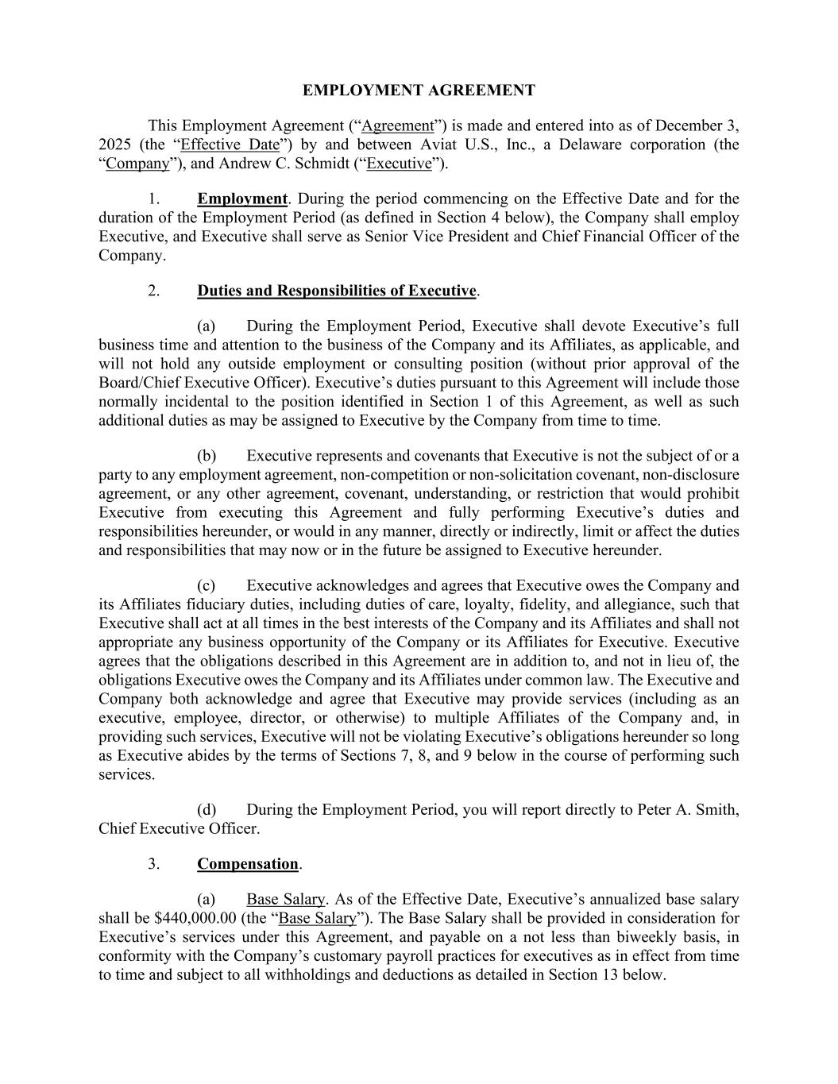
33
EMPLOYMENT AGREEMENT This Employment Agreement (“Agreement”) is made and entered into as of December 3, 2025 (the “Effective Date”) by and between Aviat U.S., Inc., a Delaware corporation (the “Company”), and Andrew C. Schmidt (“Executive”). 1. Employment. During the period commencing on the Effective Date and for the duration of the Employment Period (as defined in Section 4 below), the Company shall employ Executive, and Executive shall serve as Senior Vice President and Chief Financial Officer of the Company. 2. Duties and Responsibilities of Executive. (a) During the Employment Period, Executive shall devote Executive’s full business time and attention to the business of the Company and its Affiliates, as applicable, and will not hold any outside employment or consulting position (without prior approval of the Board/Chief Executive Officer). Executive’s duties pursuant to this Agreement will include those normally incidental to the position identified in Section 1 of this Agreement, as well as such additional duties as may be assigned to Executive by the Company from time to time. (b) Executive represents and covenants that Executive is not the subject of or a party to any employment agreement, non-competition or non-solicitation covenant, non-disclosure agreement, or any other agreement, covenant, understanding, or restriction that would prohibit Executive from executing this Agreement and fully performing Executive’s duties and responsibilities hereunder, or would in any manner, directly or indirectly, limit or affect the duties and responsibilities that may now or in the future be assigned to Executive hereunder. (c) Executive acknowledges and agrees that Executive owes the Company and its Affiliates fiduciary duties, including duties of care, loyalty, fidelity, and allegiance, such that Executive shall act at all times in the best interests of the Company and its Affiliates and shall not appropriate any business opportunity of the Company or its Affiliates for Executive. Executive agrees that the obligations described in this Agreement are in addition to, and not in lieu of, the obligations Executive owes the Company and its Affiliates under common law. The Executive and Company both acknowledge and agree that Executive may provide services (including as an executive, employee, director, or otherwise) to multiple Affiliates of the Company and, in providing such services, Executive will not be violating Executive’s obligations hereunder so long as Executive abides by the terms of Sections 7, 8, and 9 below in the course of performing such services. (d) During the Employment Period, you will report directly to Peter A. Smith, Chief Executive Officer. 3. Compensation. (a) Base Salary. As of the Effective Date, Executive’s annualized base salary shall be $440,000.00 (the “Base Salary”). The Base Salary shall be provided in consideration for Executive’s services under this Agreement, and payable on a not less than biweekly basis, in conformity with the Company’s customary payroll practices for executives as in effect from time to time and subject to all withholdings and deductions as detailed in Section 13 below.

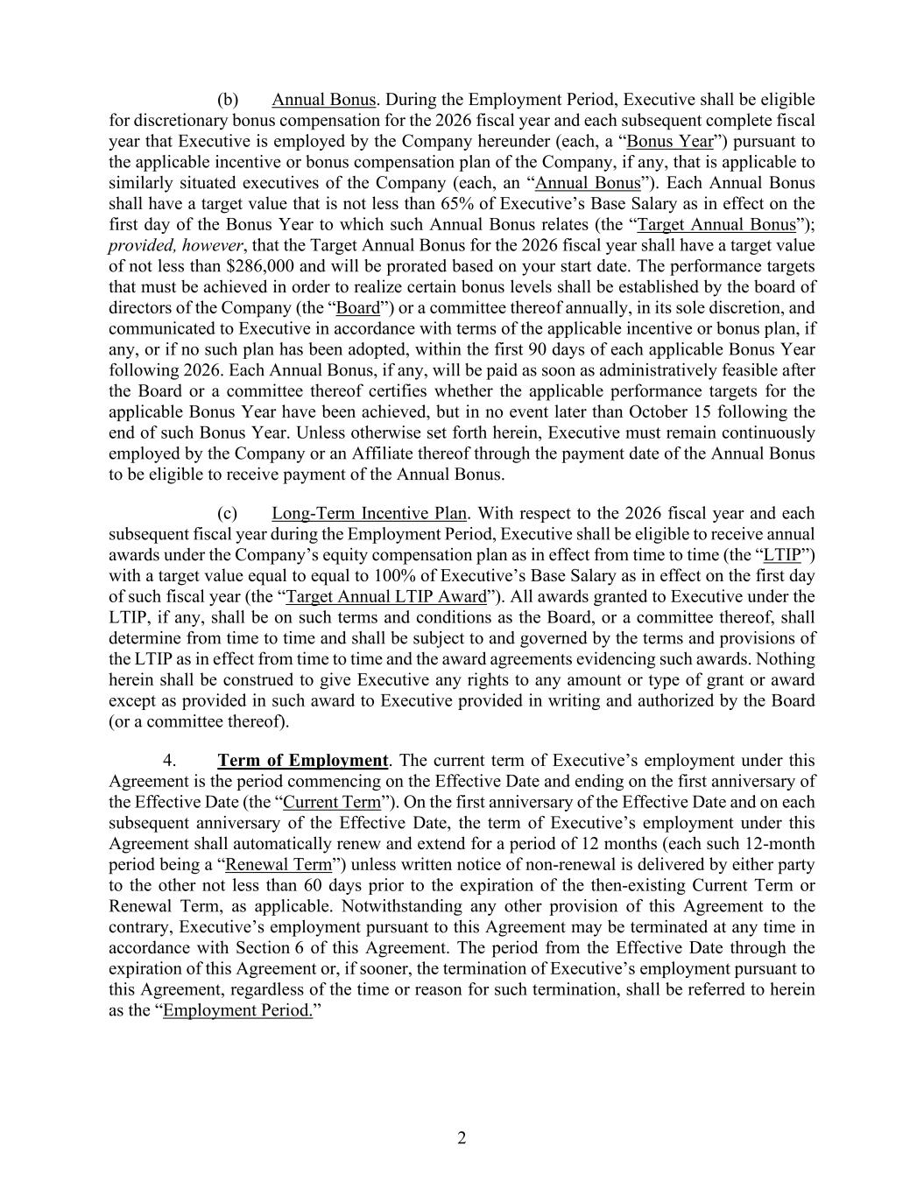
2 (b) Annual Bonus. During the Employment Period, Executive shall be eligible for discretionary bonus compensation for the 2026 fiscal year and each subsequent complete fiscal year that Executive is employed by the Company hereunder (each, a “Bonus Year”) pursuant to the applicable incentive or bonus compensation plan of the Company, if any, that is applicable to similarly situated executives of the Company (each, an “Annual Bonus”). Each Annual Bonus shall have a target value that is not less than 65% of Executive’s Base Salary as in effect on the first day of the Bonus Year to which such Annual Bonus relates (the “Target Annual Bonus”); provided, however, that the Target Annual Bonus for the 2026 fiscal year shall have a target value of not less than $286,000 and will be prorated based on your start date. The performance targets that must be achieved in order to realize certain bonus levels shall be established by the board of directors of the Company (the “Board”) or a committee thereof annually, in its sole discretion, and communicated to Executive in accordance with terms of the applicable incentive or bonus plan, if any, or if no such plan has been adopted, within the first 90 days of each applicable Bonus Year following 2026. Each Annual Bonus, if any, will be paid as soon as administratively feasible after the Board or a committee thereof certifies whether the applicable performance targets for the applicable Bonus Year have been achieved, but in no event later than October 15 following the end of such Bonus Year. Unless otherwise set forth herein, Executive must remain continuously employed by the Company or an Affiliate thereof through the payment date of the Annual Bonus to be eligible to receive payment of the Annual Bonus. (c) Long-Term Incentive Plan. With respect to the 2026 fiscal year and each subsequent fiscal year during the Employment Period, Executive shall be eligible to receive annual awards under the Company’s equity compensation plan as in effect from time to time (the “LTIP”) with a target value equal to equal to 100% of Executive’s Base Salary as in effect on the first day of such fiscal year (the “Target Annual LTIP Award”). All awards granted to Executive under the LTIP, if any, shall be on such terms and conditions as the Board, or a committee thereof, shall determine from time to time and shall be subject to and governed by the terms and provisions of the LTIP as in effect from time to time and the award agreements evidencing such awards. Nothing herein shall be construed to give Executive any rights to any amount or type of grant or award except as provided in such award to Executive provided in writing and authorized by the Board (or a committee thereof). 4. Term of Employment. The current term of Executive’s employment under this Agreement is the period commencing on the Effective Date and ending on the first anniversary of the Effective Date (the “Current Term”). On the first anniversary of the Effective Date and on each subsequent anniversary of the Effective Date, the term of Executive’s employment under this Agreement shall automatically renew and extend for a period of 12 months (each such 12-month period being a “Renewal Term”) unless written notice of non-renewal is delivered by either party to the other not less than 60 days prior to the expiration of the then-existing Current Term or Renewal Term, as applicable. Notwithstanding any other provision of this Agreement to the contrary, Executive’s employment pursuant to this Agreement may be terminated at any time in accordance with Section 6 of this Agreement. The period from the Effective Date through the expiration of this Agreement or, if sooner, the termination of Executive’s employment pursuant to this Agreement, regardless of the time or reason for such termination, shall be referred to herein as the “Employment Period.”

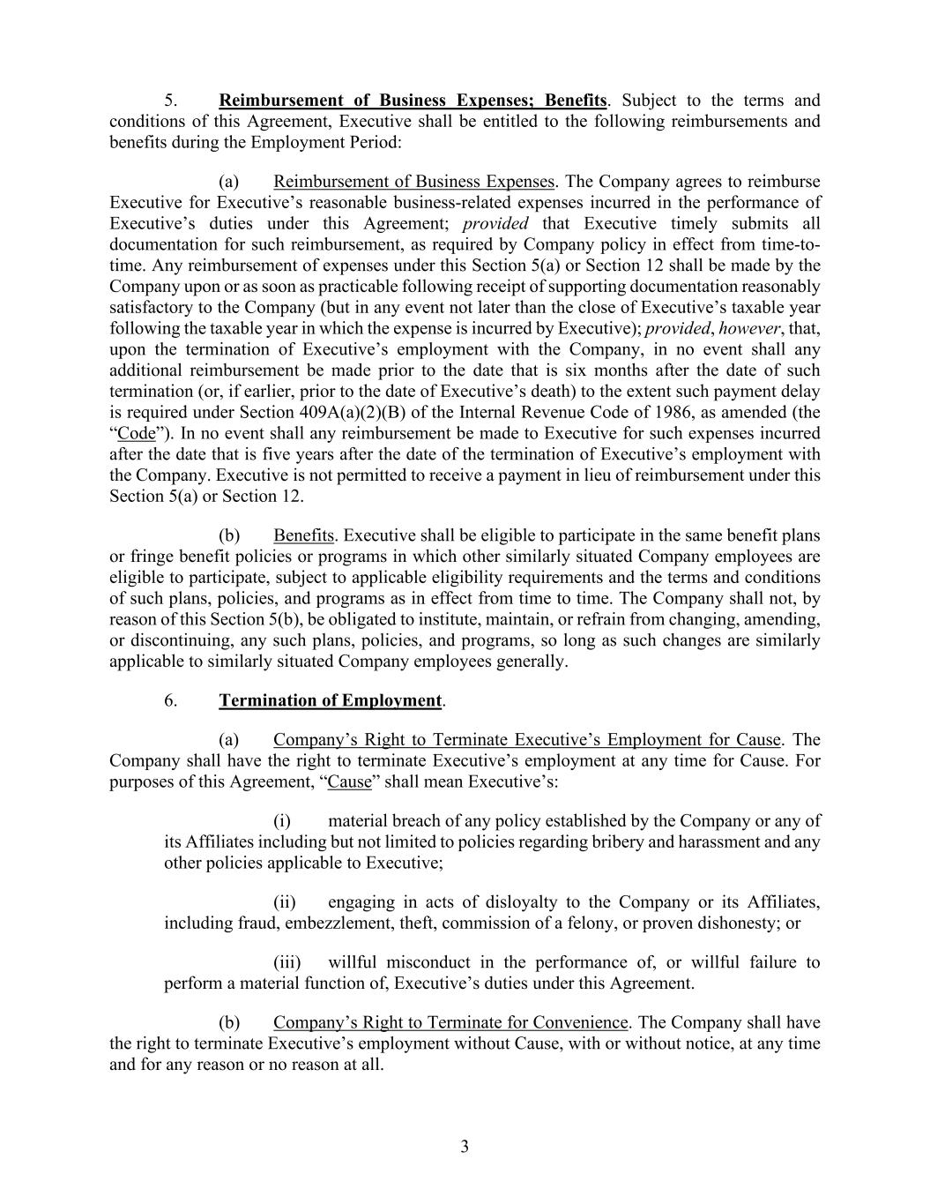
3 5. Reimbursement of Business Expenses; Benefits. Subject to the terms and conditions of this Agreement, Executive shall be entitled to the following reimbursements and benefits during the Employment Period: (a) Reimbursement of Business Expenses. The Company agrees to reimburse Executive for Executive’s reasonable business-related expenses incurred in the performance of Executive’s duties under this Agreement; provided that Executive timely submits all documentation for such reimbursement, as required by Company policy in effect from time-to- time. Any reimbursement of expenses under this Section 5(a) or Section 12 shall be made by the Company upon or as soon as practicable following receipt of supporting documentation reasonably satisfactory to the Company (but in any event not later than the close of Executive’s taxable year following the taxable year in which the expense is incurred by Executive); provided, however, that, upon the termination of Executive’s employment with the Company, in no event shall any additional reimbursement be made prior to the date that is six months after the date of such termination (or, if earlier, prior to the date of Executive’s death) to the extent such payment delay is required under Section 409A(a)(2)(B) of the Internal Revenue Code of 1986, as amended (the “Code”). In no event shall any reimbursement be made to Executive for such expenses incurred after the date that is five years after the date of the termination of Executive’s employment with the Company. Executive is not permitted to receive a payment in lieu of reimbursement under this Section 5(a) or Section 12. (b) Benefits. Executive shall be eligible to participate in the same benefit plans or fringe benefit policies or programs in which other similarly situated Company employees are eligible to participate, subject to applicable eligibility requirements and the terms and conditions of such plans, policies, and programs as in effect from time to time. The Company shall not, by reason of this Section 5(b), be obligated to institute, maintain, or refrain from changing, amending, or discontinuing, any such plans, policies, and programs, so long as such changes are similarly applicable to similarly situated Company employees generally. 6. Termination of Employment. (a) Company’s Right to Terminate Executive’s Employment for Cause. The Company shall have the right to terminate Executive’s employment at any time for Cause. For purposes of this Agreement, “Cause” shall mean Executive’s: (i) material breach of any policy established by the Company or any of its Affiliates including but not limited to policies regarding bribery and harassment and any other policies applicable to Executive; (ii) engaging in acts of disloyalty to the Company or its Affiliates, including fraud, embezzlement, theft, commission of a felony, or proven dishonesty; or (iii) willful misconduct in the performance of, or willful failure to perform a material function of, Executive’s duties under this Agreement. (b) Company’s Right to Terminate for Convenience. The Company shall have the right to terminate Executive’s employment without Cause, with or without notice, at any time and for any reason or no reason at all.

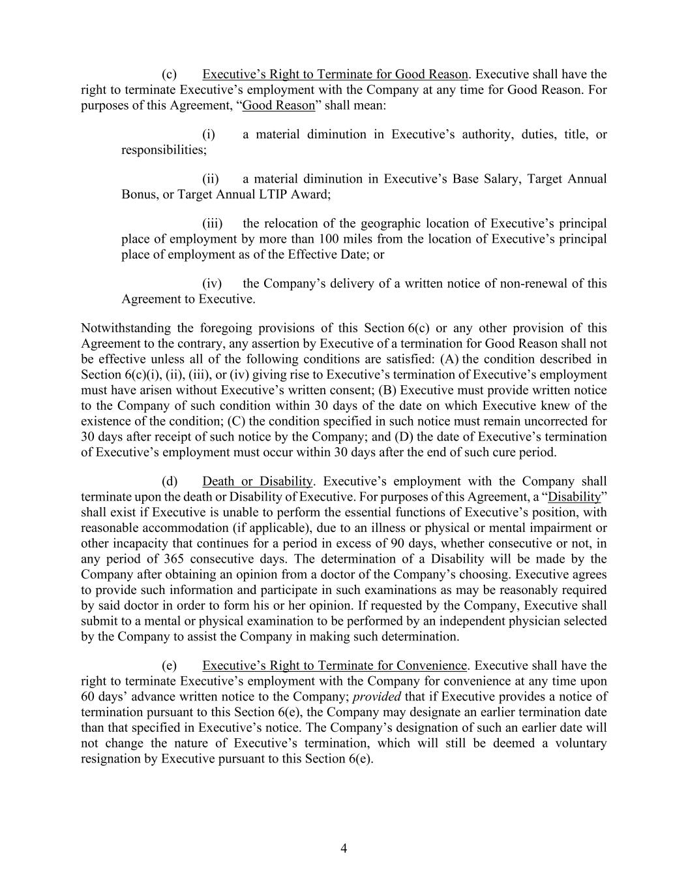
4 (c) Executive’s Right to Terminate for Good Reason. Executive shall have the right to terminate Executive’s employment with the Company at any time for Good Reason. For purposes of this Agreement, “Good Reason” shall mean: (i) a material diminution in Executive’s authority, duties, title, or responsibilities; (ii) a material diminution in Executive’s Base Salary, Target Annual Bonus, or Target Annual LTIP Award; (iii) the relocation of the geographic location of Executive’s principal place of employment by more than 100 miles from the location of Executive’s principal place of employment as of the Effective Date; or (iv) the Company’s delivery of a written notice of non-renewal of this Agreement to Executive. Notwithstanding the foregoing provisions of this Section 6(c) or any other provision of this Agreement to the contrary, any assertion by Executive of a termination for Good Reason shall not be effective unless all of the following conditions are satisfied: (A) the condition described in Section 6(c)(i), (ii), (iii), or (iv) giving rise to Executive’s termination of Executive’s employment must have arisen without Executive’s written consent; (B) Executive must provide written notice to the Company of such condition within 30 days of the date on which Executive knew of the existence of the condition; (C) the condition specified in such notice must remain uncorrected for 30 days after receipt of such notice by the Company; and (D) the date of Executive’s termination of Executive’s employment must occur within 30 days after the end of such cure period. (d) Death or Disability. Executive’s employment with the Company shall terminate upon the death or Disability of Executive. For purposes of this Agreement, a “Disability” shall exist if Executive is unable to perform the essential functions of Executive’s position, with reasonable accommodation (if applicable), due to an illness or physical or mental impairment or other incapacity that continues for a period in excess of 90 days, whether consecutive or not, in any period of 365 consecutive days. The determination of a Disability will be made by the Company after obtaining an opinion from a doctor of the Company’s choosing. Executive agrees to provide such information and participate in such examinations as may be reasonably required by said doctor in order to form his or her opinion. If requested by the Company, Executive shall submit to a mental or physical examination to be performed by an independent physician selected by the Company to assist the Company in making such determination. (e) Executive’s Right to Terminate for Convenience. Executive shall have the right to terminate Executive’s employment with the Company for convenience at any time upon 60 days’ advance written notice to the Company; provided that if Executive provides a notice of termination pursuant to this Section 6(e), the Company may designate an earlier termination date than that specified in Executive’s notice. The Company’s designation of such an earlier date will not change the nature of Executive’s termination, which will still be deemed a voluntary resignation by Executive pursuant to this Section 6(e).

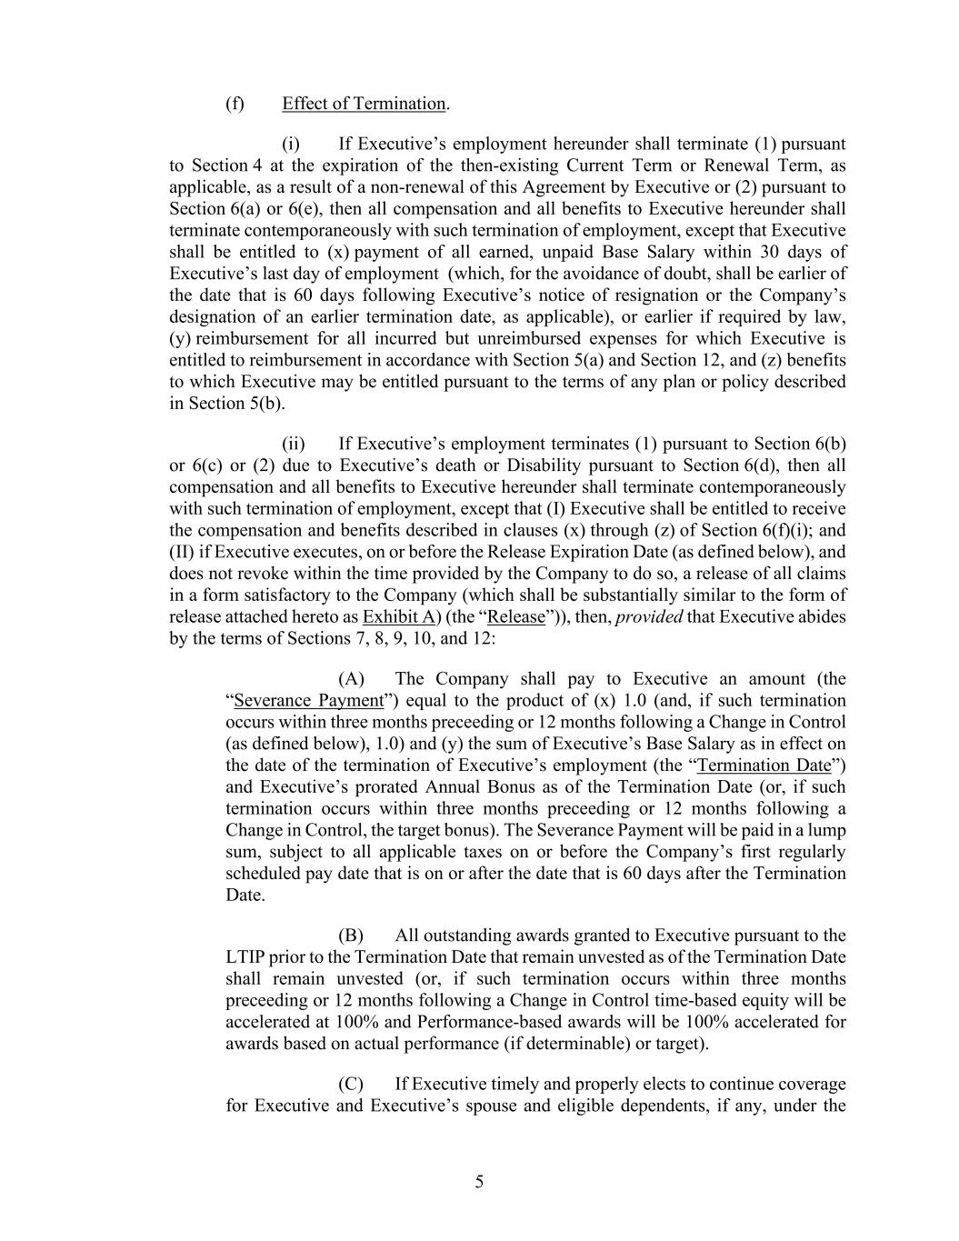
5 (f) Effect of Termination. (i) If Executive’s employment hereunder shall terminate (1) pursuant to Section 4 at the expiration of the then-existing Current Term or Renewal Term, as applicable, as a result of a non-renewal of this Agreement by Executive or (2) pursuant to Section 6(a) or 6(e), then all compensation and all benefits to Executive hereunder shall terminate contemporaneously with such termination of employment, except that Executive shall be entitled to (x) payment of all earned, unpaid Base Salary within 30 days of Executive’s last day of employment (which, for the avoidance of doubt, shall be earlier of the date that is 60 days following Executive’s notice of resignation or the Company’s designation of an earlier termination date, as applicable), or earlier if required by law, (y) reimbursement for all incurred but unreimbursed expenses for which Executive is entitled to reimbursement in accordance with Section 5(a) and Section 12, and (z) benefits to which Executive may be entitled pursuant to the terms of any plan or policy described in Section 5(b). (ii) If Executive’s employment terminates (1) pursuant to Section 6(b) or 6(c) or (2) due to Executive’s death or Disability pursuant to Section 6(d), then all compensation and all benefits to Executive hereunder shall terminate contemporaneously with such termination of employment, except that (I) Executive shall be entitled to receive the compensation and benefits described in clauses (x) through (z) of Section 6(f)(i); and (II) if Executive executes, on or before the Release Expiration Date (as defined below), and does not revoke within the time provided by the Company to do so, a release of all claims in a form satisfactory to the Company (which shall be substantially similar to the form of release attached hereto as Exhibit A) (the “Release”)), then, provided that Executive abides by the terms of Sections 7, 8, 9, 10, and 12: (A) The Company shall pay to Executive an amount (the “Severance Payment”) equal to the product of (x) 1.0 (and, if such termination occurs within three months preceeding or 12 months following a Change in Control (as defined below), 1.0) and (y) the sum of Executive’s Base Salary as in effect on the date of the termination of Executive’s employment (the “Termination Date”) and Executive’s prorated Annual Bonus as of the Termination Date (or, if such termination occurs within three months preceeding or 12 months following a Change in Control, the target bonus). The Severance Payment will be paid in a lump sum, subject to all applicable taxes on or before the Company’s first regularly scheduled pay date that is on or after the date that is 60 days after the Termination Date. (B) All outstanding awards granted to Executive pursuant to the LTIP prior to the Termination Date that remain unvested as of the Termination Date shall remain unvested (or, if such termination occurs within three months preceeding or 12 months following a Change in Control time-based equity will be accelerated at 100% and Performance-based awards will be 100% accelerated for awards based on actual performance (if determinable) or target). (C) If Executive timely and properly elects to continue coverage for Executive and Executive’s spouse and eligible dependents, if any, under the

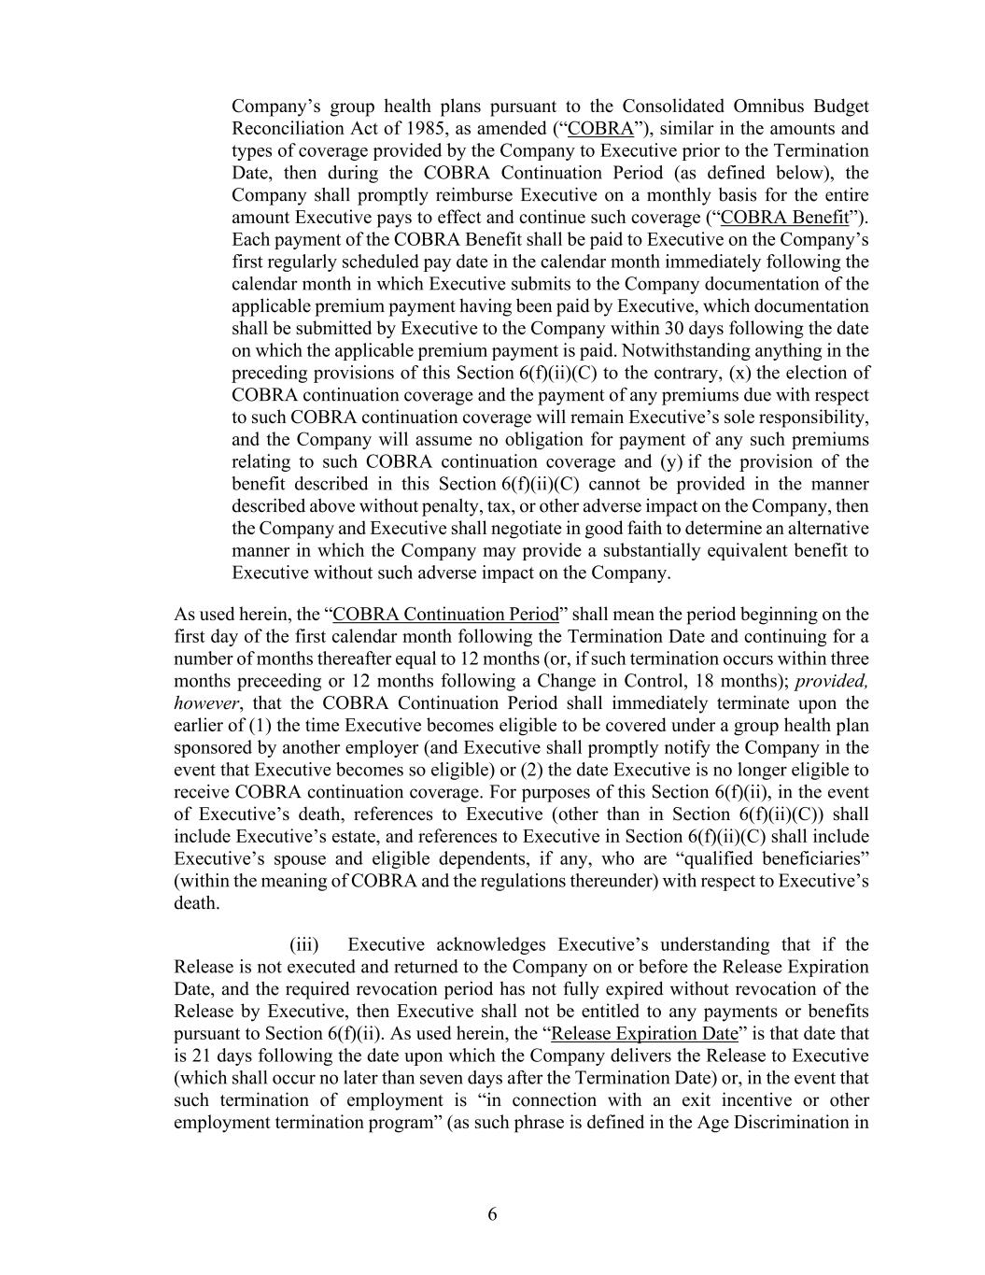
6 Company’s group health plans pursuant to the Consolidated Omnibus Budget Reconciliation Act of 1985, as amended (“COBRA”), similar in the amounts and types of coverage provided by the Company to Executive prior to the Termination Date, then during the COBRA Continuation Period (as defined below), the Company shall promptly reimburse Executive on a monthly basis for the entire amount Executive pays to effect and continue such coverage (“COBRA Benefit”). Each payment of the COBRA Benefit shall be paid to Executive on the Company’s first regularly scheduled pay date in the calendar month immediately following the calendar month in which Executive submits to the Company documentation of the applicable premium payment having been paid by Executive, which documentation shall be submitted by Executive to the Company within 30 days following the date on which the applicable premium payment is paid. Notwithstanding anything in the preceding provisions of this Section 6(f)(ii)(C) to the contrary, (x) the election of COBRA continuation coverage and the payment of any premiums due with respect to such COBRA continuation coverage will remain Executive’s sole responsibility, and the Company will assume no obligation for payment of any such premiums relating to such COBRA continuation coverage and (y) if the provision of the benefit described in this Section 6(f)(ii)(C) cannot be provided in the manner described above without penalty, tax, or other adverse impact on the Company, then the Company and Executive shall negotiate in good faith to determine an alternative manner in which the Company may provide a substantially equivalent benefit to Executive without such adverse impact on the Company. As used herein, the “COBRA Continuation Period” shall mean the period beginning on the first day of the first calendar month following the Termination Date and continuing for a number of months thereafter equal to 12 months (or, if such termination occurs within three months preceeding or 12 months following a Change in Control, 18 months); provided, however, that the COBRA Continuation Period shall immediately terminate upon the earlier of (1) the time Executive becomes eligible to be covered under a group health plan sponsored by another employer (and Executive shall promptly notify the Company in the event that Executive becomes so eligible) or (2) the date Executive is no longer eligible to receive COBRA continuation coverage. For purposes of this Section 6(f)(ii), in the event of Executive’s death, references to Executive (other than in Section 6(f)(ii)(C)) shall include Executive’s estate, and references to Executive in Section 6(f)(ii)(C) shall include Executive’s spouse and eligible dependents, if any, who are “qualified beneficiaries” (within the meaning of COBRA and the regulations thereunder) with respect to Executive’s death. (iii) Executive acknowledges Executive’s understanding that if the Release is not executed and returned to the Company on or before the Release Expiration Date, and the required revocation period has not fully expired without revocation of the Release by Executive, then Executive shall not be entitled to any payments or benefits pursuant to Section 6(f)(ii). As used herein, the “Release Expiration Date” is that date that is 21 days following the date upon which the Company delivers the Release to Executive (which shall occur no later than seven days after the Termination Date) or, in the event that such termination of employment is “in connection with an exit incentive or other employment termination program” (as such phrase is defined in the Age Discrimination in

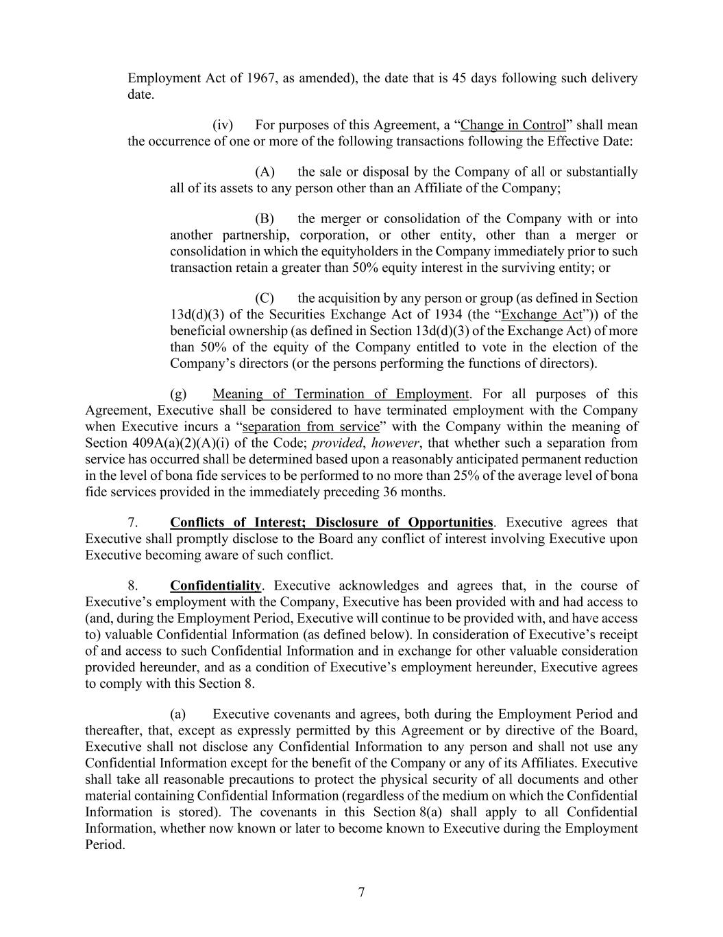
7 Employment Act of 1967, as amended), the date that is 45 days following such delivery date. (iv) For purposes of this Agreement, a “Change in Control” shall mean the occurrence of one or more of the following transactions following the Effective Date: (A) the sale or disposal by the Company of all or substantially all of its assets to any person other than an Affiliate of the Company; (B) the merger or consolidation of the Company with or into another partnership, corporation, or other entity, other than a merger or consolidation in which the equityholders in the Company immediately prior to such transaction retain a greater than 50% equity interest in the surviving entity; or (C) the acquisition by any person or group (as defined in Section 13d(d)(3) of the Securities Exchange Act of 1934 (the “Exchange Act”)) of the beneficial ownership (as defined in Section 13d(d)(3) of the Exchange Act) of more than 50% of the equity of the Company entitled to vote in the election of the Company’s directors (or the persons performing the functions of directors). (g) Meaning of Termination of Employment. For all purposes of this Agreement, Executive shall be considered to have terminated employment with the Company when Executive incurs a “separation from service” with the Company within the meaning of Section 409A(a)(2)(A)(i) of the Code; provided, however, that whether such a separation from service has occurred shall be determined based upon a reasonably anticipated permanent reduction in the level of bona fide services to be performed to no more than 25% of the average level of bona fide services provided in the immediately preceding 36 months. 7. Conflicts of Interest; Disclosure of Opportunities. Executive agrees that Executive shall promptly disclose to the Board any conflict of interest involving Executive upon Executive becoming aware of such conflict. 8. Confidentiality. Executive acknowledges and agrees that, in the course of Executive’s employment with the Company, Executive has been provided with and had access to (and, during the Employment Period, Executive will continue to be provided with, and have access to) valuable Confidential Information (as defined below). In consideration of Executive’s receipt of and access to such Confidential Information and in exchange for other valuable consideration provided hereunder, and as a condition of Executive’s employment hereunder, Executive agrees to comply with this Section 8. (a) Executive covenants and agrees, both during the Employment Period and thereafter, that, except as expressly permitted by this Agreement or by directive of the Board, Executive shall not disclose any Confidential Information to any person and shall not use any Confidential Information except for the benefit of the Company or any of its Affiliates. Executive shall take all reasonable precautions to protect the physical security of all documents and other material containing Confidential Information (regardless of the medium on which the Confidential Information is stored). The covenants in this Section 8(a) shall apply to all Confidential Information, whether now known or later to become known to Executive during the Employment Period.

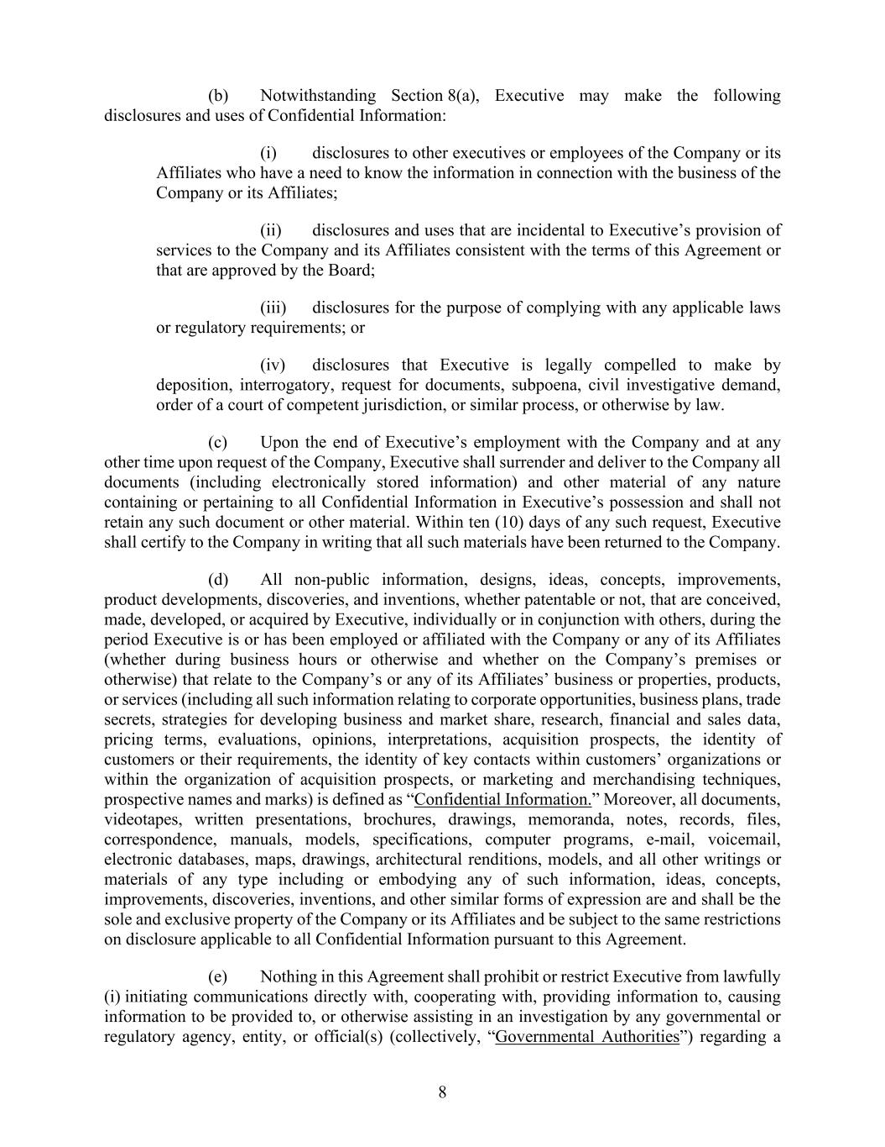
8 (b) Notwithstanding Section 8(a), Executive may make the following disclosures and uses of Confidential Information: (i) disclosures to other executives or employees of the Company or its Affiliates who have a need to know the information in connection with the business of the Company or its Affiliates; (ii) disclosures and uses that are incidental to Executive’s provision of services to the Company and its Affiliates consistent with the terms of this Agreement or that are approved by the Board; (iii) disclosures for the purpose of complying with any applicable laws or regulatory requirements; or (iv) disclosures that Executive is legally compelled to make by deposition, interrogatory, request for documents, subpoena, civil investigative demand, order of a court of competent jurisdiction, or similar process, or otherwise by law. (c) Upon the end of Executive’s employment with the Company and at any other time upon request of the Company, Executive shall surrender and deliver to the Company all documents (including electronically stored information) and other material of any nature containing or pertaining to all Confidential Information in Executive’s possession and shall not retain any such document or other material. Within ten (10) days of any such request, Executive shall certify to the Company in writing that all such materials have been returned to the Company. (d) All non-public information, designs, ideas, concepts, improvements, product developments, discoveries, and inventions, whether patentable or not, that are conceived, made, developed, or acquired by Executive, individually or in conjunction with others, during the period Executive is or has been employed or affiliated with the Company or any of its Affiliates (whether during business hours or otherwise and whether on the Company’s premises or otherwise) that relate to the Company’s or any of its Affiliates’ business or properties, products, or services (including all such information relating to corporate opportunities, business plans, trade secrets, strategies for developing business and market share, research, financial and sales data, pricing terms, evaluations, opinions, interpretations, acquisition prospects, the identity of customers or their requirements, the identity of key contacts within customers’ organizations or within the organization of acquisition prospects, or marketing and merchandising techniques, prospective names and marks) is defined as “Confidential Information.” Moreover, all documents, videotapes, written presentations, brochures, drawings, memoranda, notes, records, files, correspondence, manuals, models, specifications, computer programs, e-mail, voicemail, electronic databases, maps, drawings, architectural renditions, models, and all other writings or materials of any type including or embodying any of such information, ideas, concepts, improvements, discoveries, inventions, and other similar forms of expression are and shall be the sole and exclusive property of the Company or its Affiliates and be subject to the same restrictions on disclosure applicable to all Confidential Information pursuant to this Agreement. (e) Nothing in this Agreement shall prohibit or restrict Executive from lawfully (i) initiating communications directly with, cooperating with, providing information to, causing information to be provided to, or otherwise assisting in an investigation by any governmental or regulatory agency, entity, or official(s) (collectively, “Governmental Authorities”) regarding a

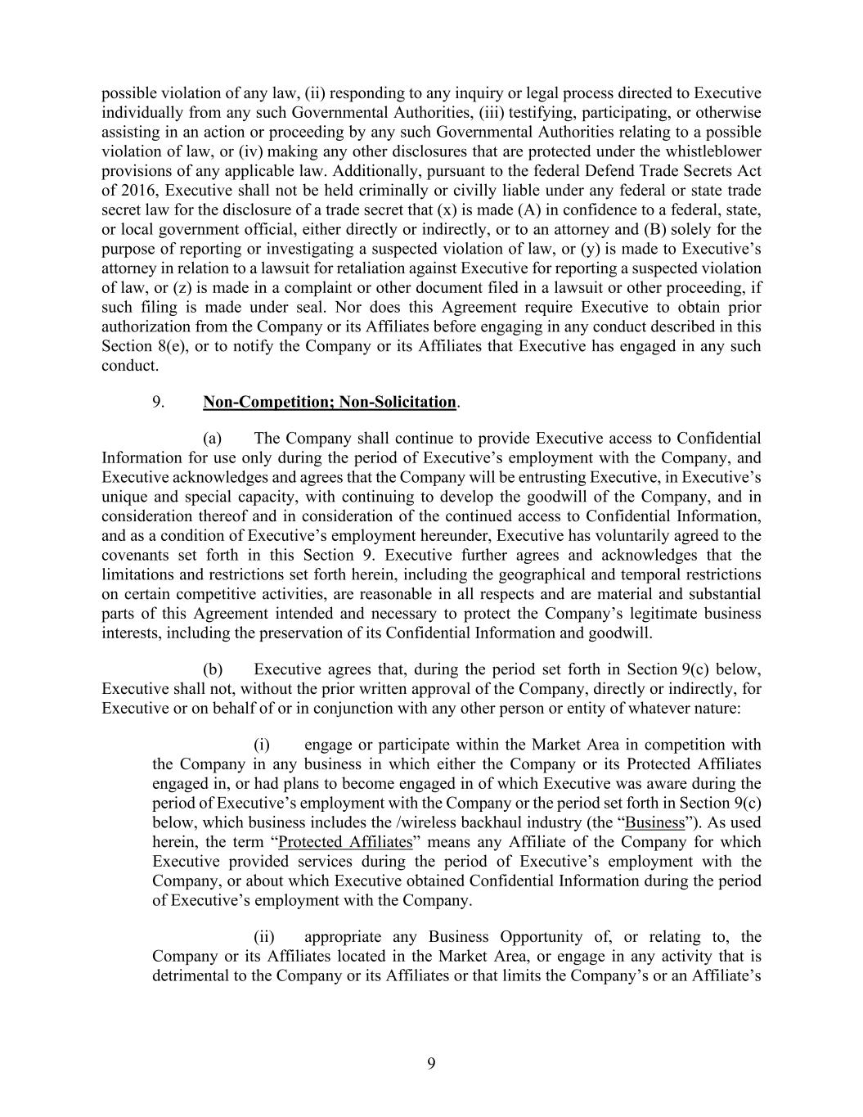
9 possible violation of any law, (ii) responding to any inquiry or legal process directed to Executive individually from any such Governmental Authorities, (iii) testifying, participating, or otherwise assisting in an action or proceeding by any such Governmental Authorities relating to a possible violation of law, or (iv) making any other disclosures that are protected under the whistleblower provisions of any applicable law. Additionally, pursuant to the federal Defend Trade Secrets Act of 2016, Executive shall not be held criminally or civilly liable under any federal or state trade secret law for the disclosure of a trade secret that (x) is made (A) in confidence to a federal, state, or local government official, either directly or indirectly, or to an attorney and (B) solely for the purpose of reporting or investigating a suspected violation of law, or (y) is made to Executive’s attorney in relation to a lawsuit for retaliation against Executive for reporting a suspected violation of law, or (z) is made in a complaint or other document filed in a lawsuit or other proceeding, if such filing is made under seal. Nor does this Agreement require Executive to obtain prior authorization from the Company or its Affiliates before engaging in any conduct described in this Section 8(e), or to notify the Company or its Affiliates that Executive has engaged in any such conduct. 9. Non-Competition; Non-Solicitation. (a) The Company shall continue to provide Executive access to Confidential Information for use only during the period of Executive’s employment with the Company, and Executive acknowledges and agrees that the Company will be entrusting Executive, in Executive’s unique and special capacity, with continuing to develop the goodwill of the Company, and in consideration thereof and in consideration of the continued access to Confidential Information, and as a condition of Executive’s employment hereunder, Executive has voluntarily agreed to the covenants set forth in this Section 9. Executive further agrees and acknowledges that the limitations and restrictions set forth herein, including the geographical and temporal restrictions on certain competitive activities, are reasonable in all respects and are material and substantial parts of this Agreement intended and necessary to protect the Company’s legitimate business interests, including the preservation of its Confidential Information and goodwill. (b) Executive agrees that, during the period set forth in Section 9(c) below, Executive shall not, without the prior written approval of the Company, directly or indirectly, for Executive or on behalf of or in conjunction with any other person or entity of whatever nature: (i) engage or participate within the Market Area in competition with the Company in any business in which either the Company or its Protected Affiliates engaged in, or had plans to become engaged in of which Executive was aware during the period of Executive’s employment with the Company or the period set forth in Section 9(c) below, which business includes the /wireless backhaul industry (the “Business”). As used herein, the term “Protected Affiliates” means any Affiliate of the Company for which Executive provided services during the period of Executive’s employment with the Company, or about which Executive obtained Confidential Information during the period of Executive’s employment with the Company. (ii) appropriate any Business Opportunity of, or relating to, the Company or its Affiliates located in the Market Area, or engage in any activity that is detrimental to the Company or its Affiliates or that limits the Company’s or an Affiliate’s

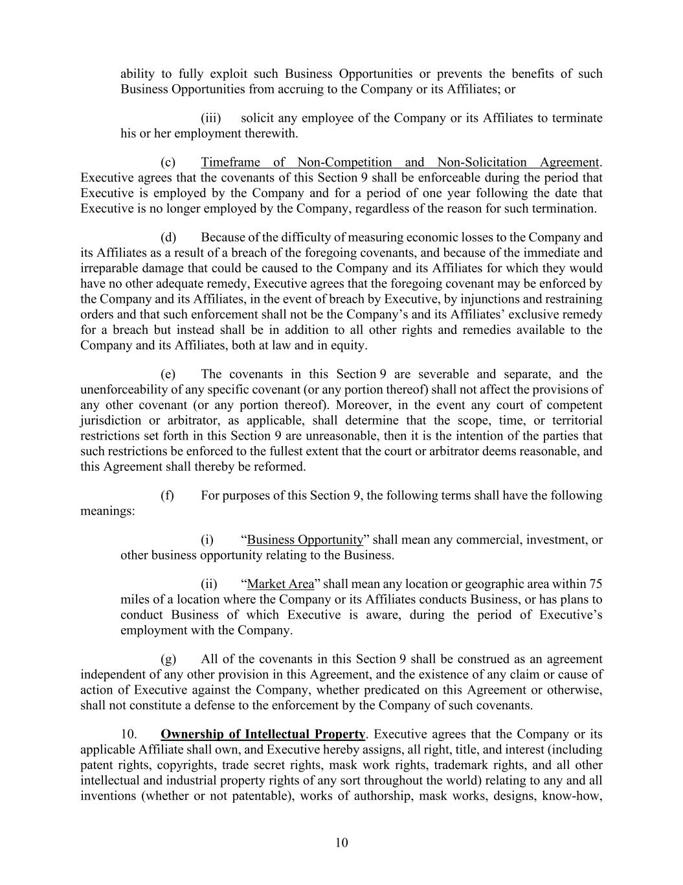
10 ability to fully exploit such Business Opportunities or prevents the benefits of such Business Opportunities from accruing to the Company or its Affiliates; or (iii) solicit any employee of the Company or its Affiliates to terminate his or her employment therewith. (c) Timeframe of Non-Competition and Non-Solicitation Agreement. Executive agrees that the covenants of this Section 9 shall be enforceable during the period that Executive is employed by the Company and for a period of one year following the date that Executive is no longer employed by the Company, regardless of the reason for such termination. (d) Because of the difficulty of measuring economic losses to the Company and its Affiliates as a result of a breach of the foregoing covenants, and because of the immediate and irreparable damage that could be caused to the Company and its Affiliates for which they would have no other adequate remedy, Executive agrees that the foregoing covenant may be enforced by the Company and its Affiliates, in the event of breach by Executive, by injunctions and restraining orders and that such enforcement shall not be the Company’s and its Affiliates’ exclusive remedy for a breach but instead shall be in addition to all other rights and remedies available to the Company and its Affiliates, both at law and in equity. (e) The covenants in this Section 9 are severable and separate, and the unenforceability of any specific covenant (or any portion thereof) shall not affect the provisions of any other covenant (or any portion thereof). Moreover, in the event any court of competent jurisdiction or arbitrator, as applicable, shall determine that the scope, time, or territorial restrictions set forth in this Section 9 are unreasonable, then it is the intention of the parties that such restrictions be enforced to the fullest extent that the court or arbitrator deems reasonable, and this Agreement shall thereby be reformed. (f) For purposes of this Section 9, the following terms shall have the following meanings: (i) “Business Opportunity” shall mean any commercial, investment, or other business opportunity relating to the Business. (ii) “Market Area” shall mean any location or geographic area within 75 miles of a location where the Company or its Affiliates conducts Business, or has plans to conduct Business of which Executive is aware, during the period of Executive’s employment with the Company. (g) All of the covenants in this Section 9 shall be construed as an agreement independent of any other provision in this Agreement, and the existence of any claim or cause of action of Executive against the Company, whether predicated on this Agreement or otherwise, shall not constitute a defense to the enforcement by the Company of such covenants. 10. Ownership of Intellectual Property. Executive agrees that the Company or its applicable Affiliate shall own, and Executive hereby assigns, all right, title, and interest (including patent rights, copyrights, trade secret rights, mask work rights, trademark rights, and all other intellectual and industrial property rights of any sort throughout the world) relating to any and all inventions (whether or not patentable), works of authorship, mask works, designs, know-how,

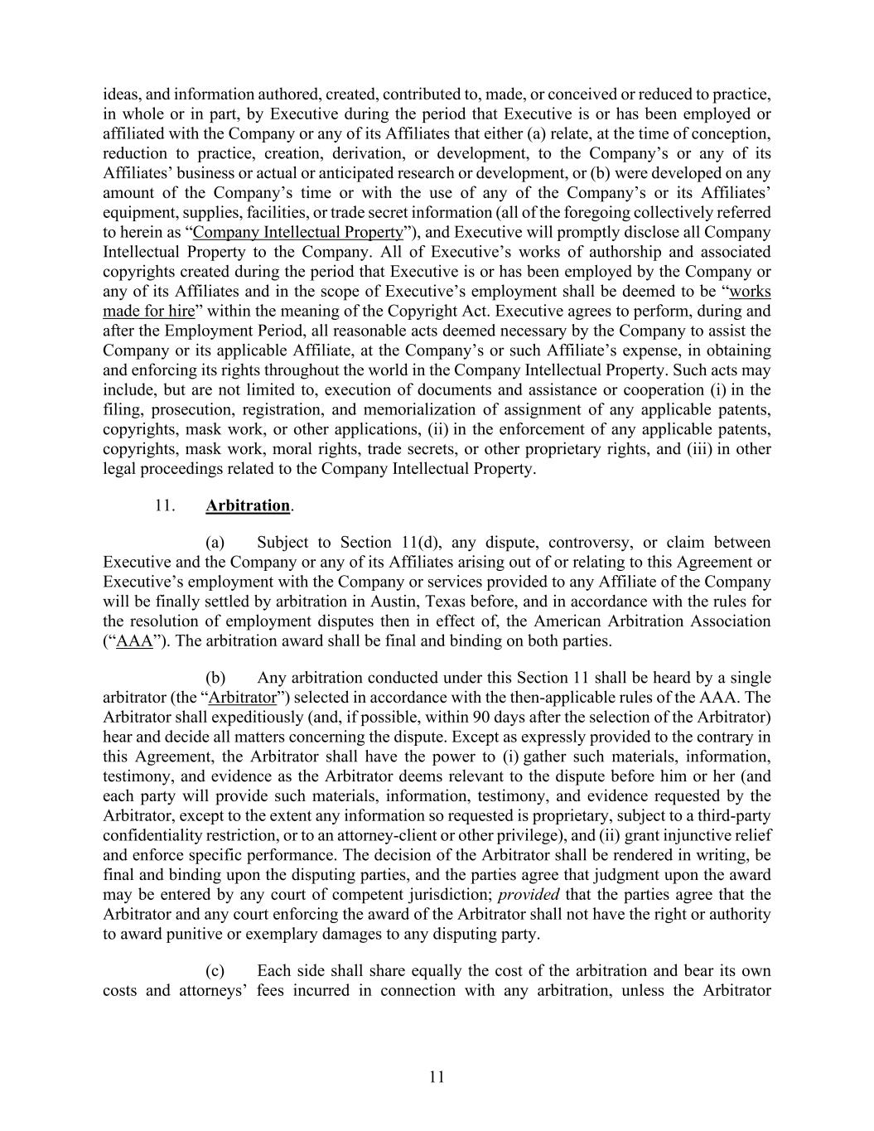
11 ideas, and information authored, created, contributed to, made, or conceived or reduced to practice, in whole or in part, by Executive during the period that Executive is or has been employed or affiliated with the Company or any of its Affiliates that either (a) relate, at the time of conception, reduction to practice, creation, derivation, or development, to the Company’s or any of its Affiliates’ business or actual or anticipated research or development, or (b) were developed on any amount of the Company’s time or with the use of any of the Company’s or its Affiliates’ equipment, supplies, facilities, or trade secret information (all of the foregoing collectively referred to herein as “Company Intellectual Property”), and Executive will promptly disclose all Company Intellectual Property to the Company. All of Executive’s works of authorship and associated copyrights created during the period that Executive is or has been employed by the Company or any of its Affiliates and in the scope of Executive’s employment shall be deemed to be “works made for hire” within the meaning of the Copyright Act. Executive agrees to perform, during and after the Employment Period, all reasonable acts deemed necessary by the Company to assist the Company or its applicable Affiliate, at the Company’s or such Affiliate’s expense, in obtaining and enforcing its rights throughout the world in the Company Intellectual Property. Such acts may include, but are not limited to, execution of documents and assistance or cooperation (i) in the filing, prosecution, registration, and memorialization of assignment of any applicable patents, copyrights, mask work, or other applications, (ii) in the enforcement of any applicable patents, copyrights, mask work, moral rights, trade secrets, or other proprietary rights, and (iii) in other legal proceedings related to the Company Intellectual Property. 11. Arbitration. (a) Subject to Section 11(d), any dispute, controversy, or claim between Executive and the Company or any of its Affiliates arising out of or relating to this Agreement or Executive’s employment with the Company or services provided to any Affiliate of the Company will be finally settled by arbitration in Austin, Texas before, and in accordance with the rules for the resolution of employment disputes then in effect of, the American Arbitration Association (“AAA”). The arbitration award shall be final and binding on both parties. (b) Any arbitration conducted under this Section 11 shall be heard by a single arbitrator (the “Arbitrator”) selected in accordance with the then-applicable rules of the AAA. The Arbitrator shall expeditiously (and, if possible, within 90 days after the selection of the Arbitrator) hear and decide all matters concerning the dispute. Except as expressly provided to the contrary in this Agreement, the Arbitrator shall have the power to (i) gather such materials, information, testimony, and evidence as the Arbitrator deems relevant to the dispute before him or her (and each party will provide such materials, information, testimony, and evidence requested by the Arbitrator, except to the extent any information so requested is proprietary, subject to a third-party confidentiality restriction, or to an attorney-client or other privilege), and (ii) grant injunctive relief and enforce specific performance. The decision of the Arbitrator shall be rendered in writing, be final and binding upon the disputing parties, and the parties agree that judgment upon the award may be entered by any court of competent jurisdiction; provided that the parties agree that the Arbitrator and any court enforcing the award of the Arbitrator shall not have the right or authority to award punitive or exemplary damages to any disputing party. (c) Each side shall share equally the cost of the arbitration and bear its own costs and attorneys’ fees incurred in connection with any arbitration, unless the Arbitrator

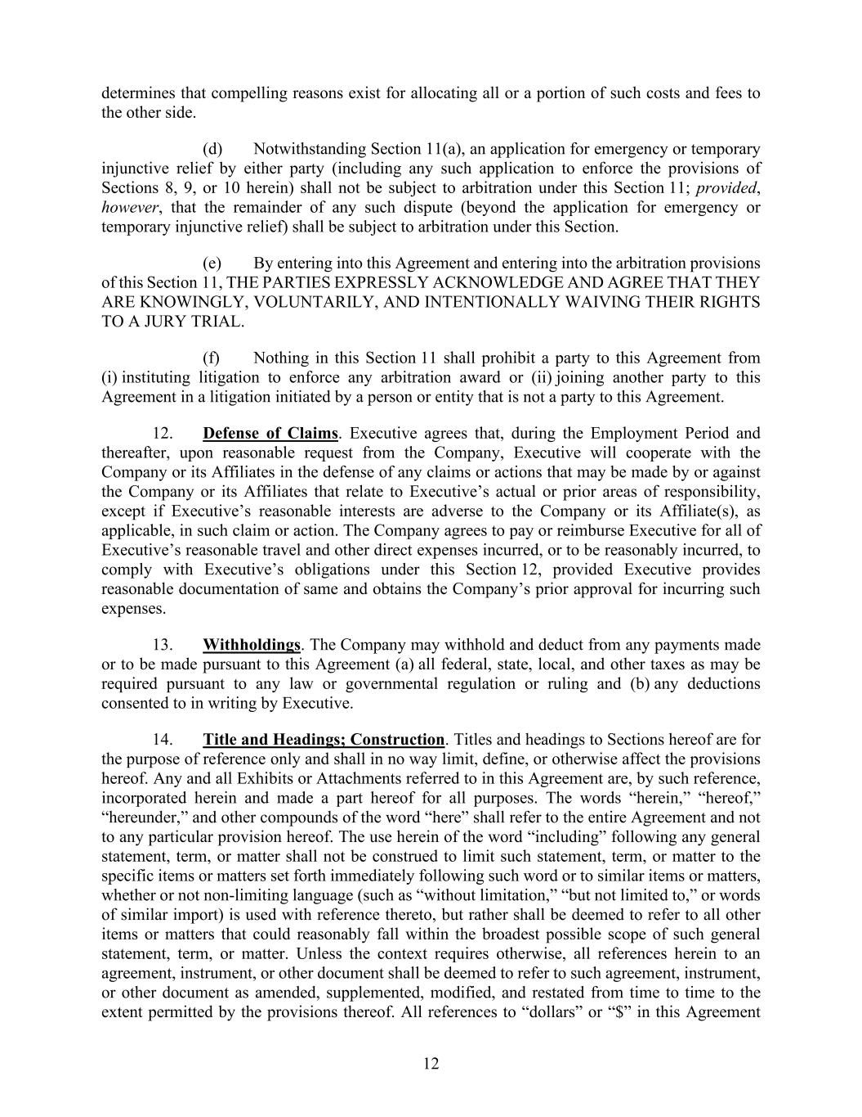
12 determines that compelling reasons exist for allocating all or a portion of such costs and fees to the other side. (d) Notwithstanding Section 11(a), an application for emergency or temporary injunctive relief by either party (including any such application to enforce the provisions of Sections 8, 9, or 10 herein) shall not be subject to arbitration under this Section 11; provided, however, that the remainder of any such dispute (beyond the application for emergency or temporary injunctive relief) shall be subject to arbitration under this Section. (e) By entering into this Agreement and entering into the arbitration provisions of this Section 11, THE PARTIES EXPRESSLY ACKNOWLEDGE AND AGREE THAT THEY ARE KNOWINGLY, VOLUNTARILY, AND INTENTIONALLY WAIVING THEIR RIGHTS TO A JURY TRIAL. (f) Nothing in this Section 11 shall prohibit a party to this Agreement from (i) instituting litigation to enforce any arbitration award or (ii) joining another party to this Agreement in a litigation initiated by a person or entity that is not a party to this Agreement. 12. Defense of Claims. Executive agrees that, during the Employment Period and thereafter, upon reasonable request from the Company, Executive will cooperate with the Company or its Affiliates in the defense of any claims or actions that may be made by or against the Company or its Affiliates that relate to Executive’s actual or prior areas of responsibility, except if Executive’s reasonable interests are adverse to the Company or its Affiliate(s), as applicable, in such claim or action. The Company agrees to pay or reimburse Executive for all of Executive’s reasonable travel and other direct expenses incurred, or to be reasonably incurred, to comply with Executive’s obligations under this Section 12, provided Executive provides reasonable documentation of same and obtains the Company’s prior approval for incurring such expenses. 13. Withholdings. The Company may withhold and deduct from any payments made or to be made pursuant to this Agreement (a) all federal, state, local, and other taxes as may be required pursuant to any law or governmental regulation or ruling and (b) any deductions consented to in writing by Executive. 14. Title and Headings; Construction. Titles and headings to Sections hereof are for the purpose of reference only and shall in no way limit, define, or otherwise affect the provisions hereof. Any and all Exhibits or Attachments referred to in this Agreement are, by such reference, incorporated herein and made a part hereof for all purposes. The words “herein,” “hereof,” “hereunder,” and other compounds of the word “here” shall refer to the entire Agreement and not to any particular provision hereof. The use herein of the word “including” following any general statement, term, or matter shall not be construed to limit such statement, term, or matter to the specific items or matters set forth immediately following such word or to similar items or matters, whether or not non-limiting language (such as “without limitation,” “but not limited to,” or words of similar import) is used with reference thereto, but rather shall be deemed to refer to all other items or matters that could reasonably fall within the broadest possible scope of such general statement, term, or matter. Unless the context requires otherwise, all references herein to an agreement, instrument, or other document shall be deemed to refer to such agreement, instrument, or other document as amended, supplemented, modified, and restated from time to time to the extent permitted by the provisions thereof. All references to “dollars” or “$” in this Agreement

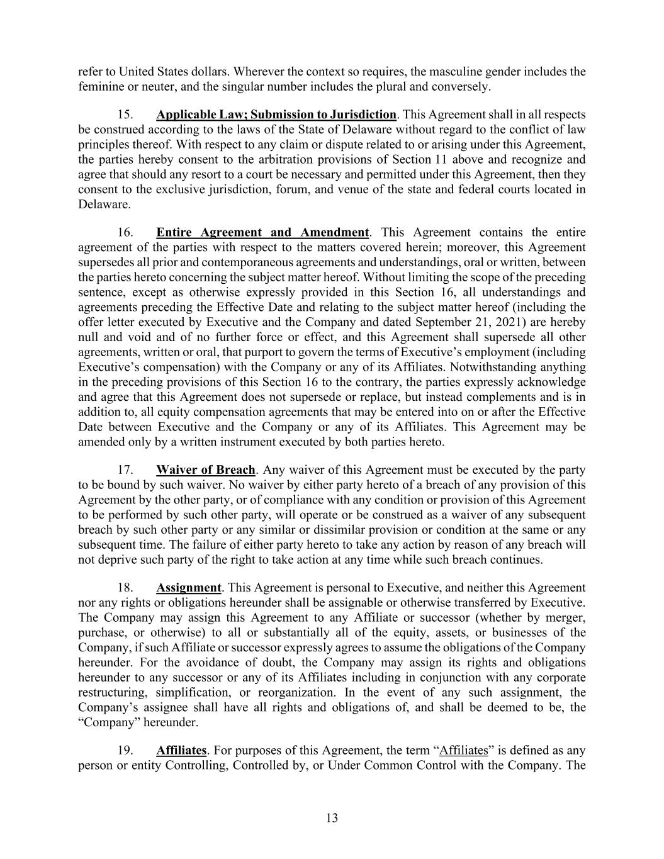
13 refer to United States dollars. Wherever the context so requires, the masculine gender includes the feminine or neuter, and the singular number includes the plural and conversely. 15. Applicable Law; Submission to Jurisdiction. This Agreement shall in all respects be construed according to the laws of the State of Delaware without regard to the conflict of law principles thereof. With respect to any claim or dispute related to or arising under this Agreement, the parties hereby consent to the arbitration provisions of Section 11 above and recognize and agree that should any resort to a court be necessary and permitted under this Agreement, then they consent to the exclusive jurisdiction, forum, and venue of the state and federal courts located in Delaware. 16. Entire Agreement and Amendment. This Agreement contains the entire agreement of the parties with respect to the matters covered herein; moreover, this Agreement supersedes all prior and contemporaneous agreements and understandings, oral or written, between the parties hereto concerning the subject matter hereof. Without limiting the scope of the preceding sentence, except as otherwise expressly provided in this Section 16, all understandings and agreements preceding the Effective Date and relating to the subject matter hereof (including the offer letter executed by Executive and the Company and dated September 21, 2021) are hereby null and void and of no further force or effect, and this Agreement shall supersede all other agreements, written or oral, that purport to govern the terms of Executive’s employment (including Executive’s compensation) with the Company or any of its Affiliates. Notwithstanding anything in the preceding provisions of this Section 16 to the contrary, the parties expressly acknowledge and agree that this Agreement does not supersede or replace, but instead complements and is in addition to, all equity compensation agreements that may be entered into on or after the Effective Date between Executive and the Company or any of its Affiliates. This Agreement may be amended only by a written instrument executed by both parties hereto. 17. Waiver of Breach. Any waiver of this Agreement must be executed by the party to be bound by such waiver. No waiver by either party hereto of a breach of any provision of this Agreement by the other party, or of compliance with any condition or provision of this Agreement to be performed by such other party, will operate or be construed as a waiver of any subsequent breach by such other party or any similar or dissimilar provision or condition at the same or any subsequent time. The failure of either party hereto to take any action by reason of any breach will not deprive such party of the right to take action at any time while such breach continues. 18. Assignment. This Agreement is personal to Executive, and neither this Agreement nor any rights or obligations hereunder shall be assignable or otherwise transferred by Executive. The Company may assign this Agreement to any Affiliate or successor (whether by merger, purchase, or otherwise) to all or substantially all of the equity, assets, or businesses of the Company, if such Affiliate or successor expressly agrees to assume the obligations of the Company hereunder. For the avoidance of doubt, the Company may assign its rights and obligations hereunder to any successor or any of its Affiliates including in conjunction with any corporate restructuring, simplification, or reorganization. In the event of any such assignment, the Company’s assignee shall have all rights and obligations of, and shall be deemed to be, the “Company” hereunder. 19. Affiliates. For purposes of this Agreement, the term “Affiliates” is defined as any person or entity Controlling, Controlled by, or Under Common Control with the Company. The

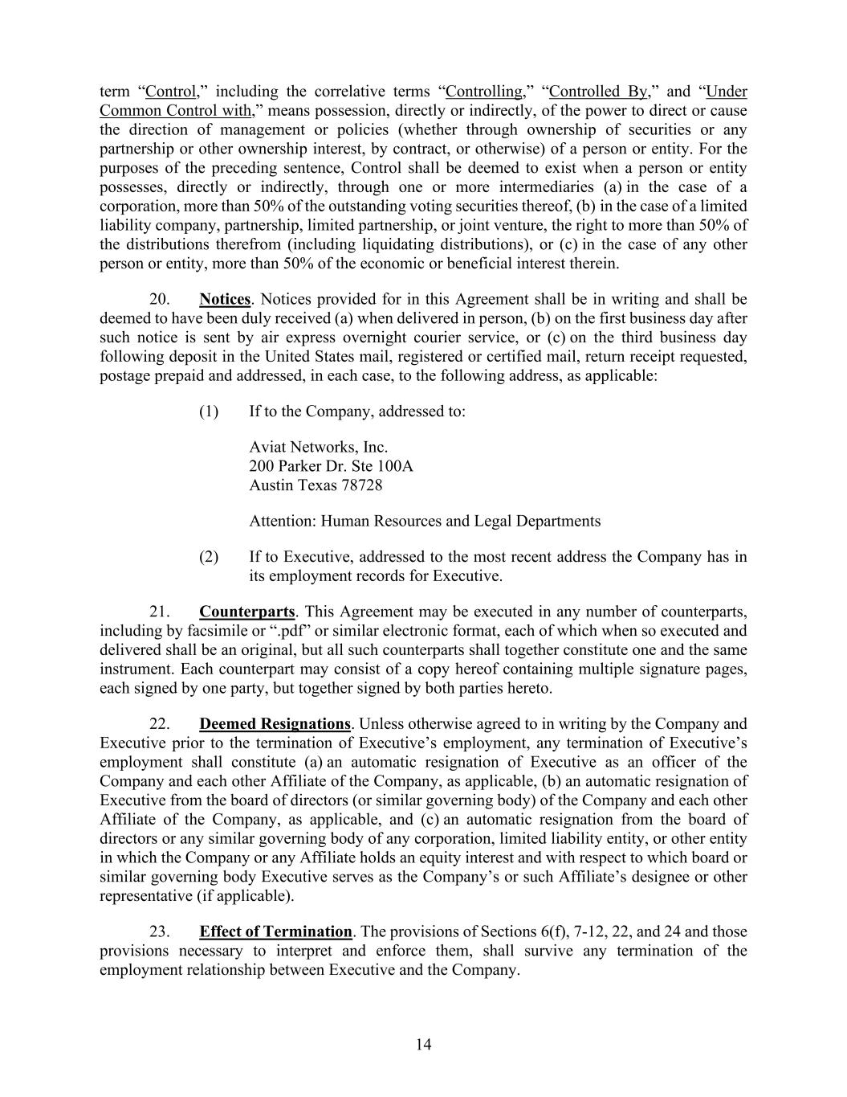
14 term “Control,” including the correlative terms “Controlling,” “Controlled By,” and “Under Common Control with,” means possession, directly or indirectly, of the power to direct or cause the direction of management or policies (whether through ownership of securities or any partnership or other ownership interest, by contract, or otherwise) of a person or entity. For the purposes of the preceding sentence, Control shall be deemed to exist when a person or entity possesses, directly or indirectly, through one or more intermediaries (a) in the case of a corporation, more than 50% of the outstanding voting securities thereof, (b) in the case of a limited liability company, partnership, limited partnership, or joint venture, the right to more than 50% of the distributions therefrom (including liquidating distributions), or (c) in the case of any other person or entity, more than 50% of the economic or beneficial interest therein. 20. Notices. Notices provided for in this Agreement shall be in writing and shall be deemed to have been duly received (a) when delivered in person, (b) on the first business day after such notice is sent by air express overnight courier service, or (c) on the third business day following deposit in the United States mail, registered or certified mail, return receipt requested, postage prepaid and addressed, in each case, to the following address, as applicable: (1) If to the Company, addressed to: Aviat Networks, Inc. 200 Parker Dr. Ste 100A Austin Texas 78728 Attention: Human Resources and Legal Departments (2) If to Executive, addressed to the most recent address the Company has in its employment records for Executive. 21. Counterparts. This Agreement may be executed in any number of counterparts, including by facsimile or “.pdf” or similar electronic format, each of which when so executed and delivered shall be an original, but all such counterparts shall together constitute one and the same instrument. Each counterpart may consist of a copy hereof containing multiple signature pages, each signed by one party, but together signed by both parties hereto. 22. Deemed Resignations. Unless otherwise agreed to in writing by the Company and Executive prior to the termination of Executive’s employment, any termination of Executive’s employment shall constitute (a) an automatic resignation of Executive as an officer of the Company and each other Affiliate of the Company, as applicable, (b) an automatic resignation of Executive from the board of directors (or similar governing body) of the Company and each other Affiliate of the Company, as applicable, and (c) an automatic resignation from the board of directors or any similar governing body of any corporation, limited liability entity, or other entity in which the Company or any Affiliate holds an equity interest and with respect to which board or similar governing body Executive serves as the Company’s or such Affiliate’s designee or other representative (if applicable). 23. Effect of Termination. The provisions of Sections 6(f), 7-12, 22, and 24 and those provisions necessary to interpret and enforce them, shall survive any termination of the employment relationship between Executive and the Company.

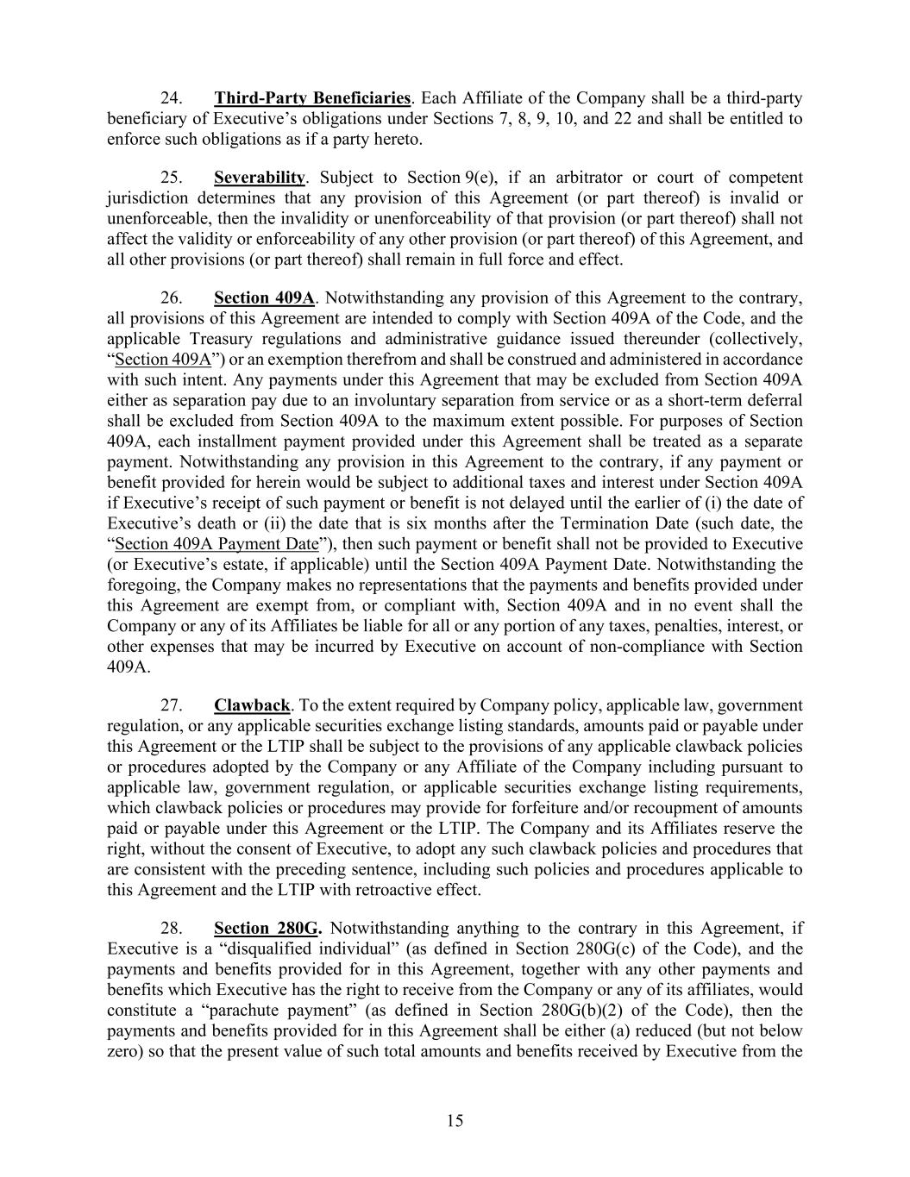
15 24. Third-Party Beneficiaries. Each Affiliate of the Company shall be a third-party beneficiary of Executive’s obligations under Sections 7, 8, 9, 10, and 22 and shall be entitled to enforce such obligations as if a party hereto. 25. Severability. Subject to Section 9(e), if an arbitrator or court of competent jurisdiction determines that any provision of this Agreement (or part thereof) is invalid or unenforceable, then the invalidity or unenforceability of that provision (or part thereof) shall not affect the validity or enforceability of any other provision (or part thereof) of this Agreement, and all other provisions (or part thereof) shall remain in full force and effect. 26. Section 409A. Notwithstanding any provision of this Agreement to the contrary, all provisions of this Agreement are intended to comply with Section 409A of the Code, and the applicable Treasury regulations and administrative guidance issued thereunder (collectively, “Section 409A”) or an exemption therefrom and shall be construed and administered in accordance with such intent. Any payments under this Agreement that may be excluded from Section 409A either as separation pay due to an involuntary separation from service or as a short-term deferral shall be excluded from Section 409A to the maximum extent possible. For purposes of Section 409A, each installment payment provided under this Agreement shall be treated as a separate payment. Notwithstanding any provision in this Agreement to the contrary, if any payment or benefit provided for herein would be subject to additional taxes and interest under Section 409A if Executive’s receipt of such payment or benefit is not delayed until the earlier of (i) the date of Executive’s death or (ii) the date that is six months after the Termination Date (such date, the “Section 409A Payment Date”), then such payment or benefit shall not be provided to Executive (or Executive’s estate, if applicable) until the Section 409A Payment Date. Notwithstanding the foregoing, the Company makes no representations that the payments and benefits provided under this Agreement are exempt from, or compliant with, Section 409A and in no event shall the Company or any of its Affiliates be liable for all or any portion of any taxes, penalties, interest, or other expenses that may be incurred by Executive on account of non-compliance with Section 409A. 27. Clawback. To the extent required by Company policy, applicable law, government regulation, or any applicable securities exchange listing standards, amounts paid or payable under this Agreement or the LTIP shall be subject to the provisions of any applicable clawback policies or procedures adopted by the Company or any Affiliate of the Company including pursuant to applicable law, government regulation, or applicable securities exchange listing requirements, which clawback policies or procedures may provide for forfeiture and/or recoupment of amounts paid or payable under this Agreement or the LTIP. The Company and its Affiliates reserve the right, without the consent of Executive, to adopt any such clawback policies and procedures that are consistent with the preceding sentence, including such policies and procedures applicable to this Agreement and the LTIP with retroactive effect. 28. Section 280G. Notwithstanding anything to the contrary in this Agreement, if Executive is a “disqualified individual” (as defined in Section 280G(c) of the Code), and the payments and benefits provided for in this Agreement, together with any other payments and benefits which Executive has the right to receive from the Company or any of its affiliates, would constitute a “parachute payment” (as defined in Section 280G(b)(2) of the Code), then the payments and benefits provided for in this Agreement shall be either (a) reduced (but not below zero) so that the present value of such total amounts and benefits received by Executive from the

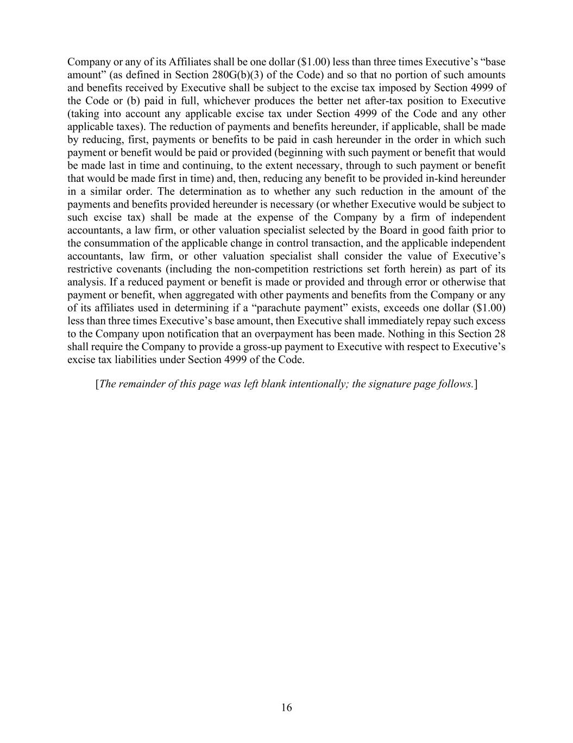
16 Company or any of its Affiliates shall be one dollar ($1.00) less than three times Executive’s “base amount” (as defined in Section 280G(b)(3) of the Code) and so that no portion of such amounts and benefits received by Executive shall be subject to the excise tax imposed by Section 4999 of the Code or (b) paid in full, whichever produces the better net after-tax position to Executive (taking into account any applicable excise tax under Section 4999 of the Code and any other applicable taxes). The reduction of payments and benefits hereunder, if applicable, shall be made by reducing, first, payments or benefits to be paid in cash hereunder in the order in which such payment or benefit would be paid or provided (beginning with such payment or benefit that would be made last in time and continuing, to the extent necessary, through to such payment or benefit that would be made first in time) and, then, reducing any benefit to be provided in-kind hereunder in a similar order. The determination as to whether any such reduction in the amount of the payments and benefits provided hereunder is necessary (or whether Executive would be subject to such excise tax) shall be made at the expense of the Company by a firm of independent accountants, a law firm, or other valuation specialist selected by the Board in good faith prior to the consummation of the applicable change in control transaction, and the applicable independent accountants, law firm, or other valuation specialist shall consider the value of Executive’s restrictive covenants (including the non-competition restrictions set forth herein) as part of its analysis. If a reduced payment or benefit is made or provided and through error or otherwise that payment or benefit, when aggregated with other payments and benefits from the Company or any of its affiliates used in determining if a “parachute payment” exists, exceeds one dollar ($1.00) less than three times Executive’s base amount, then Executive shall immediately repay such excess to the Company upon notification that an overpayment has been made. Nothing in this Section 28 shall require the Company to provide a gross-up payment to Executive with respect to Executive’s excise tax liabilities under Section 4999 of the Code. [The remainder of this page was left blank intentionally; the signature page follows.]

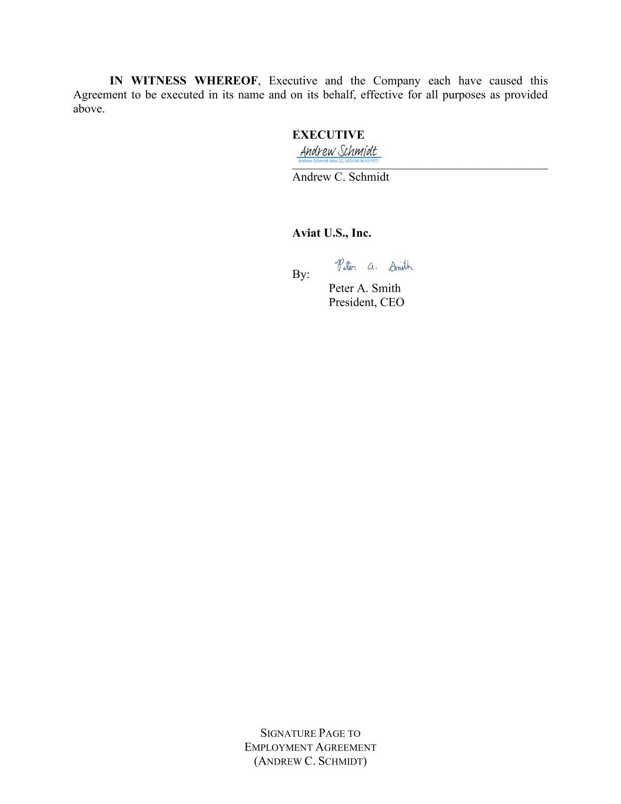
SIGNATURE PAGE TO EMPLOYMENT AGREEMENT (ANDREW C. SCHMIDT) IN WITNESS WHEREOF, Executive and the Company each have caused this Agreement to be executed in its name and on its behalf, effective for all purposes as provided above. EXECUTIVE __________________________________________ Andrew C. Schmidt Aviat U.S., Inc. By: Peter A. Smith President, CEO Andrew Schmidt (Nov 22, 2025 08:36:52 PST) Andrew Schmidt

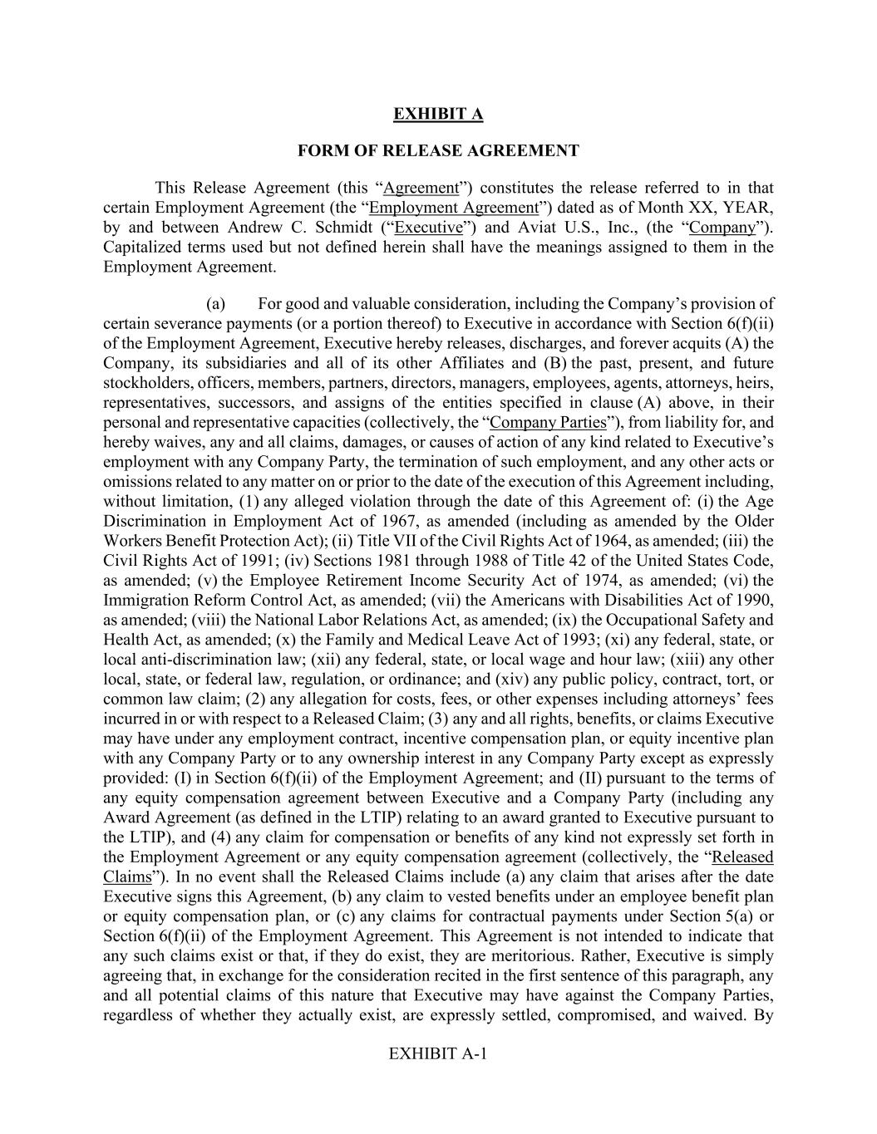
EXHIBIT A-1 EXHIBIT A FORM OF RELEASE AGREEMENT This Release Agreement (this “Agreement”) constitutes the release referred to in that certain Employment Agreement (the “Employment Agreement”) dated as of Month XX, YEAR, by and between Andrew C. Schmidt (“Executive”) and Aviat U.S., Inc., (the “Company”). Capitalized terms used but not defined herein shall have the meanings assigned to them in the Employment Agreement. (a) For good and valuable consideration, including the Company’s provision of certain severance payments (or a portion thereof) to Executive in accordance with Section 6(f)(ii) of the Employment Agreement, Executive hereby releases, discharges, and forever acquits (A) the Company, its subsidiaries and all of its other Affiliates and (B) the past, present, and future stockholders, officers, members, partners, directors, managers, employees, agents, attorneys, heirs, representatives, successors, and assigns of the entities specified in clause (A) above, in their personal and representative capacities (collectively, the “Company Parties”), from liability for, and hereby waives, any and all claims, damages, or causes of action of any kind related to Executive’s employment with any Company Party, the termination of such employment, and any other acts or omissions related to any matter on or prior to the date of the execution of this Agreement including, without limitation, (1) any alleged violation through the date of this Agreement of: (i) the Age Discrimination in Employment Act of 1967, as amended (including as amended by the Older Workers Benefit Protection Act); (ii) Title VII of the Civil Rights Act of 1964, as amended; (iii) the Civil Rights Act of 1991; (iv) Sections 1981 through 1988 of Title 42 of the United States Code, as amended; (v) the Employee Retirement Income Security Act of 1974, as amended; (vi) the Immigration Reform Control Act, as amended; (vii) the Americans with Disabilities Act of 1990, as amended; (viii) the National Labor Relations Act, as amended; (ix) the Occupational Safety and Health Act, as amended; (x) the Family and Medical Leave Act of 1993; (xi) any federal, state, or local anti-discrimination law; (xii) any federal, state, or local wage and hour law; (xiii) any other local, state, or federal law, regulation, or ordinance; and (xiv) any public policy, contract, tort, or common law claim; (2) any allegation for costs, fees, or other expenses including attorneys’ fees incurred in or with respect to a Released Claim; (3) any and all rights, benefits, or claims Executive may have under any employment contract, incentive compensation plan, or equity incentive plan with any Company Party or to any ownership interest in any Company Party except as expressly provided: (I) in Section 6(f)(ii) of the Employment Agreement; and (II) pursuant to the terms of any equity compensation agreement between Executive and a Company Party (including any Award Agreement (as defined in the LTIP) relating to an award granted to Executive pursuant to the LTIP), and (4) any claim for compensation or benefits of any kind not expressly set forth in the Employment Agreement or any equity compensation agreement (collectively, the “Released Claims”). In no event shall the Released Claims include (a) any claim that arises after the date Executive signs this Agreement, (b) any claim to vested benefits under an employee benefit plan or equity compensation plan, or (c) any claims for contractual payments under Section 5(a) or Section 6(f)(ii) of the Employment Agreement. This Agreement is not intended to indicate that any such claims exist or that, if they do exist, they are meritorious. Rather, Executive is simply agreeing that, in exchange for the consideration recited in the first sentence of this paragraph, any and all potential claims of this nature that Executive may have against the Company Parties, regardless of whether they actually exist, are expressly settled, compromised, and waived. By

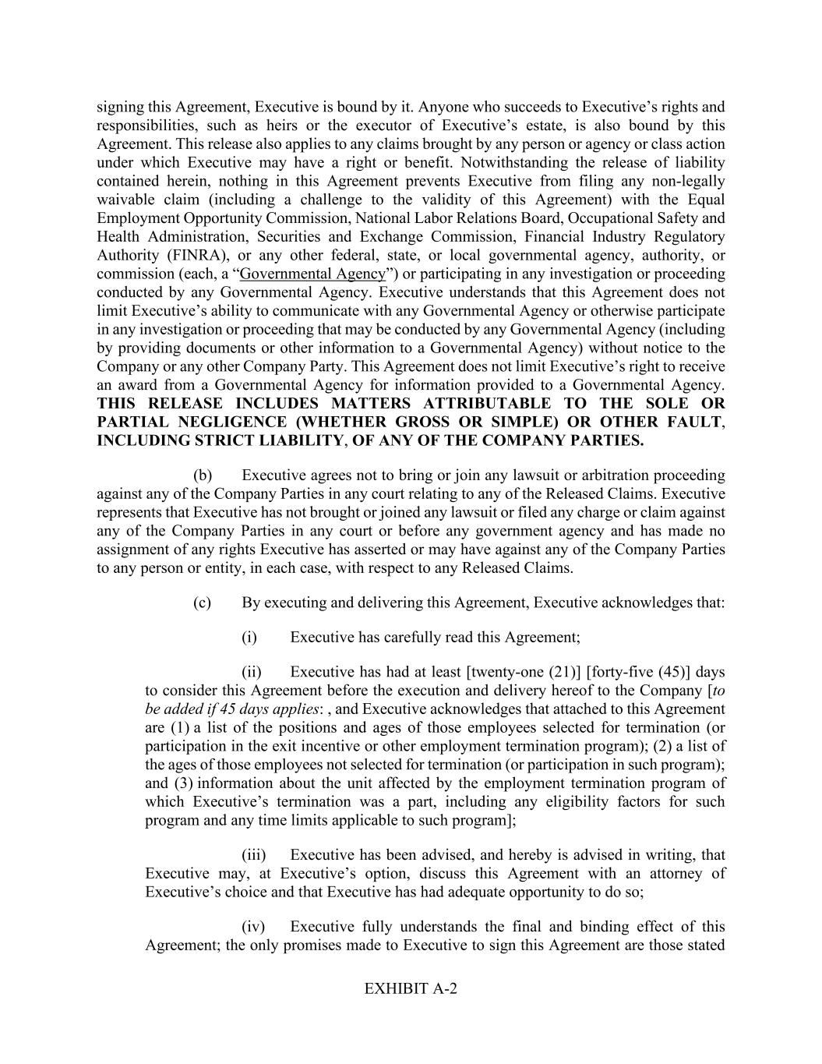
EXHIBIT A-2 signing this Agreement, Executive is bound by it. Anyone who succeeds to Executive’s rights and responsibilities, such as heirs or the executor of Executive’s estate, is also bound by this Agreement. This release also applies to any claims brought by any person or agency or class action under which Executive may have a right or benefit. Notwithstanding the release of liability contained herein, nothing in this Agreement prevents Executive from filing any non-legally waivable claim (including a challenge to the validity of this Agreement) with the Equal Employment Opportunity Commission, National Labor Relations Board, Occupational Safety and Health Administration, Securities and Exchange Commission, Financial Industry Regulatory Authority (FINRA), or any other federal, state, or local governmental agency, authority, or commission (each, a “Governmental Agency”) or participating in any investigation or proceeding conducted by any Governmental Agency. Executive understands that this Agreement does not limit Executive’s ability to communicate with any Governmental Agency or otherwise participate in any investigation or proceeding that may be conducted by any Governmental Agency (including by providing documents or other information to a Governmental Agency) without notice to the Company or any other Company Party. This Agreement does not limit Executive’s right to receive an award from a Governmental Agency for information provided to a Governmental Agency. THIS RELEASE INCLUDES MATTERS ATTRIBUTABLE TO THE SOLE OR PARTIAL NEGLIGENCE (WHETHER GROSS OR SIMPLE) OR OTHER FAULT, INCLUDING STRICT LIABILITY, OF ANY OF THE COMPANY PARTIES. (b) Executive agrees not to bring or join any lawsuit or arbitration proceeding against any of the Company Parties in any court relating to any of the Released Claims. Executive represents that Executive has not brought or joined any lawsuit or filed any charge or claim against any of the Company Parties in any court or before any government agency and has made no assignment of any rights Executive has asserted or may have against any of the Company Parties to any person or entity, in each case, with respect to any Released Claims. (c) By executing and delivering this Agreement, Executive acknowledges that: (i) Executive has carefully read this Agreement; (ii) Executive has had at least [twenty-one (21)] [forty-five (45)] days to consider this Agreement before the execution and delivery hereof to the Company [to be added if 45 days applies: , and Executive acknowledges that attached to this Agreement are (1) a list of the positions and ages of those employees selected for termination (or participation in the exit incentive or other employment termination program); (2) a list of the ages of those employees not selected for termination (or participation in such program); and (3) information about the unit affected by the employment termination program of which Executive’s termination was a part, including any eligibility factors for such program and any time limits applicable to such program]; (iii) Executive has been advised, and hereby is advised in writing, that Executive may, at Executive’s option, discuss this Agreement with an attorney of Executive’s choice and that Executive has had adequate opportunity to do so; (iv) Executive fully understands the final and binding effect of this Agreement; the only promises made to Executive to sign this Agreement are those stated

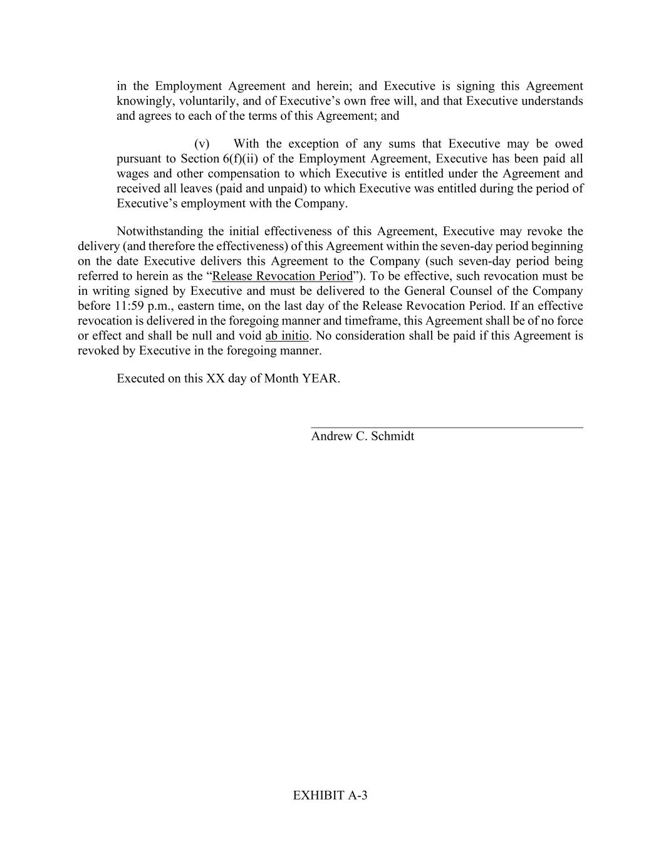
EXHIBIT A-3 in the Employment Agreement and herein; and Executive is signing this Agreement knowingly, voluntarily, and of Executive’s own free will, and that Executive understands and agrees to each of the terms of this Agreement; and (v) With the exception of any sums that Executive may be owed pursuant to Section 6(f)(ii) of the Employment Agreement, Executive has been paid all wages and other compensation to which Executive is entitled under the Agreement and received all leaves (paid and unpaid) to which Executive was entitled during the period of Executive’s employment with the Company. Notwithstanding the initial effectiveness of this Agreement, Executive may revoke the delivery (and therefore the effectiveness) of this Agreement within the seven-day period beginning on the date Executive delivers this Agreement to the Company (such seven-day period being referred to herein as the “Release Revocation Period”). To be effective, such revocation must be in writing signed by Executive and must be delivered to the General Counsel of the Company before 11:59 p.m., eastern time, on the last day of the Release Revocation Period. If an effective revocation is delivered in the foregoing manner and timeframe, this Agreement shall be of no force or effect and shall be null and void ab initio. No consideration shall be paid if this Agreement is revoked by Executive in the foregoing manner. Executed on this XX day of Month YEAR. __________________________________________ Andrew C. Schmidt

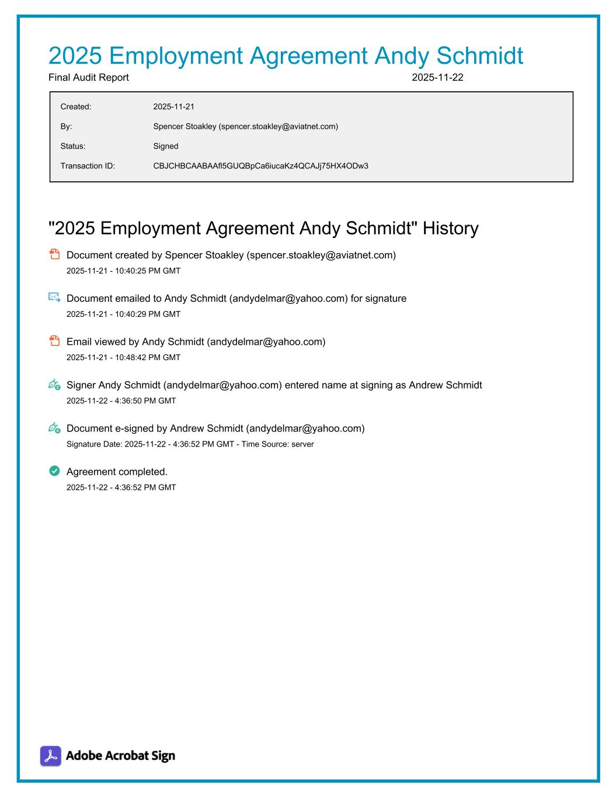
2025 Employment Agreement Andy Schmidt Final Audit Report 2025-11-22 Created: 2025-11-21 By: Spencer Stoakley (spencer.stoakley@aviatnet.com) Status: Signed Transaction ID: CBJCHBCAABAAfl5GUQBpCa6iucaKz4QCAJj75HX4ODw3 "2025 Employment Agreement Andy Schmidt" History Document created by Spencer Stoakley (spencer.stoakley@aviatnet.com) 2025-11-21 - 10:40:25 PM GMT Document emailed to Andy Schmidt (andydelmar@yahoo.com) for signature 2025-11-21 - 10:40:29 PM GMT Email viewed by Andy Schmidt (andydelmar@yahoo.com) 2025-11-21 - 10:48:42 PM GMT Signer Andy Schmidt (andydelmar@yahoo.com) entered name at signing as Andrew Schmidt 2025-11-22 - 4:36:50 PM GMT Document e-signed by Andrew Schmidt (andydelmar@yahoo.com) Signature Date: 2025-11-22 - 4:36:52 PM GMT - Time Source: server Agreement completed. 2025-11-22 - 4:36:52 PM GMT

Exhibit 31.1
CERTIFICATION PURSUANT TO SECTION 302(a)
OF THE SARBANES-OXLEY ACT OF 2002

I, Peter A. Smith, certify that:
1.I have reviewed this Quarterly Report on Form 10-Q for the fiscal quarter ended December 26, 2025, of Aviat Networks, Inc.;
2.Based on my knowledge, this report does not contain any untrue statement of a material fact or omit to state a material fact necessary to make the statements made, in light of the circumstances under which such statements were made, not misleading with respect to the period covered by this report;
3.Based on my knowledge, the financial statements, and other financial information included in this report, fairly present in all material respects the financial condition, results of operations and cash flows of the registrant as of, and for, the periods presented in this report;
4.The registrant’s other certifying officer and I are responsible for establishing and maintaining disclosure controls and procedures (as defined in Exchange Act Rules 13a-15(e) and 15d-15(e)) and internal control over financial reporting (as defined in Exchange Act Rules 13a-15(f) and 15d-15(f)) for the registrant and have:
a.Designed such disclosure controls and procedures, or caused such disclosure controls and procedures to be designed under our supervision, to ensure that material information relating to the registrant, including its consolidated subsidiaries, is made known to us by others within those entities, particularly during the period in which this report is being prepared;
b.Designed such internal control over financial reporting, or caused such internal control over financial reporting to be designed under our supervision, to provide reasonable assurance regarding the reliability of financial reporting and the preparation of financial statements for external purposes in accordance with generally accepted accounting principles;
c.Evaluated the effectiveness of the registrant’s disclosure controls and procedures and presented in this report our conclusions about the effectiveness of the disclosure controls and procedures, as of the end of the period covered by this report based on such evaluation; and
d.Disclosed in this report any change in the registrant’s internal control over financial reporting that occurred during the registrant’s most recent fiscal quarter (the registrant’s fourth fiscal quarter in the case of an annual report) that has materially affected, or is reasonably likely to materially affect, the registrant’s internal control over financial reporting; and
5.The registrant’s other certifying officer and I have disclosed, based on our most recent evaluation of internal control over financial reporting, to the registrant’s auditors and the audit committee of the registrant’s board of directors (or persons performing the equivalent functions):
a.All significant deficiencies and material weaknesses in the design or operation of internal control over financial reporting which are reasonably likely to adversely affect the registrant’s ability to record, process, summarize and report financial information; and
b.Any fraud, whether or not material, that involves management or other employees who have a significant role in the registrant’s internal control over financial reporting.

Date: |  |  | February 3, 2026 |  |  | /s/ Peter A. Smith
 |  |  |  |  |  | Name: |  |  |  |  |  | Peter A. Smith
 |  |  |  |  |  | Title: |  |  |  |  |  | President and Chief Executive Officer

Exhibit 31.2
CERTIFICATION PURSUANT TO SECTION 302(a)
OF THE SARBANES-OXLEY ACT OF 2002

I, Andrew C. Schmidt, certify that:
1.I have reviewed this Quarterly Report on Form 10-Q for the fiscal quarter ended December 26, 2025, of Aviat Networks, Inc.;
2.Based on my knowledge, this report does not contain any untrue statement of a material fact or omit to state a material fact necessary to make the statements made, in light of the circumstances under which such statements were made, not misleading with respect to the period covered by this report;
3.Based on my knowledge, the financial statements, and other financial information included in this report, fairly present in all material respects the financial condition, results of operations and cash flows of the registrant as of, and for, the periods presented in this report;
4.The registrant’s other certifying officer and I are responsible for establishing and maintaining disclosure controls and procedures (as defined in Exchange Act Rules 13a-15(e) and 15d-15(e)) and internal control over financial reporting (as defined in Exchange Act Rules 13a-15(f) and 15d-15(f)) for the registrant and have:
a.Designed such disclosure controls and procedures, or caused such disclosure controls and procedures to be designed under our supervision, to ensure that material information relating to the registrant, including its consolidated subsidiaries, is made known to us by others within those entities, particularly during the period in which this report is being prepared;
b.Designed such internal control over financial reporting, or caused such internal control over financial reporting to be designed under our supervision, to provide reasonable assurance regarding the reliability of financial reporting and the preparation of financial statements for external purposes in accordance with generally accepted accounting principles;
c.Evaluated the effectiveness of the registrant’s disclosure controls and procedures and presented in this report our conclusions about the effectiveness of the disclosure controls and procedures, as of the end of the period covered by this report based on such evaluation; and
d.Disclosed in this report any change in the registrant’s internal control over financial reporting that occurred during the registrant’s most recent fiscal quarter (the registrant’s fourth fiscal quarter in the case of an annual report) that has materially affected, or is reasonably likely to materially affect, the registrant’s internal control over financial reporting; and
5.The registrant’s other certifying officer and I have disclosed, based on our most recent evaluation of internal control over financial reporting, to the registrant’s auditors and the audit committee of the registrant’s board of directors (or persons performing the equivalent functions):
a.All significant deficiencies and material weaknesses in the design or operation of internal control over financial reporting which are reasonably likely to adversely affect the registrant’s ability to record, process, summarize and report financial information; and
b.Any fraud, whether or not material, that involves management or other employees who have a significant role in the registrant’s internal control over financial reporting.

Date: |  |  | February 3, 2026 |  |  | /s/ Andrew C. Schmidt
 |  |  |  |  |  | Name: |  |  |  |  |  | Andrew C. Schmidt
 |  |  |  |  |  | Title: |  |  |  |  |  | Senior Vice President and Chief Financial Officer

Exhibit 32.1

CERTIFICATIONS OF CHIEF EXECUTIVE OFFICER AND
PRINCIPAL FINANCIAL OFFICER OF AVIAT NETWORKS, INC.
PURSUANT TO TITLE 18 OF THE UNITED STATES CODE SECTION 1350,
AS ADOPTED PURSUANT TO SECTION 906 OF THE SARBANES-OXLEY ACT OF 2002

In connection with the filing of the Quarterly Report on Form 10-Q of Aviat Networks, Inc. (“Aviat Networks”) for the fiscal quarter ended December 26, 2025, as filed with the Securities and Exchange Commission on the date hereof (the “Report”), we, Peter A. Smith, President and Chief Executive Officer of Aviat Networks, and Andrew C. Schmidt, Senior Vice President and Chief Financial Officer of Aviat Networks, hereby certify, pursuant to Section 906 of the Sarbanes-Oxley Act of 2002, 18 U.S.C. §1350, that:
1.The Report fully complies with the requirements of Section 13(a) or 15(d), as applicable, of the Securities Exchange Act of 1934, as amended; and
2.The information contained in the Report fairly presents, in all material respects, the financial condition and results of operations of Aviat Networks as of the dates and for the periods expressed in the Report.

Date: February 3, 2026 |  |  |  |  |  | /s/ Peter A. Smith
 |  |  |  |  |  | Name: Peter A. Smith
 |  |  |  |  |  | Title: President and Chief Executive Officer
Date: February 3, 2026 |  |  |  |  |  | /s/ Andrew C. Schmidt
 |  |  |  |  |  | Name: Andrew C. Schmidt
 |  |  |  |  |  | Title: Senior Vice President and Chief Financial Officer

